Supplementary Material

Vibrational energy transfer near a dissociative adsorption transition state: State-to-state study of HCl collisions at Au(111)
Jan Geweke^{1,2,3,)}, Pranav R. Shirhatti^{1,3}, Igor Rahinov⁴, Christof Bartels^{1,3,)} and Alec M. Wodtke^{1,2,3,5}

¹Department of Dynamics at Surfaces, Max Planck Institute for Biophysical Chemistry, 37077 Göttingen, Germany.
²Max-Planck - EPFL Center for Molecular Nanoscience and Technology, Institute of Chemical Sciences and Engineering (ISIC), Station 6, École Polytechnique Fédérale de Lausanne, CH-1015 Lausanne, Switzerland.
³Institute for Physical Chemistry, Georg-August University of Göttingen, 37077 Göttingen, Germany.
⁴Department of Natural Sciences, The Open University of Israel, 4353701 Ra’anana, Israel.
⁵International Center for Advanced Studies of Energy Conversion, Georg-August University of Göttingen, 37077 Göttingen, Germany.

Vibrational state-specific relative sensitivity factors
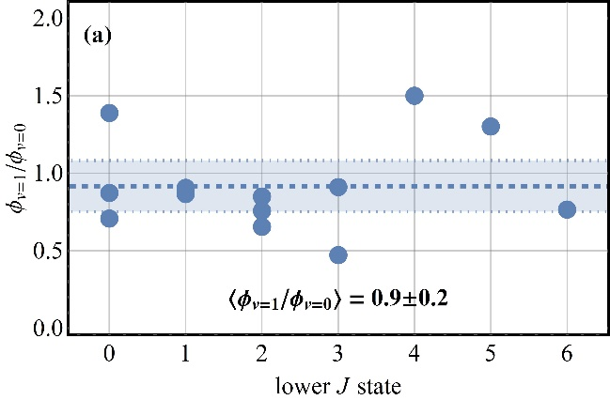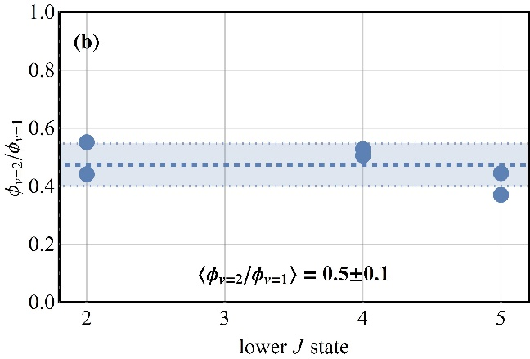

FIG. SI-1. Relative sensitivity factors – $ϕ_{v=1}/ϕ_{v=0}$ shown in (a) and $ϕ_{v=2}/ϕ_{v=1}$ shown in (b) – for different HCl rotational states indexed by the rotational quantum number J of v = 0 (a) and v = 1 (b), respectively. The thick dashed blue line denotes the mean value in each panel. The shaded areas denote the 95 % confidence interval for the mean value. Sensitivity factors for most J states were measured at least two times.

As described in section II.B. of the main text, we determined relative sensitivities for REMPI detection of HCl molecules when probing v = 0,1 and 2. Fig. SI-1 shows the results for several individual rotational states of each vibrational state. To summarize these results, v = 0 and v = 1 are detected with nearly equal sensitivity. v = 2 detection is only about half as sensitive as that of v = 1. Furthermore, within the uncertainty of our experiments, the sensitivity factors are not dependent on the rotational quantum number J in the range of J states studied here. Therefore, we calculated the mean relative detection sensitivity $〈ϕ_{v=1}/ϕ_{v=0}〉$ and its confidence interval using all the data points shown in (a), and the mean relative detection sensitivity $〈ϕ_{v=2}/ϕ_{v=1}〉$ and its confidence interval using all the data points shown in (b).

Time-of-flight data
Velocity distributions of the scattered molecules were derived from IR-UV double resonance time-of-flight experiments. Representative data at two incidence translational energies are shown in Fig. SI-2a. The data were fitted with functions $P_{t}\left(t\right)$ obtained from flowing Maxwell-Boltzmann distributions that were converted from velocity to time space. In addition, density-to-flux conversions were applied:
$$P_{t}\left(t\right)=A{\left(\frac{t}{l}\right)}^{2}\left(\frac{l}{t^{2}}\right){\left(\frac{l}{t}\right)}^{3}exp\left[-{\frac{\left(l/t-v_{0}\right)}{α^{2}}}^{2}\right] (SI-1)$$
Here, $t$ is the flight time, $l$ the flight distance, $α$ is a parameter describing the width of the distribution, and $v_{0}$ is the mean velocity. The fitted distributions $P_{t}\left(t\right)$ can then be converted to translational energy distributions $P_{E}\left(E\right)$ – some of these are shown in Fig. SI-2b.
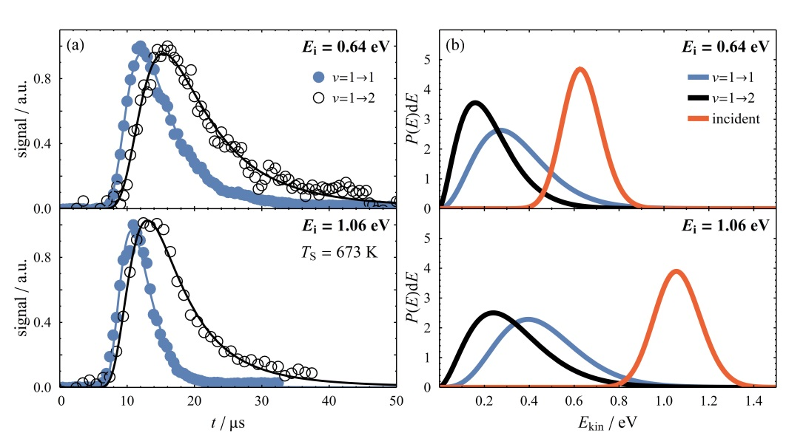
Fig. SI-2. Arrival time and incidence energy distributions of vibrationally elastic and inelastic scattering channels resulting from HCl collisions with Au(111). Results for two incidence energies at a surface temperature of 673 K are shown in blue and black for v = 1 → 1 and v = 1 → 2 scattering, respectively, in panel (a). Data points are shown as symbols and fits to these points according to Eq. SI-1 are shown as solid lines. The probed rotational state is J = 5 in each case. In panel (b) the resulting energy distributions are shown for scattered molecules in v = 1 (blue), v = 2 (black), and incident molecules in v = 1 (red).

These distributions depend on the HCl quantum state chosen for detection. Similar results to those of Fig. SI-2 were obtained for a variety of final rotational states of the scattered HCl molecules; the mean final translational energies for these individual experiments are shown in Fig. SI-3.
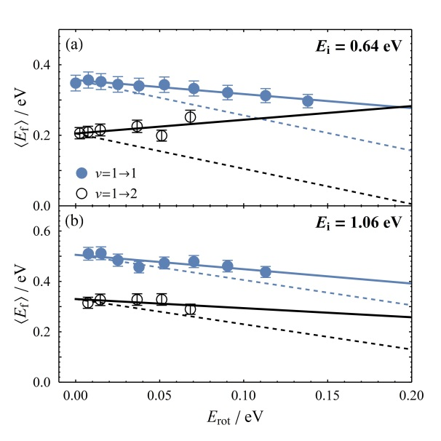
Fig. SI-3. Dependence of final HCl translational energy on final rotational energy. For incidence energies of (a) 0.64 eV and (b) 1.06 eV the mean final translational energy $〈E_{f}〉$ is plotted against the molecules’ final rotational energy ($E_{rot}$) in filled blue and open black symbols for v = 1 → 1 and v = 1 → 2 scattering, respectively. Dashed lines have a slope of -1, what would be expected for a strict anti-correlation between $E_{rot}$ and $〈E_{f}〉$. T_{S} = 673 K.

Examining Fig. SI-3 reveals anti-correlation between the final translational, $〈E_{f}〉$, and rotational energy, $E_{rot}$, i.e. the mean final translational energy decreases with increasing final rotational energy (for most but not all data). In general, the incidence translational energy $E_{i}$ is redistributed into final translational energy, $E_{f}$, rotational energy, $E_{rot}$, and excitation of the surface, $E_{surf}$:
$$E_{i}=E_{f}+E_{rot}+E_{surf} (SI-2).$$
Interestingly, the vibrationally inelastic channel shows a weaker dependence of $〈E_{f}〉$ on $E_{rot}$ for $〈E_{i}〉$ = 1.06 eV and an inverted dependence at $〈E_{i}〉$ = 0.64 eV (i.e. $〈E_{f}〉$ increases with increasing $E_{rot}$). Similar behavior was also observed for scattering of NO from Au(111), with the effect being larger for excitation compared to relaxation.^{1,2} For making comparisons between different vibrational channels, we now consider the results of Fig. SI-3 in the limit of zero rotational excitation $E_{rot}→0$ and emphasize two key points:
- First, for the vibrationally elastic channel (v = 1 → 1), we see that the mean final translational energies are 52±4 % of the mean incidence translational energies, which is close to the so-called Baule limit (the prediction of the binary collision model for a collision between a particle of the mass of an HCl molecule and one of the mass of Au atom) of ~ 48 %.³⁻⁵ Our results are in good agreement with previous observations on vibrationally elastic scattering of HCl/Au(111) in the v = 2 → 2 and v = 0 → 0 channels.^{4,5}
- Second, for the vibrationally inelastic channel (v = 1 → 2) the HCl molecules retain only 35±4 % of their mean incidence translational energy, indicating coupling between translational (T) and vibrational (V) energy of the molecule during the encounter with the surface (T-to-V coupling). This is consistent with V-to-T coupling reported previously for the HCl(v = 2 → 1) channel – in that case, the molecules which had undergone vibrational relaxation had higher outbound kinetic energy than those scattered vibrationally elastically.⁴
While the purpose of this work is not to present a detailed explanation of these subtle effects, the state-resolved translational energies are important as they were used to correct for the velocity dependence of the REMPI detection sensitivities.

NO (v = 2 → 3) results
Only few published data for vibrational excitation from a lower v state differing from v = 0 are available for a variety of surface temperatures (cf. Ref. 6,7). One possible comparison can be drawn with the data for NO/Au(111) v = 2 → 3 excitation (unpublished results). Probabilities for v = 2 → 3 excitation of NO/Au(111) were determined in a procedure similar to the one employed for HCl (v = 1 → 2; see the main publication) and NO (v = 0 → 1; see Ref. 8,9) excitation.
In short, a pulsed beam of 15 % NO seeded in H₂ (E_{i} = 0.41 eV) was scattered from a Au(111) surface in the same apparatus as described in section II.A. Prior to collision, NO molecules were excited to v = 2 via the R(0.5) transition using the high resolution IR source described in the main text tuned to $\tilde{ν}$ = 3728.982 cm⁻¹. For detection of scattered molecules in v = 2 and 3 a (1+1) REMPI scheme was employed (see Ref. 8 for further details). Figure SI-4 shows examples of REMPI spectra of scattered NO (v = 2,3) for two surface temperatures T_{S}. The spectra have been corrected for detector gain and laser power.
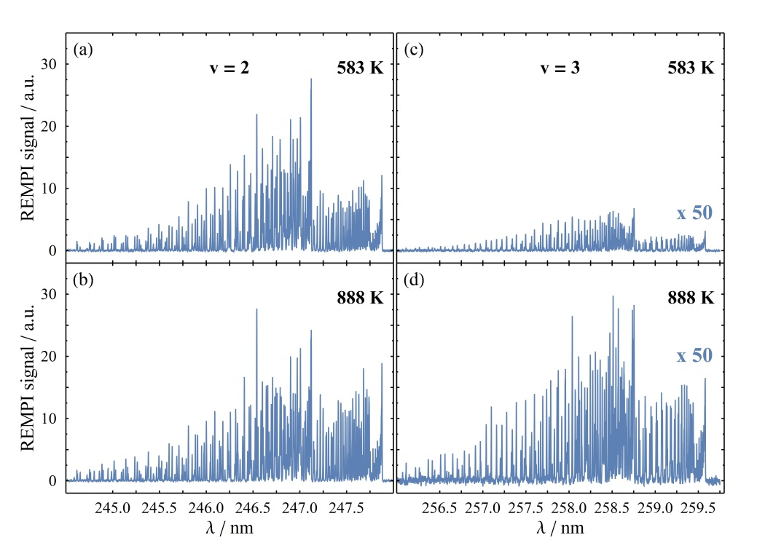
FIG SI-4. NO(v = 2 → 3) scattering in collisions of NO with Au(111). REMPI spectra of the scattered molecules in v = 2 and 3 at a surface temperature of (a, c) 583 K and 888 K (b, d). Spectra for the same v state were recorded under the same experimental conditions with E_{i} = 0.41 eV. While the change in the v = 2 intensities is almost undetectable, the increase in v = 3 intensity for higher surface temperature is clearly seen. The spectra are corrected for laser power and detector gain. For the sake of visualization, the v = 3 spectra are multiplied by a factor of 50.

Based on the intensities in these spectra, vibrational excitation probabilities were calculated following modified versions of Equations 4-6 in Ref. 8 and Equations 3-4 in the main text. In the analysis, the influence of vibrational relaxation was taken into account by including the survival probability of v = 2 reported in Ref. 6. The surface temperature dependence of these probabilities is depicted in Fig. SI-5 in comparison with previously published data for v = 0 → 1 excitation.^{8,9} In addition, fits to the exponential nonadiabatic term of Equation 5 in the main publication, $A_{v,v'}^{nonad.}\left(E_{i}\right)exp\left(- \frac{E_{v,v'}}{k_{B}T_{S}}\right)$, are shown. In contrast to the HCl/Au(111) system, where we see a nine-fold increase in the nonadiabatic A-factor going from v = 0 → 1 to v = 1 → 2 excitation, the derived A-factor for NO only increases by a factor of 1.8 going from v = 0 → 1 to v = 2 → 3.
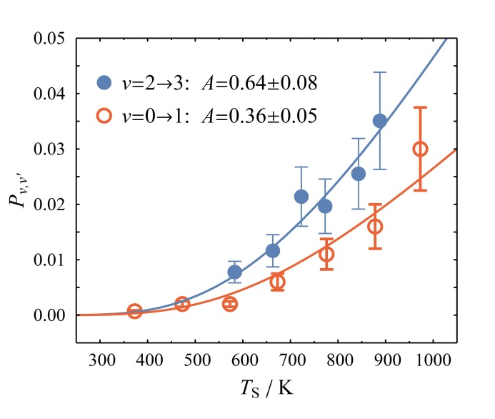
FIG. SI-5. Comparison of vibrational excitation probabilities for NO/Au(111). For v = 0 → 1^{8,9} (red open circles) and v = 2 → 3 (blue filled circles), the excitation probability P_{v,v’} is plotted against the surface temperature at an incidence translational energy of 0.41 eV. Solid lines denote fits to Eq. 7 in the main text (approximately exponential increase of the vibrational excitation with surface temperature). A-factors, which reflect the intrinsic electronically nonadiabatic interaction strength corrected for the temperature-dependent population of hot electron-hole pairs, are derived in this way and shown next to the legend.

Angular distributions
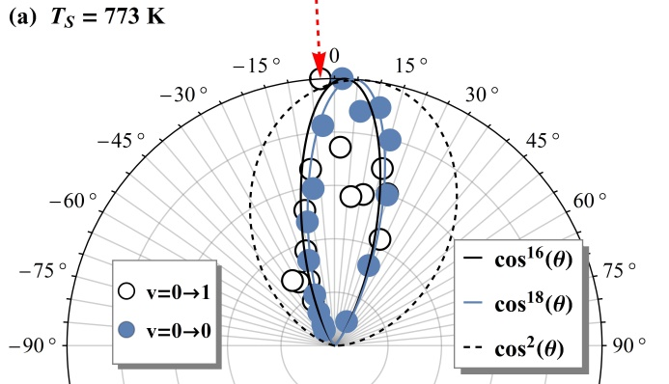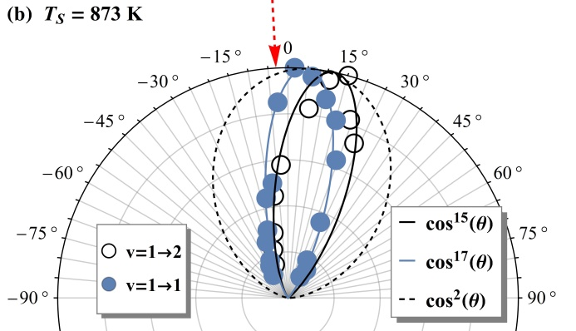
FIG. SI-6. HCl scattering angular distributions for various vibrational scattering channels. Shown are the vibrationally elastic (filled blue circles) and inelastic (open black circles) channels for v = 0 $→$ 1 (a) and v = 1 $→$ 2 (b) scattering. Solid lines in the corresponding colors represent fits given in the legend while the black dashed line represents the expectation for thermal desorption in form of a cos²(θ) function. The incident beam with an incidence angle of approx. 3° is depicted by a dashed red arrow.

In addition to the time-of-flight data, angular distributions for vibrationally elastic and inelastic channels for v = 0 $→$ 1 and v = 1 $→$ 2 scattering were measured. Fig. SI-6 shows distributions that can be described by narrow cos^{x}(θ-θ₀) distributions¹⁰ (with x = 15-18). This clearly deviates from the behavior expected if the HCl molecules would have been trapped on the surface and thermalized prior to desorption (x = 1-2 depending on how the laser is focused⁸ – or more precisely: the extent of the detection region). In combination with the velocity distributions of the scattered molecules this shows that direct single-bounce scattering (as opposed to trapping-desorption) is the main channel under these experimental conditions. The fact that the different scattering channels exhibit nearly identical angular distributions also simplifies the derivation of surface collision induced vibrational transition probabilities.

References
¹ K. Golibrzuch, P. R. Shirhatti, J. Altschaffel, I. Rahinov, D. J. Auerbach, A. M. Wodtke, and C. Bartels, J. Phys. Chem. A 117, 8750 (2013).
² K. Golibrzuch, P. R. Shirhatti, I. Rahinov, D. J. Auerbach, A. M. Wodtke, and C. Bartels, Phys. Chem. Chem. Phys. 16, 7602 (2014).
³ B. Baule, Ann. Phys. 349, 145 (1914).
⁴ I. Rahinov, R. Cooper, C. Yuan, X. Yang, D. J. Auerbach, and A. M. Wodtke, J. Chem. Phys. 129, 214708 (2008).
⁵ R. Cooper, I. Rahinov, C. Yuan, X. Yang, D. J. Auerbach, and A. M. Wodtke, J. Vac. Sci. Technol. A 27, 907 (2009).
⁶ Y. Huang, A. M. Wodtke, H. Hou, C. T. Rettner, and D. J. Auerbach, Phys. Rev. Lett. 84, 2985 (2000).
⁷ A. M. Wodtke, Y. H. Huang, and D. J. Auerbach, Chem Phys Lett 364 (2002).
⁸ R. Cooper, Z. Li, K. Golibrzuch, C. Bartels, I. Rahinov, D. J. Auerbach, and A. M. Wodtke, J. Chem. Phys. 137, 064705 (2012).
⁹ D. Matsiev, Z. Li, R. Cooper, I. Rahinov, C. Bartels, D. J. Auerbach, and A. M. Wodtke, Phys. Chem. Chem. Phys. 13, 8153 (2011).
¹⁰ This offset in the scattering angle is mostly due to a small tilt of our surface, i. e. the incidence angle is not exactly 0°. Based on the deviation in the scattering angle for v=1→2 scattering, problems in measuring the angular distribution cannot be completely excluded.

Author to whom correspondence should be addressed: jan.geweke@mpibpc.mpg.de
Present Address: Institute of Physics, University of Freiburg, 79104 Freiburg, Germany

