Supporting Information for:
Stability of odd versus even electron gas-phase (quasi)molecular ions derived from pyridine-substituted
N-heterotriangulenes
Jakob F. Hitzenberger,^{a)} Pavlo O. Dral,^{c)} Ute Meinhardt,^{b)} Timothy Clark,^{d)} Walter Thiel,^{c)} Milan Kivala,* ^{b)} and Thomas Drewello* ^{a)}

a) Physical Chemistry I, Department of Chemistry and Pharmacy, Friedrich-Alexander University Erlangen-Nürnberg (FAU), Egerlandstraße 3, 91058 Erlangen, Germany.
b) Organic Chemistry I, Department of Chemistry and Pharmacy, Friedrich-Alexander University Erlangen-Nürnberg (FAU), Henkestraße 42, 91054 Erlangen, Germany.
c) Max-Planck-Institut für Kohlenforschung, Kaiser-Wilhelm-Platz 1, 45470 Mülheim an der Ruhr, Germany.
d) Computer-Chemie-Centrum, Department of Chemistry and Pharmacy, Friedrich-Alexander University Erlangen-Nürnberg (FAU), Nägelbachstraße 25, 91052 Erlangen, Germany.
* To whom correspondence should be addressed: milan.kivala@fau.de, thomas.drewello@fau.de.

Table of contents

1 Experimental Settings 3
2 Mass Spectra 4
3 Computational Details 6
3.1 Aromaticity 7
3.2 First Methyl Loss from [NTGPy₂+H]⁺ and [NTGPy₃+H]⁺ 8
4 Conversion of E_{lab} into E_{com} (QqToF) 9
5 Extraction of the E_{CoM}(50%) values (QqToF) : 9
6 Extraction of the E_{CoM}(50%) values for the mixture of [NTGPy]⁺• and [NTGPy+H]⁺ (QqToF) 10
7 Extraction of the E_{onset} values from the mixture of [NTGPy]⁺• and [NTGPy+H]⁺ (ion trap) 12
8 Calculations of the [M]^{+•} and [M+H]⁺ ratios 13
9 References 14

Experimental Settings

The ESI experiments were conducted with two different ESI-mass spectrometers:
The first instrument was an ESI-quadrupole time-of-flight (QqToF) mass spectrometer (micrOTOF-Q II, Bruker, Bremen, Germany). The following settings were applied. Flow rate of the sample solution by syringe pump infusion 3.0 mL/min, nebuliser nitrogen pressure 400 hPa, capillary entrance voltage 3.5 kV, spray shield voltage 3 kV, nitrogen dry gas temperature 453 K, dry gas flow rate 4.0 L/min.
The second instrument was an ESI-quadrupole ion trap instrument (esquire6000, Bruker, Bremen, Germany). The following settings were applied: Flow rate of the sample solution by syringe pump infusion 4.0 µL/min, nebuliser nitrogen pressure 689 hPa, capillary entrance voltage 4 kV, spray shield voltage 3.5 kV, nitrogen dry gas temperature 573 K, dry gas flow rate 5.0 L/min, the helium buffer/collision gas pressure was set to 4.0 × 10⁻⁶ hPa.

Mass Spectra

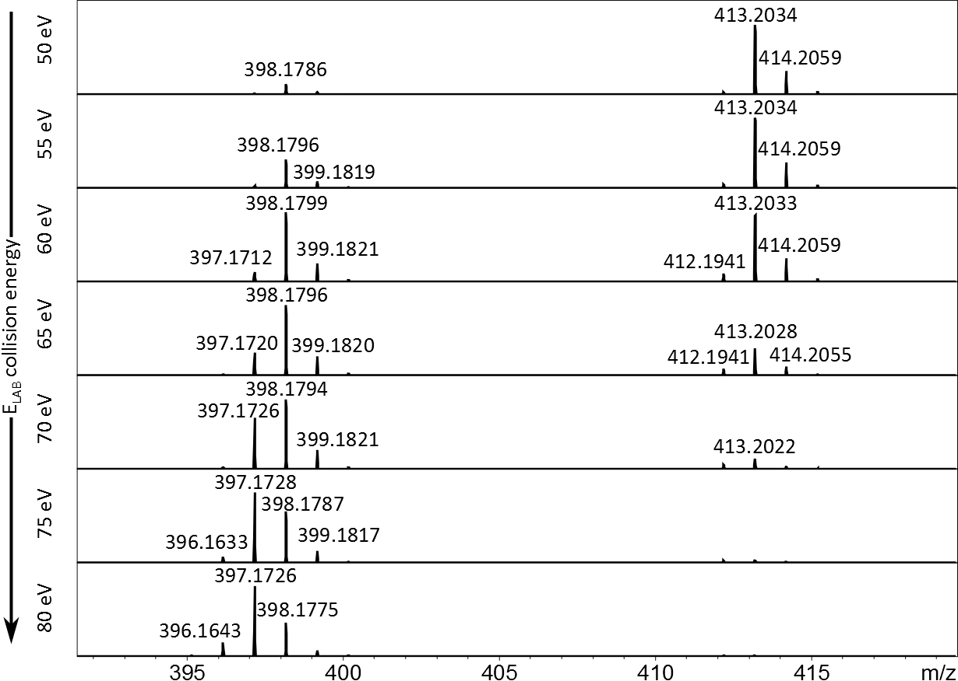
Figure S1: CID mass spectra of NTGPy with the collision energy E_{lab} ranging from 50 -80 eV, depicting the dissociation of hydrogens after dissociation of three •CH₃-radicals.

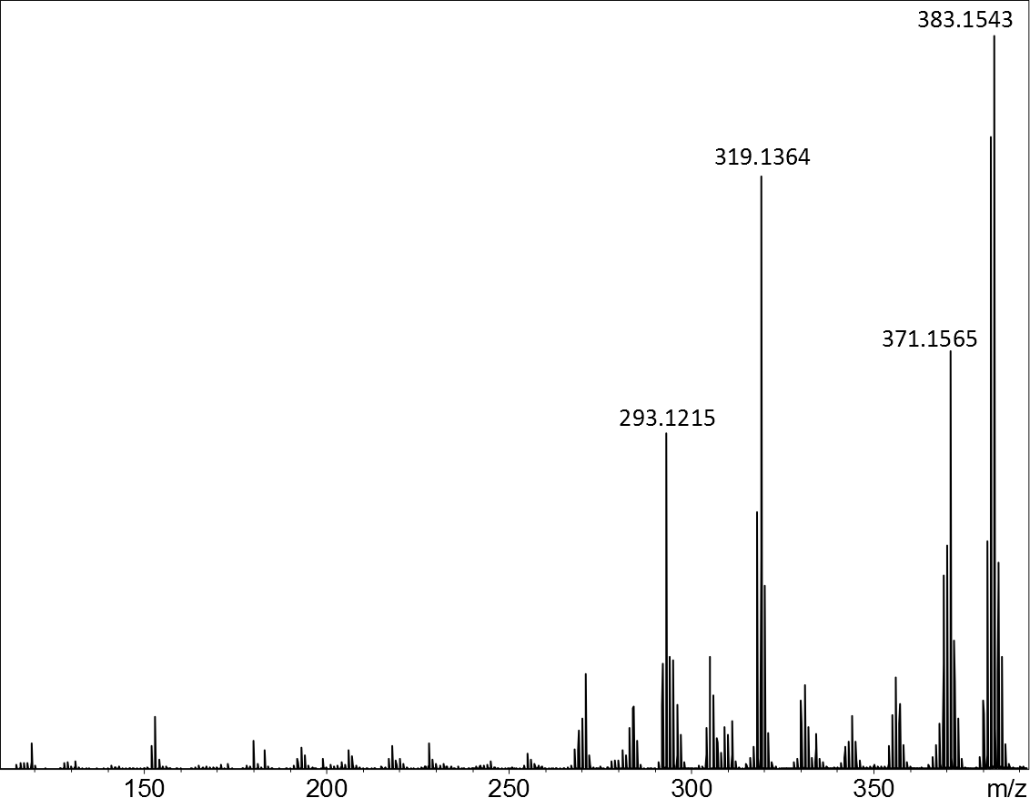
Figure S2: CID mass spectrum of [NTGPy]^{+•} at a collision energy of 100 eV resulting in rupture of the N-heterotriangulene core.

Computational Details
All calculations were performed with the Gaussian 09 program suite.¹ Geometry optimizations, normal vibrational modes within the harmonic approximation calculated to characterize minima, and zero-point energy (ZPE) corrections were calculated at the ωB97XD²/6-31G(d)³⁻¹⁴ level of theory. Additional single point calculations were performed with MP2¹⁵/cc-pVDZ¹⁶⁻²⁰ on the geometries optimized at ωB97XD/6-31G(d). All MP2 and DFT energies reported in the main text include ZPEs.
Cartesian coordinates of all calculated species at the ωB97XD/6-31G(d) levels of theory and archives of Gaussian 09 calculations at both ωB97XD/6-31G(d) and MP2/cc-pVDZ are provided in an accompanying directory SI_Stability_N-Heterotriangulenes_Calculations, which is provided as a .zip file.
Calculations for open-shell species were performed using unrestricted Kohn–Sham approach to DFT (UωB97XD/6-31G(d)) and restricted open-shell MP2 (ROMP2/cc-pVDZ). Using unrestricted MP2 leads to too large errors caused by significant spin contamination and thus ROMP2²¹⁻²³ is used in this study. On the other hand, unrestricted DFT is known to provide fairly accurate energetics on its own as it suffers much less from spin contamination than single-determinantal ab initio methods.²⁴ Single-point ROMP2 calculations on the UωB97XD/6-31G(d)-optimized geometries should further reduce the remaining error arising from spin contamination at UωB97XD/6-31G(d), whose expectation values of the total spin <S²> are given for all investigated species in the archives of the Gaussian 09 calculations.

Aromaticity
Figure S3. Numbering of rings of [NTGPy]^{+•}, [NTGPy _ p-CH₃]⁺, [NTGPy+H]⁺, and
[(NTGPy+H) _ p-CH₃]^{+•}. Alternative representation of the N-heterotriangulene cores using Clar’s sextets²⁵⁻²⁷.

Table S1. Nuclear independent chemical shifts²⁸⁻³⁰ values at the centers of rings A–D of [NTGPy]^{+•}, [NTGPy _ p-CH₃]⁺, [NTGPy+H]⁺, and [(NTGPy+H) _ p-CH₃]^{+•} calculated with the self-consistent field–gauge-independent atomic orbital³¹⁻³⁶ method at the
B3LYP³⁷⁻³⁹/6–311++G(d,p)^{6-14, 40-42} level of theory on the ωB97XD/6-31G(d)-optimized geometries.
Species | A | B | C | D
[NTGPy]^{+•} | −6.6 | 3.5 | 3.5 | −5.7
[NTGPy _ p-CH₃]⁺ | −8.1 | −6.5 | 5.5 | −6.6
[NTGPy+H]⁺ | −7.6 | 3.4 | 4.0 | −4.2
[(NTGPy+H) _ p-CH₃]^{+•} | −6.4 | 0.3 | 4.8 | −4.6

First Methyl Loss from [NTGPy₂+H]⁺ and [NTGPy₃+H]⁺
Figure S4. First methyl loss products from [NTGPy₂+H]⁺ and [NTGPy₃+H]⁺.

Table S2. Energies of first methyl loss from [NTGPy₂+H]⁺ and [NTGPy₃+H]⁺ (and for comparison from [NTGPy+H]⁺) in eV at the ROMP2/cc-pVDZ level of theory on the ωB97XD/6-31G(d)-optimized geometries. Energies include ZPEs calculated at ωB97XD/
6-31G(d).
Species | Fragmentation products | Dissociation energy
[NTGPy+H]⁺ | [(NTGPy+H) _ p-CH₃]^{+•} | 2.78
 | [(NTGPy+H) _ o-CH₃]^{+•} | 2.68
[NTGPy₂+H]⁺ | [(NTGPy₂+H) _ p,o-CH₃]^{+•} | 2.77
 | [(NTGPy₂+H) _ o,p-CH₃]^{+•} | 2.68
 | [(NTGPy₂+H) _ o,o-CH₃]^{+•} | 2.67
[NTGPy₃+H]⁺ | [(NTGPy₃+H) _ p-CH₃]^{+•} | 2.80
 | [(NTGPy₃+H) _ o-CH₃]^{+•} | 2.71

Conversion of E_{lab} into E_{com} (QqToF)

The four N-heterotriangulenes (NTG and NTGPy_{n}, with n = 1–3) were isolated and fragmented in collisions with N₂ at different laboratory collision energies (E_{lab}) that ranged from 0 to 80 eV. The laboratory collision energy is converted to the total energy available for dissociation, called center-of-mass collision energy (E_{CoM}), by the following relationship
E_{CoM}=(m_{n}*E_{lab})/(m_{i}+m_{n})
where m_{n} represents the molecular mass of the neutral collision gas N₂ and m_{i} the molecular mass of the investigated ion.

Extraction of the E_{CoM}(50%) values (QqToF) :
The results of the energy-dependent dissociation experiments were fitted by the sigmoidal Boltzmann equation:
$$y=(A_{2}-A_{1})\left[1+exp\left(\frac{x-x_{0}}{dx}\right)\right]$$
The x₀ value, the inflexion point, is equal to the E_{CoM}(50%) value. The error of E_{CoM}(50%) can be estimated by fitting the maximal and minimal error-curve as shown in Figure S4.
Table S2: E_{CoM}(50%) with errors for the dissociation of the precursors
Precursor | E_{CoM}(50%)
[NTG] ^{+•} | 1.076 ± 0.012
[NTGPy]^{+•} | 2.365 ± 0.001
[NTGPy₂+H]⁺ | 2.210 ± 0.055
[NTGPy₃+H]⁺ | 2.133 ± 0.001

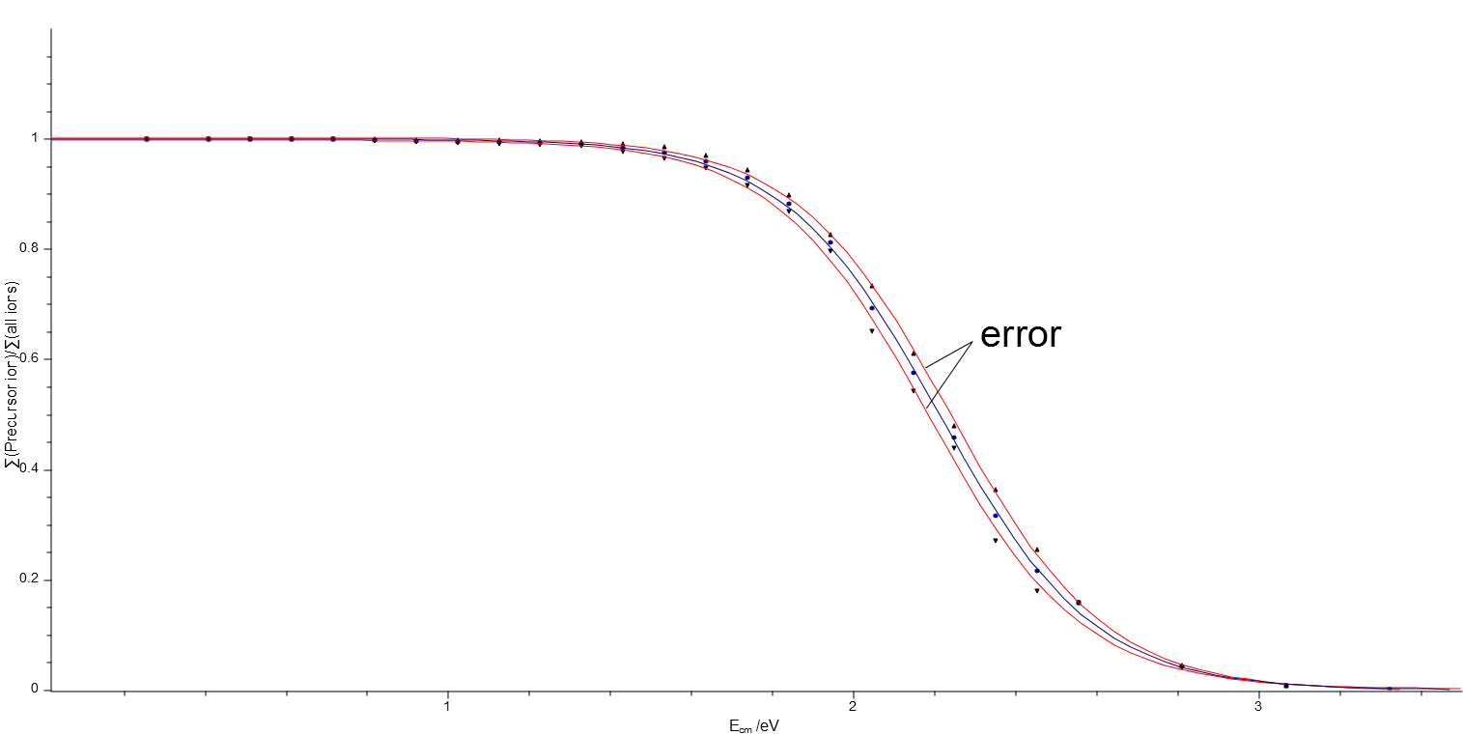
Figure S5: Error estimation of the sigmoidal Boltzmann fit of the dissociation of the precursor [NTGPy₂+H]⁺ using the QqToF mass spectrometer (x-axis: E_{CoM} and y-axis: ratio of precursor ion intensity to sum of intensities of all signals).

Extraction of the E_{CoM}(50%) values for the mixture of [NTGPy]⁺• and [NTGPy+H]⁺ (QqToF)

In this case, a Boltzmann fit is not possible. Instead, the graph was fitted by a multipeak-fit.
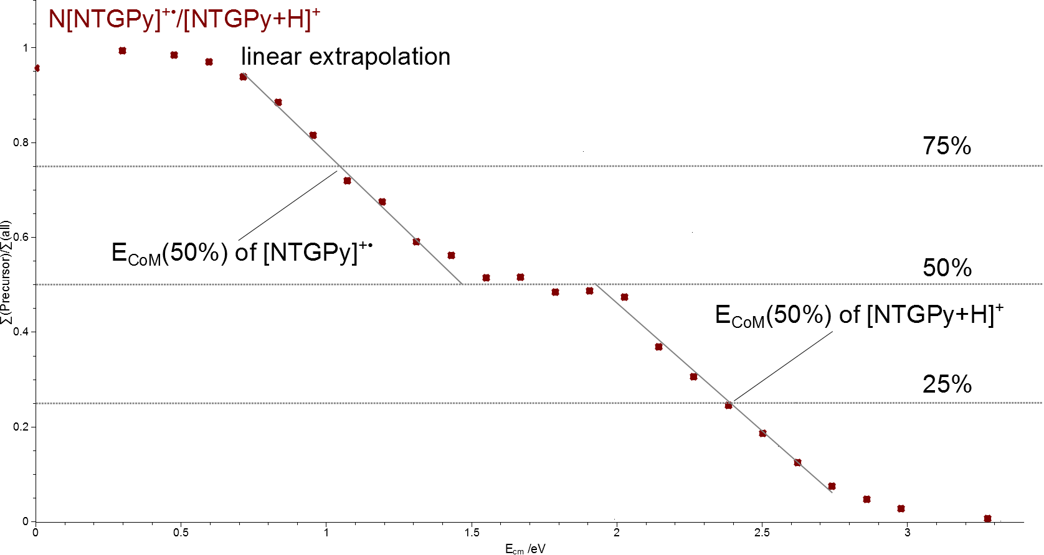
Figure S6: Energy-dependent dissociation behaviour of the precursor ions of [NTGPy]^{+•} and [NTGPy+H]⁺ using the QqToF mass spectrometer (x-axis: E_{CoM} and y-axis: ratio of precursor ion intensity to sum of intensities of all signals). The respective E_{CoM}(50%) values are marked.

The E_{CoM}(50%) values were calculated by linear extrapolation of the respective slope. The ratio of the radical cation and protonated species was 1:1. Therefore, as shown in Figure S6 above, the E_{CoM}(50%) value of the radical cation, characterizing 50% of the dissociation of the radical cation was obtained at 75% of the total dissociation of the bimodal curve. The E_{CoM}(50%) value of the protonated species was accordingly obtained at 25% of the total dissociation.

Extraction of the E_{onset} values from the mixture of [NTGPy]⁺• and [NTGPy+H]⁺ (ion trap)

The E_{Onset} values were calculated by linear extrapolation of the respective slope. The error can be estimated by linear extrapolation of the slopes with the maximal and minimal x-axis intersection within the error bars.
Table S3: E_{onset} values of the mixture of [NTGPy]⁺• and [NTGPy+H]⁺
Precursor | E_{Onset} /10⁻³V
[NTGPy]^{+•} | 1.96 ± 0.12
[NTGPy-15]^{+•} | 3.87 ± 0.19
[NTGPy-30]^{+•} | 4.12 ± 0.51
[NTGPy+H]⁺ | 4.12 ± 0.07
[NTGPy+H-15]⁺ | 4.86 ± 0.24
[NTGPy+H-30]⁺ | 5.29 ± 0.45
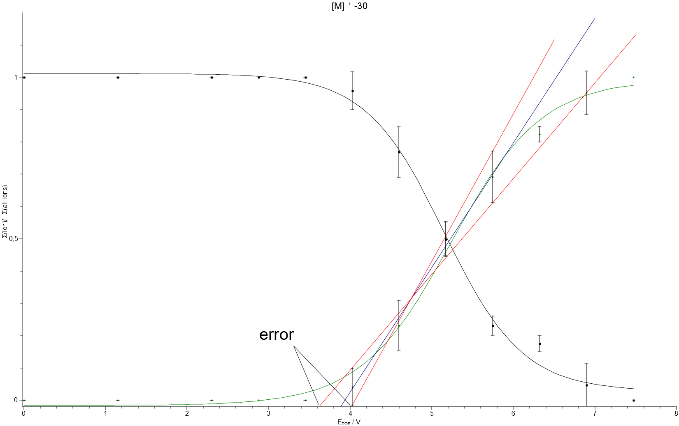
Figure S7: Error of the linear extrapolation of [NTGPy-15]^{+•} using the ion trap mass spectrometer (x-axis: E_{DOF} and y-axis: ratio of precursor ion intensity to sum of intensities of all signals).

Calculations of the [M]^{+•} and [M+H]⁺ ratios

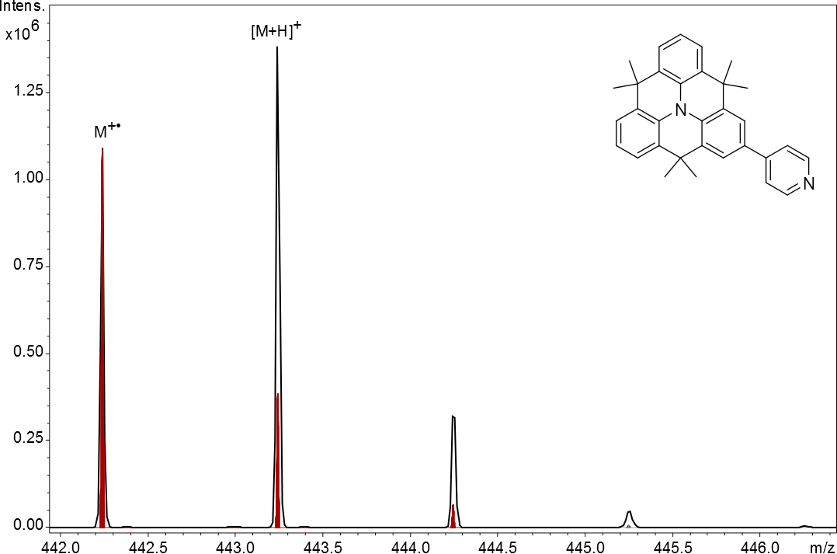
Figure S 8: Measured spectrum (black) of [NTGPy]^{+•} and [NTGPy+H]⁺ and simulated spectrum (red) of [NTGPy]^{+•}
The overlap of the isotope patterns of the radical cation and protonated species was taken into account. Their ratios, shown in Figure 1, have been obtained in the following way. The isotope peak with the lowest mass of [M]^{+•} does not overlap with [M+H]⁺ and therefore was used to calculate the intensity of the second (¹³C₁), third (¹³C₂) and fourth (¹³C₃) isotope peak of [M]^{+•}, using a standard program for the calculation of isotope patterns. For the total intensity of [M]^{+•}, these intensities were added to the intensity of the first isotope peak. The total intensity of [M+H]⁺ was calculated by addition of the intensities of all [M+H]⁺-containing peaks and subtraction of the calculated intensities of the second, third and fourth isotope peak of [M]^{+•}. From Figure 2, it is evident that [M+H]⁺ ions do not undergo the loss of one H-atom, so that the low mass isotope peak of [M]^{+•} cannot be obscured by such a reaction.

References

1. M. J. Frisch, G. W. Trucks, H. B. Schlegel, G. E. Scuseria, M. A. Robb, J. R. Cheeseman, G. Scalmani, V. Barone, B. Mennucci, G. A. Petersson, H. Nakatsuji, M. Caricato, X. Li, H. P. Hratchian, A. F. Izmaylov, J. Bloino, G. Zheng, J. L. Sonnenberg, M. Hada, M. Ehara, K. Toyota, R. Fukuda, J. Hasegawa, M. Ishida, T. Nakajima, Y. Honda, O. Kitao, H. Nakai, T. Vreven, J. A. Montgomery Jr., J. E. Peralta, F. Ogliaro, M. J. Bearpark, J. Heyd, E. N. Brothers, K. N. Kudin, V. N. Staroverov, R. Kobayashi, J. Normand, K. Raghavachari, A. P. Rendell, J. C. Burant, S. S. Iyengar, J. Tomasi, M. Cossi, N. Rega, N. J. Millam, M. Klene, J. E. Knox, J. B. Cross, V. Bakken, C. Adamo, J. Jaramillo, R. Gomperts, R. E. Stratmann, O. Yazyev, A. J. Austin, R. Cammi, C. Pomelli, J. W. Ochterski, R. L. Martin, K. Morokuma, V. G. Zakrzewski, G. A. Voth, P. Salvador, J. J. Dannenberg, S. Dapprich, A. D. Daniels, Ö. Farkas, J. B. Foresman, J. V. Ortiz, J. Cioslowski and D. J. Fox, Gaussian 09, Revision D.01; Gaussian, Inc.: Wallingford, CT, USA, 2009.
2. J.-D. Chai and M. Head-Gordon, Phys. Chem. Chem. Phys., 2008, 10, 6615-6620.
3. M. S. Gordon, Chem. Phys. Lett., 1980, 76, 163-168.
4. J. S. Binkley, J. A. Pople and W. J. Hehre, J. Am. Chem. Soc., 1980, 102, 939-947.
5. M. S. Gordon, J. S. Binkley, J. A. Pople, W. J. Pietro and W. J. Hehre, J. Am. Chem. Soc., 1982, 104, 2797-2803.
6. J.-P. Blaudeau, M. P. McGrath, L. A. Curtiss and L. Radom, J. Chem. Phys., 1997, 107, 5016-5021.
7. R. Ditchfield, W. J. Hehre and J. A. Pople, J. Chem. Phys., 1971, 54, 724-728.
8. M. M. Francl, W. J. Pietro, W. J. Hehre, J. S. Binkley, D. J. DeFrees, J. A. Pople and M. S. Gordon, J. Chem. Phys., 1982, 77, 3654-3665.
9. W. J. Hehre, R. Ditchfield and J. A. Pople, J. Chem. Phys., 1972, 56, 2257-2261.
10. V. A. Rassolov, J. A. Pople, M. A. Ratner and T. L. Windus, J. Chem. Phys., 1998, 109, 1223-1229.
11. R. C. Binning Jr. and L. A. Curtiss, J. Comput. Chem., 1990, 11, 1206-1216.
12. V. A. Rassolov, M. A. Ratner, J. A. Pople, P. C. Redfern and L. A. Curtiss, J. Comput. Chem., 2001, 22, 976-984.
13. P. C. Hariharan and J. A. Pople, Mol. Phys., 1974, 27, 209-214.
14. P. C. Hariharan and J. A. Pople, Theor. Chem. Acc., 1973, 28, 213-222.
15. C. Møller and M. S. Plesset, Phys. Rev., 1934, 46, 618-622.
16. T. H. Dunning Jr., J. Chem. Phys., 1989, 90, 1007-1023.
17. R. A. Kendall, T. H. Dunning Jr. and R. J. Harrison, J. Chem. Phys., 1992, 96, 6796-6806.
18. K. A. Peterson, D. E. Woon and T. H. Dunning Jr., J. Chem. Phys., 1994, 100, 7410-7415.
19. A. K. Wilson, T. van Mourik and T. H. Dunning Jr., J. Mol. Struct. THEOCHEM, 1996, 388, 339-349.
20. D. E. Woon and T. H. Dunning Jr., J. Chem. Phys., 1993, 98, 1358-1371.
21. P. J. Knowles, J. S. Andrews, R. D. Amos, N. C. Handy and J. A. Pople, Chem. Phys. Lett., 1991, 186, 130-136.
22. W. J. Lauderdale, J. F. Stanton, J. Gauss, J. D. Watts and R. J. Bartlett, Chem. Phys. Lett., 1991, 187, 21-28.
23. W. J. Lauderdale, J. F. Stanton, J. r. Gauss, J. D. Watts and R. J. Bartlett, J. Chem. Phys., 1992, 97, 6606.
24. A. Montoya, T. N. Truong and A. F. Sarofim, J. Phys. Chem. A, 2000, 104, 6108-6110.
25. E. Clar, The Aromatic Sextet, Wiley, London, 1972.
26. D. Cremer and H. Günther, Liebigs Ann. Chem., 1972, 763, 87-108.
27. D. Moran, F. Stahl, H. F. Bettinger, H. F. Schaefer and P. v. R. Schleyer, J. Am. Chem. Soc., 2003, 125, 6746-6752.
28. P. V. Schleyer, H. J. Jiao, N. J. R. V. Hommes, V. G. Malkin and O. L. Malkina, J. Am. Chem. Soc., 1997, 119, 12669-12670.
29. P. V. Schleyer, C. Maerker, A. Dransfeld, H. J. Jiao and N. J. R. V. Hommes, J. Am. Chem. Soc., 1996, 118, 6317-6318.
30. Z. F. Chen, C. S. Wannere, C. Corminboeuf, R. Puchta and P. V. Schleyer, Chem. Rev., 2005, 105, 3842-3888.
31. J. R. Cheeseman, G. W. Trucks, T. A. Keith and M. J. Frisch, J. Chem. Phys., 1996, 104, 5497-5509.
32. R. Ditchfield, Mol. Phys., 1974, 27, 789-807.
33. K. Ruud, T. Helgaker, K. L. Bak, P. Jorgensen and H. J. A. Jensen, J. Chem. Phys., 1993, 99, 3847-3859.
34. K. Wolinski, J. F. Hinton and P. Pulay, J. Am. Chem. Soc., 1990, 112, 8251-8260.
35. F. London, J. Phys. Radium, 1937, 8, 397-409.
36. R. McWeeny, Phys. Rev., 1962, 126, 1028.
37. A. D. Becke, J. Chem. Phys., 1993, 98, 5648-5652.
38. C. Lee, W. Yang and R. G. Parr, Phys. Rev. B, 1988, 37, 785-789.
39. B. Miehlich, A. Savin, H. Stoll and H. Preuss, Chem. Phys. Lett., 1989, 157, 200-206.
40. T. Clark, J. Chandrasekhar, G. W. Spitznagel and P. V. Schleyer, J. Comput. Chem., 1983, 4, 294-301.
41. M. J. Frisch, J. A. Pople and J. S. Binkley, J Chem Phys, 1984, 80, 3265-3269.
42. S. Hashimoto, K. Seki, N. Sato and H. Inokuchi, J. Chem. Phys., 1982, 76, 163-172.

