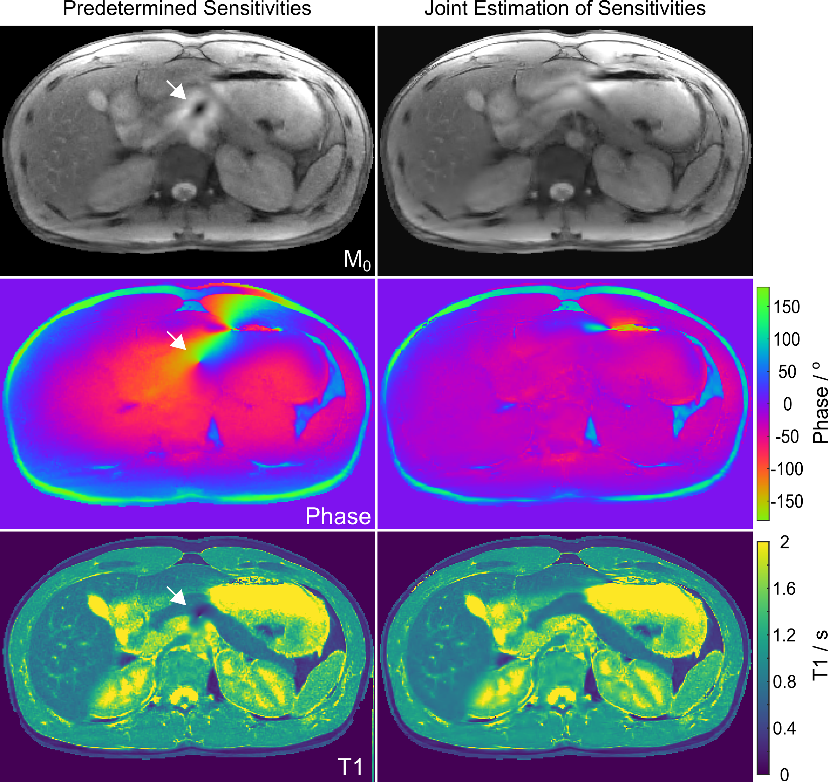

Supporting FIG. S1. (Top) Estimated M₀ maps, (middle) corresponding phase maps, and (bottom) T1 maps of the human abdomen obtained for a model-based reconstruction with L1 regularization using (left) predetermined coil sensitivities and (right) jointly estimated coil sensitivities as proposed. The predetermined coil sensitivities were taken from the last 10 frames of a corresponding NLINV reconstruction as described in Ref. (4). Signal void in the M₀ map resulting from a spurious phase pole (arrows) is caused by miscalibrated coil sensitivities and manifests as an artifact in the T1 map.

