Dissecting Hofmeister effects: Direct anion-amide interaction is weaker than cation-amide binding
Vasileios Balos, Heejae Kim, Mischa Bonn and Johannes Hunger*

Abstract: While there is increasing evidence for ion-induced destabilization of proteins through direct ion-protein interactions, the binding strength of anions to proteins relative to cation-protein binding has remained elusive. Here, we use the rotational mobility of a model amide in aqueous solution as a reporter for the interaction of different anions with amide groups. We find that protein stabilizing salts like KCl and KNO₃ do not affect the rotational mobility of the amide. Conversely, protein denaturants like KSCN and KI markedly reduce the orientational freedom of the amide group. Thus, our results provide evidence for a direct denaturation mechanism. Comparison of the present findings to results for cations shows that the binding strength of anions to amides is – in contrast to common belief – weaker than the interaction of cations with the amide.
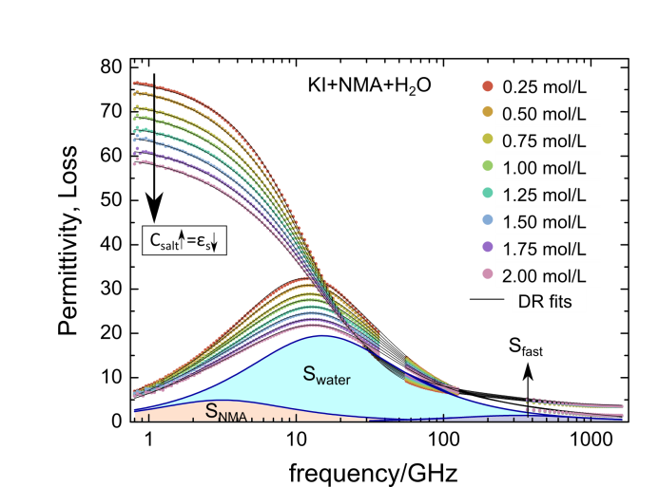
The effect of salts on biomolecular behaviour, such as protein denaturation, protein crystallization and enzymatic activity, has been proven to follow the Hofmeister series^{[1–5]} in which cations with high surface charge density and anions with low surface charge density tend to destabilize proteins. In recent years, it has been manifested that direct interactions between biomolecules and ions dominate the ion-protein interaction^{[2,3]}, although water-mediated, indirect effects are also not negligible.^{[4,6,7]} The direct interactions between biomolecules and ions are highly complex^{[3,5]} due to: (i) the complexity of salt solutions themselves^{[8]} and (ii) the plethora of potential specific and non-specific interaction sites of biomolecules (e.g. backbone, side-chains, termini, etc. of a protein).^{[3,4,9,10]} Given this complexity, it is imperative to correlate the binding of ions to biomolecules with Hofmeister effects to gain detailed understanding of the underlying mechanism.^{[3]}
Figure 1 Complex permittivity spectra of NMA(aq) with increasing concentration of KI. Symbols correspond to experimental data and solid lines show fits with the dielectric relaxation model (eq. 1). The shaded areas show the contribution of the individual relaxation modes to ε''(ν) for $c_{salt}=2$ mol/L (red-shaded: NMA; light blue shaded: bulk water; dark blue shaded: fast water relaxation). The Ohmic loss contribution (last term of eq. 1) has been subtracted for visual clarity.

Direct interactions have been studied by numerous spectroscopic studies of the amide backbone, the structural motif common to all proteins.^{[9,11–14]} Although direct interactions are occasionally challenged,^{[15]} studies of NMR chemical shifts of the amide’s protons^{[9,11,12]} find the proximity of anions to the amide to follow the Hofmeister series.^{[16]} Likewise, the amide C=O vibration^{[14]} and also the NMR chemical shift of the C=O carbon^{[17]} are affected by interaction with cations, in line with direct amide-cation binding.^{[14]} These studies have led to the view that cation-amide interaction plays a less important role in Hofmeister effects than anion-amide interaction.^{[3,14]} Moreover, while some computational studies support this view,^{[12,16,18]} others have reached the opposite conclusion.^{[19]} We note that the different spectroscopic sensitivities and/or the different interaction sites that are studied (e.g. the N-H or the C=O group of the amide) make it nearly impossible to compare the interaction strength of cations to that of anions. Here, we use the rotational mobility of the amide group as measure for ion-amide interaction,^{[20]} which is equally sensitive to both, interaction of cations and anions.

To study the anion-amide interaction, we use aqueous solutions of N-Methylacetamide (NMA), an amide rich molecule, in the presence of inorganic salts. Though NMA and its rotational dynamics differ from a protein, it is an ideal model to exclusively study the interactions specific to amide group. To span a wide range of monovalent anions within the Hofmeister series we add potassium salts of Cl⁻, NO₃⁻, Br⁻, I⁻ and SCN⁻. While the concentration of the salts, c_{salt}, was varied, the concentration of NMA was kept constant at 2 mol/L. The rotational dynamics of NMA in solution were determined using dielectric relaxation spectroscopy (DRS), which probes the polarization of the samples in an externally applied alternating electric field with field frequency $ν$.^{[21,22]} For dipolar liquids at microwave frequencies the polarization predominantly results from alignment of permanent dipoles along the applied electric field. Thus, for the present samples, DRS probes both the rotation of dipolar water and dipolar NMA molecules. The frequency dependent polarization is measured as complex permittivity, $\hat{ε}\left(ν\right)=ε^{'}\left(ν\right)-iε''(ν)$, with the real part $ε^{'}\left(ν\right)$ representing the permittivity and the imaginary part $ε''(ν)$ the dielectric loss. Here, we cover frequencies at $0.8≤ν/GHz≤36$ and $56≤ν/GHz≤125$ using a frequency domain reflectometer and $0.3≤ν/THz≤1.6$ using a THz time domain spectrometer (for details see Supporting information, SI).^{[23]}
[∗] V. Balos, Dr. H. Kim, Prof. M. Bonn, Dr. J. Hunger*
Department for Molecular Spectroscopy
Max Planck Institute for Polymer Research
Ackermannweg 10, 55128 Mainz (Germany)
E-mail: hunger@mpip-mainz.mpg.de
In Fig. 1 we show the dielectric spectra of aqueous solutions of NMA (2 mol/L) with varying concentration of KI. All spectra are dominated by a dispersion in $ε^{'}$ centred at ~10 GHz and a corresponding peak in $ε^{''}$. This relaxation stems from the orientational relaxation of the dipolar water and NMA molecules, with both relaxations closely overlapping.^{[20,24]} As apparent from Fig. 1, the dominant effect of adding electrolyte to the solution is a reduction of the total relaxation amplitude, i.e. the reduction of the (loss) peak area. The reduction of the relaxation amplitude goes along with a reduction of the static dielectric constant (the limiting value of $ε^{'}$ for $ν→0$). This decrease in permittivity $∆ε={ε'}_{ν→0}\left(c_{salt}=0\right)-{ε'}_{ν→0}\left(c_{salt}\right)$) is generally referred to as depolarization and is common to all studied samples (Figs. S1 & S2, SI).

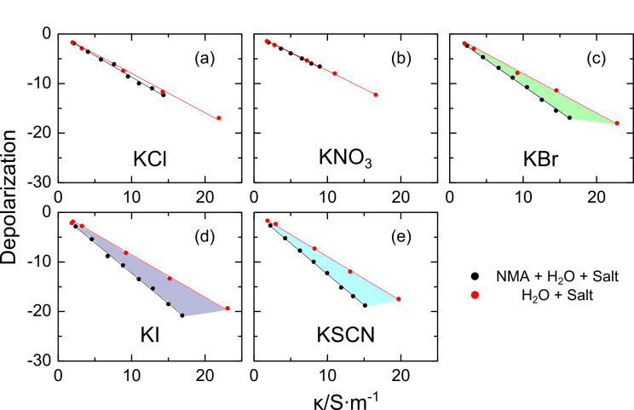
In general, the magnitude of the dielectric constant is determined by the equilibrium alignment of the molecular dipoles against thermal motion. Thus, depolarization is indicative of a reduced ability of the dipoles to align to the external field. For the present samples, a minor contribution to the depolarization stems from dilution of the molecular dipoles upon adding salt ($c_{H_{2}O}$ is reduced upon increasing $c_{salt}$). For electrolyte solutions $∆ε$ is correlated to the presence of mobile ions and scales with the samples’ conductivity, $κ$,^{[20,25,26]} which is in line with kinetic depolarization (KD)^{[20,25–27]} being the dominating depolarization mechanism. KD results from coupling of the ions translational motion to the rotational motion of the dipolar molecule: the molecular dipoles follow the strong local electrical field imposed by the passing ion rather than the externally applied electric field. It is important to note that for the ternary mixtures used here – as a result of the large effective dipole moment of NMA and the sensitivity of DRS to the squared dipole moment – $∆ε$ is about 5 times larger when ions affect a NMA molecule compared to the reduction of the rotational mobility of a water molecule.^{[20]} Thus, the magnitude of $∆ε$ with varying $κ$ for solutions of aqueous NMA + salt provides insight into the distribution of ions within the solution: with increasing proximity of the ions to the NMA molecules in solution, $∆ε$ will be correspondingly larger. The depolarization of the aqueous salt solution represents the limiting case where the ions solely affect water molecules. Hence, comparison of $∆ε$ for NMA/salt/H₂O solutions to $∆ε$ for salt/H₂O solutions provides a direct measure of the ion-NMA interaction strength.
Figure 2. Total depolarization, ∆ε, for (a) KCl, (b) KNO₃, (c) KBr, (d) KI and (e) KSCN in aqueous (red) and aqueous NMA (2 mol/L) solutions (black), as a function of conductivity, κ. The shaded areas are visual aids to highlight the difference between solutions in water and NMA(aq).

In Fig. 2 we show $∆ε$ as a function of $κ$ for the studied salts of the Hofmeister series both in aqueous solution (red symbols) and for solutions containing 2 mol/L NMA (black symbols). The slopes shown in Fig. 2 for the salt/H₂O solutions are nearly independent of the nature of the salt (except for KNO₃ and KSCN where ion-pair relaxation and anion relaxation, respectively, contribute,^{[28]} see SI), which indicates that the observed depolarization can be qualitatively accounted for by solely dilution and KD as underlying depolarization mechanism (Fig. S3, SI). This observation is in agreement with earlier studies of aqueous solutions of these ions.^{[29,30]} In contrast to the binary salt/H₂O samples, the slope of the depolarization vs $κ$ strongly depends on the nature of the anion for the ternary solutions (NMA/salt/H₂O): While for ions with weak protein denaturation tendency like KCl and KNO₃ the data in Fig. 2 for the aqueous solution and for the 2 mol/L NMA solution virtually overlap, the depolarization for the 2 mol/L NMA solutions increasingly deviate from the aqueous case when denaturants like KI and KSCN are added. For the strongest denaturant of the present study, KSCN, $∆ε$ is enhanced by ~30% for the NMA/KSCN/H₂O solution compared to the KSCN/H₂O samples. As elaborated before, this enhanced depolarization can be assigned to preferential interaction of the salt with NMA. Hence, our results are indicative of enhanced proximity of Br⁻, I⁻, and SCN⁻ to NMA, in accordance with direct interaction of denaturing anions with amide groups.

The depolarization, which is directly accessible from the measured spectra and is model-independent, gives qualitative insights into ion-amide interaction. To quantify the observations, we decompose the individual contributions of water and NMA to the spectra using a relaxation model. For neat water two relaxation modes are observed in the frequency range of the present study: the collective rotational relaxation of hydrogen-bonded water at ~20 GHz and a weak relaxation at ~200 GHz.^{[22]} Addition of dipolar NMA molecules has been shown to result in an additional Debye-type relaxation mode at ~4 GHz.^{[20,31]} Hence, assuming uncorrelated dipolar rotation, we use a combination of three relaxation modes to model the experimental spectra:
$$\hat{ε}\left(ν\right)= \frac{S_{NMA}}{1+(2πiντ_{NMA})}+\frac{S_{water, exp}}{1+{(2πiντ_{water})}^{(1-α)}}+ \frac{S_{fast}}{1+ (2πiντ_{fast})}+ ε_{∞}+ \frac{κ}{2πiνε_{0}} (1)$$
where S_{j} and τ_{j} are the relaxation amplitudes and times respectively, $ε_{∞}$ the infinite frequency permittivity, and $ε_{0}$ the permittivity of free space. The last term of eq. 1 accounts for Ohmic losses due to the sample’s DC conductivity, $κ$. In analogy to the observations made for many aqueous electrolytes, we used a symmetrically broadened Cole-Cole mode for the main water relaxation with $α$ being a measure for the width of the relaxation mode.^{[20,32]}

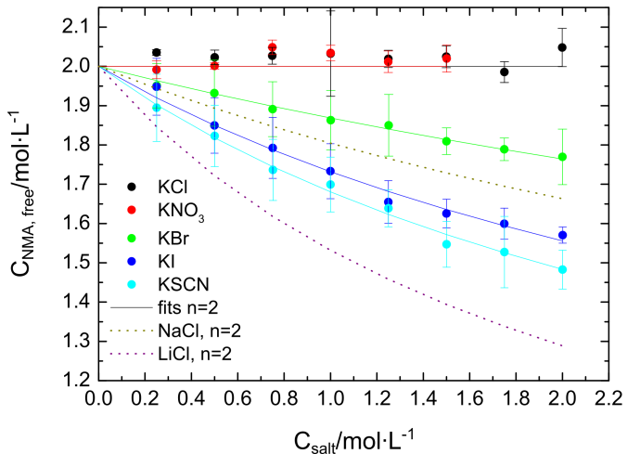
Due to the closely overlapping relaxation modes of NMA and water we constrain the description by reducing the number of adjustable parameters. As water is the dominant species in solution ($c_{H_{2}O}$is at least 20 times higher than the solute concentration), the amplitude of the water relaxation is fixed to that of an ideal solution (random distribution of the ions in solution; for details see SI and Refs. 20 & 28).

As can be seen from Fig. 1 (see also Fig. S1) such a constrained model describes the experimental spectra very well. From these fits we find the fast water relaxation mode to be little affected by the addition of the salt (see Figs. S5 & S6) and only $S_{fast}$ increases slightly with increasing $c_{salt}$. This mode can be interpreted in terms of rapid, small angular motion of a water molecule preceding slower, large angular jumps.^{[33]} As such, the increasing amplitude is consistent with an increasing angular degree of freedom in the hydration shell of the anion.^{[34]} In line with what has been found for binary aqueous electrolytes,^{[30]} $τ_{water}$ broadens (Fig. S7) and decreases with increasing $c_{salt}$ (Fig. S6), which indicates an on average broader distribution and weakening of the hydrogen-bonds of water^{[30,35]} or analogously a reduced collectivity of the water rotation.^{[27]} Conversely, $τ_{NMA}$ increases with increasing $c_{salt}$, which is in accordance with increasing sample viscosity and thus hydrodynamically controlled rotational motion of NMA.^{[20,31]} More importantly, the obtained values of $S_{NMA}$ can be directly related to the apparent concentration of NMA, i.e. the molecules that are not affected by the salt, $c_{NMA, free}$ (see SI). As can be seen from its values in Fig. 3, the rotational mobility of NMA is virtually unaffected by the addition of KCl and KNO₃. In contrast, KSCN, KI, and KBr markedly reduce $c_{NMA, free}$, which is in line with the qualitative conclusions from Fig. 2 (see above). The observed reduction of $c_{NMA, free}$ may stem from both reduced mobility of individual NMA molecules and reduced interaction between NMA molecules.^{[27]}
Figure 3 Concentration of free NMA molecules as a function of salt concentration. The solid lines correspond to fits using eq. 3 with $n=2$. Error bars correspond to the standard deviation within at least 6 independent measurements. For comparison results for variation of the cation (NaCl and LiCl) with $n=2$ are included.^{[20]}

Following Ref. 20, we quantify this interaction assuming an association equilibrium of n NMA molecules, interacting with an anion A⁻:
$A^{-}+nNMA⇆nNMA∙A^{-}$ (2)
With the corresponding equilibrium constant $K$ defined as:
$K=\frac{c_{nNMA∙A^{-}}}{{(C_{NMA,free})}^{n}∙c_{A^{-}}}$ (3)
As can be seen from the solid lines in Fig. 3 such association equilibria excellently describe the observed decrease of c_{NMA,free} with $c_{salt}$ assuming binding of up to two NMA molecules ($n=2$ in eq. 3), while $n=1$ gives a worse description of the data (Fig. S8).^{[36]} The thus obtained association constants for $n=2$ are in line with what one would expect from the Hofmeister series: ${K_{KBr}^{DRS}}^{}=0.02 L^{2}{mol}^{-2}$, ${K_{KI}^{DRS}}^{}=0.05 L^{2}{mol}^{-2}$ and ${K_{KSCN}^{DRS}}^{}=0.07 L^{2}{mol}^{-2}$. For the anions with high denaturation efficiency, as SCN⁻ and I⁻, the extracted values of $K$ assuming $n=1$ (following Ref. 11) in eq. 3 (${K_{KSCN}^{DRS}}^{}=0.25 L^{}{mol}^{-1}$ and ${K_{KI}^{DRS}}^{}=0.20 L^{}{mol}^{-1}$), are lower than those reported using the solubility of amide rich polymers ($K_{{SCN}^{-}}^{sol}=4 L^{}{mol}^{-1}$ and $K_{I^{-}}^{sol}=1.5L^{}{mol}^{-1}$)^{[11]} or the NMR chemical shift of the amide protons ($K_{{SCN}^{-}}^{NMR}=14L^{}{mol}^{-1}$ and $K_{I^{-}}^{NMR}=3.8L^{}{mol}^{-1}$).^{[11]} This spread in inferred interaction strength highlights the technique dependence of the precise values for the inferred association constants.

The equal sensitivity of the rotational mobility of NMA to interaction with anions and cations allows for a quantitative comparison of the present results to our earlier results on Hofmeister cations.^{[20]} This comparison shows that the anion-amide interaction is weaker than cation-amide binding: As can be seen from the dotted lines in Fig. 3 showing c_{NMA,free} for varying concentration of NaCl and LiCl, the strongly denaturing Li⁺ cation has an even larger effect on the mobility of NMA, than SCN⁻. Our results indicate that when comparing monovalent anions and cations located at the very extreme positions in the Hofmeister series, cations can reduce the rotational mobility about twice more than anions (cf. $K_{KSCN}^{DRS}=0.07 L^{2}{mol}^{-2}$ and $K_{LiCl}^{DRS}=0.13 L^{2}{mol}^{-2}$ ^{[20]} for $n=2$).

The stronger interaction of cations with the NMA C=O group than that of the cation with the N-H group, is in accordance with results from molecular dynamics simulations.^{[9,19]} Given that the intramolecular amide-amide N-H…O=C hydrogen-bond between these two groups is a key binding motif that stabilizes the secondary structure of proteins, one might expect from the ion-amide interaction strengths that cations more strongly destabilize proteins than anions. Yet, anions are overall appreciably more efficient in disrupting the structure of proteins.^{[2]} This apparent contradiction indicates that the interaction of ions with protein amide moieties, causing a weakening of the amide-amide bonds, is not the sole cause of ion-induced protein destabilization. Specifically for the anions, additional sites of interaction are the side-chains of the amino-acids, which are important for determining the protein structure. The destabilizing effect of anions on hydrophobic interactions^{[37]} may explain the disproportionally large effect of anions on protein stability. The observation reported here that the anion-amide interaction strength follows the Hofmeister series, indicates that direct ion-amide interactions are also relevant for protein stability, in particular for stabilization of the unfolded (random-coil) protein in solution with its amide groups exposed to the salt solution.

Acknowledgements
This work was funded by the Deutsche Forschungsgemeinschaft (DFG) #HU1860/4. HK acknowledges funding from the European Union's Horizon 2020 programme (grant #658467).
Keywords: Specific Ion effects •Anions •Amide Backbone •Dielectric Spectroscopy •Denaturation
[1] F. Hofmeister, Arch. Exp. Pathol. Pharmakol. 1888, 24, 247–260.
[2] Y. Zhang, P. S. Cremer, Annu. Rev. Phys. Chem. 2010, 61, 63–83.
[3] P. Jungwirth, P. S. Cremer, Nat. Chem. 2014, 6, 261–263.
[4] W. J. Xie, Y. Q. Gao, J. Phys. Chem. Lett. 2013, 4, 4247–4252.
[5] A. Salis, B. W. Ninham, Chem. Soc. Rev. 2014, 43, 7358–7377.
[6] J. Holzmann, R. Ludwig, A. Geiger, D. Paschek, Angew. Chemie Int. Ed. 2007, 46, 8907–8911; Angew. Chem. 2007, 119, 9065–9069.
[7] D. Paschek, R. Ludwig, Angew. Chemie Int. Ed. 2011, 50, 352–353; Angew. Chem. 2011, 123, 368–370.
[8] Y. Marcus, Chem. Rev. 2009, 109, 1346–1370.
[9] a) J. Hladílková, J. Heyda, K. B. Rembert, H. I. Okur, Y. Kurra, W. R. Liu, C. Hilty, P. S. Cremer, P. Jungwirth, J. Phys. Chem. Lett. 2013, 4, 4069–4073. b) J. Paterová, K. B. Rembert, J. Heyda, Y. Kurra, H. I. Okur, W. R. Liu, C. Hilty, P. S. Cremer, P. Jungwirth, J. Phys. Chem. B 2013, 117, 8150–8.
[10] H. Meuzelaar, M. R. Panman, S. Woutersen, Angew. Chemie Int. Ed. 2015, 54, 15255–15259; Angew. Chem. 2015, 127, 15470–15474.
[11] K. B. Rembert, H. I. Okur, C. Hilty, P. S. Cremer, Langmuir 2015, 31, 3459–3464.
[12] K. B. Rembert, J. Paterová, J. Heyda, C. Hilty, P. Jungwirth, P. S. Cremer, J. Am. Chem. Soc. 2012, 134, 10039–10046.
[13] H. Kim, H. Lee, G. Lee, H. Kim, M. Cho, J. Chem. Phys. 2012, 136, 124501.
[14] H. I. Okur, J. Kherb, P. S. Cremer, J. Am. Chem. Soc. 2013, 135, 5062–7.
[15] R. L. Baldwin, Biophys. J. 1996, 71, 2056–2063.
[16] E. A. Algaer, N. F. A. van der Vegt, J. Phys. Chem. B 2011, 115, 13781–13787.
[17] C. P. Rao, P. Balaram, C. N. R. Rao, J. Chem. Soc., Faraday Trans. I 1980, 76, 1008–1013.
[18] N. Schwierz, D. Horinek, R. R. Netz, Langmuir 2013, 29, 2602–2614.
[19] a) H. Du, R. Wickramasinghe, X. Qian, J. Phys. Chem. B 2010, 114, 16594–16604. b) J. Heyda, J. C. Vincent, D. J. Tobias, J. Dzubiella, P. Jungwirth, J. Phys. Chem. B 2010, 114, 1213–1220.
[20] a) V. Balos, M. Bonn, J. Hunger, Phys. Chem. Chem. Phys. 2015, 17, 28539–28543. b) V. Balos, M. Bonn, J. Hunger, Phys. Chem. Chem. Phys. 2016, 18, 1346–1347.
[21] a) F. Kremer, A. Schönhals, Broadband Dielectric Spectroscopy, Springer, Berlin, 2003. b) U. Kaatze, Y. Feldman, Meas. Sci. Technol. 2006, 17, R17–R35.
[22] T. Fukasawa, T. Sato, J. Watanabe, Y. Hama, W. Kunz, R. Buchner, Phys. Rev. Lett. 2005, 95, 197802.
[23] W. Ensing, J. Hunger, N. Ottosson, H. J. Bakker, J. Phys. Chem. C 2013, 117, 12930–12935.
[24] R. Pottel, D. Adolph, U. Kaatze, Ber. Bunsenges. Phys. Chem. 1975, 79, 278–285.
[25] M. Sega, S. Kantorovich, A. Arnold, Phys. Chem. Chem. Phys. 2015, 17, 130–133.
[26] N. Ottosson, J. Hunger, H. J. Bakker, J. Am. Chem. Soc. 2014, 136, 12808–12811.
[27] K. F. Rinne, S. Gekle, R. R. Netz, J. Phys. Chem. A 2014, 118, 11667–11677.
[28] Note that for KNO₃ the depolarization is slightly smaller than what would be expected assuming KD and dilution, which can be explained by weak formation of dipolar ion-pairs (see SI, Figs. S3 & S4). Similiarly, for KSCN, the non-centrosymmetric nature of SCN⁻ results in a weak contribution of the rotation of SCN⁻ to the spectra. We correct for these weak contributions to the spectra in our quantitative analysis (see SI).
[29] T. Chen, G. Hefter, R. Buchner, J. Phys. Chem. A 2003, 107, 4025–4031.
[30] W. Wachter, W. Kunz, R. Buchner, G. Hefter, J. Phys. Chem. A 2005, 109, 8675–8683.
[31] U. Kaatze, H. Gerke, R. Pottel, J. Phys. Chem. 1986, 90, 5464–5469.
[32] U. Kaatze, J. Phys. Chem. 1987, 91, 3111–3113.
[33] A. Y. Zasetsky, Phys. Rev. Lett. 2011, 107, 117601.
[34] S. T. van der Post, K. Tielrooij, J. Hunger, E. H. G. Backus, H. J. Bakker, Faraday Discuss. 2013, 160, 171.
[35] H. J. Bakker, Chem. Rev. 2008, 108, 1456–73.
[36] We note that leaving $n$ as a free parameter gives values scattered around $n=2$: $n_{KBr}=(2.6±0.7)$, $n_{KI}=(2.0±0.5)$ and $n_{KSCN}=\left(1.8±0.4\right)$.
[37] P. Jungwirth, B. Winter, Annu. Rev. Phys. Chem. 2008, 59, 343–366.

Entry for the Table of Contents

COMMUNICATION
Negative vibes: Anions interact directly with amide groups and the interaction strength follows a direct Hofmeister series. The binding of anions to the amide group is however weaker than those of comparable monovalent cations. |  | 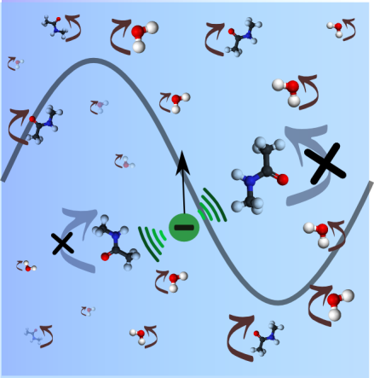 |  | V. Balos, H. Kim, M. Bonn, J. Hunger*  Page No. – Page No.  Dissecting Hofmeister effects: Direct anion-amide interaction is weaker than cation-amide binding

