S1. Gamma power contrast comparisons - analyses of single contrasts, interaction effect, and between-group interaction effects.
When comparing the single conditions, cluster-based permutation tests revealed no differences between DM and CM (p = .37), DM and DO (p = .21), CM and CO (p = .30) or DO and CO (p = .12). We did not observe a gestural enhancement effect in the gamma band when comparing DM-DO to CM-CO (p = .09), and we observed no between-group differences between native and non-native listeners in the gamma band (p = .11).
S2. Alpha power contrast comparisons - analyses of single contrasts
Analyses of the single contrasts of the four conditions revealed that in line with previous research on degraded speech comprehension (Weisz et al., 2011; Obleser and Weisz, 2012; Becker et al., 2013; Meyer et al., 2013; Strauß et al., 2014a; Strauß et al., 2014b; Wostmann et al., 2015), as well as our study on native listeners (Drijvers et al., 2018a), alpha power was increased when comparing DO to CO (one significant positive cluster, p = .024, 1.35 – 1.85 s). In a gestural context, however, cluster-based permutation tests revealed that alpha power was more suppressed in response to DM than DO (one significant negative cluster, p < .02, 0.7 – 2.0 s) Finally, alpha power did not differ in response to CM as compared to CO (p = .07) or when comparing DM and CM (p = .38).
S3. Beta power contrast comparisons - analyses of single contrasts
Beta power was more suppressed for DG than CG (one negative cluster, p = .04, 0.7 – 0.9 s) and more suppressed for DG than D (one negative cluster, p < .01, 0.7 – 0.9s). Beta power did not differ between CM and CO (p = .06), and was more enhanced in response to DO than CO (one positive cluster, p = .03, 0.7 – 0.95 s).

Figure S1
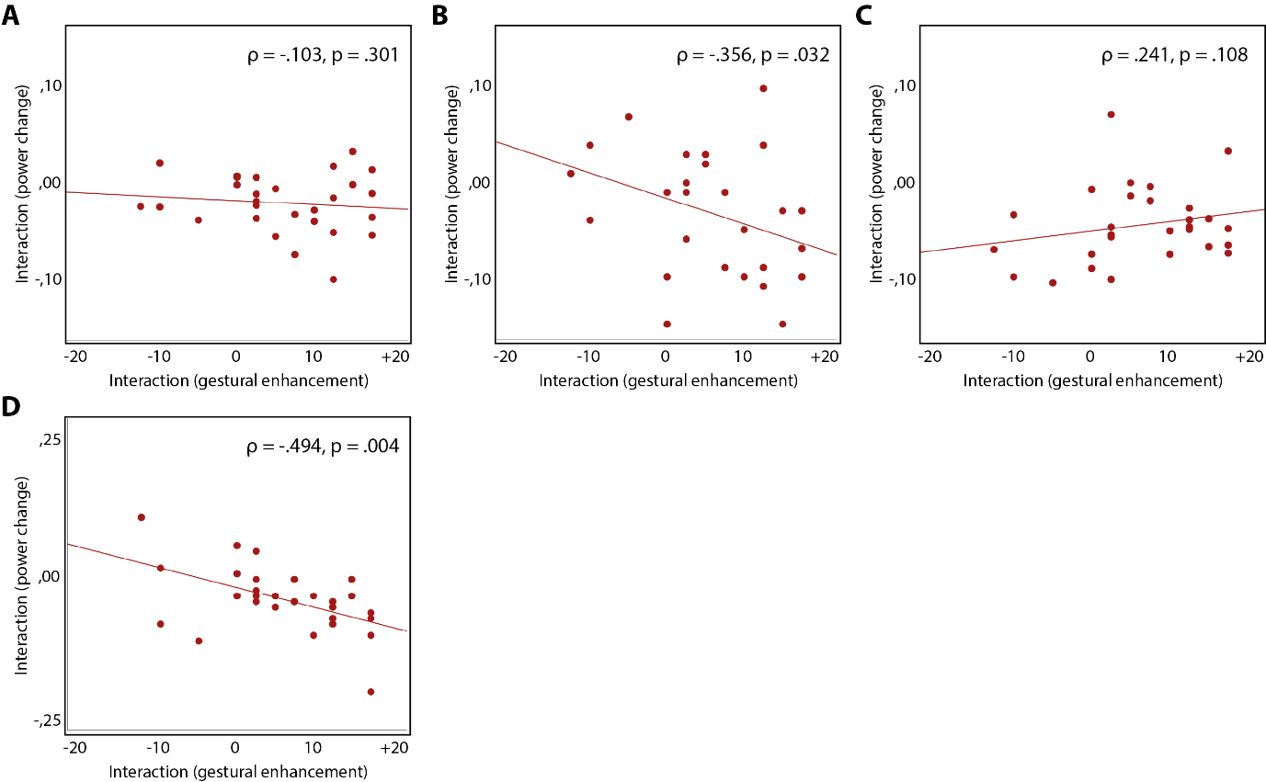
Figure S1: A-C: correlations between gestural enhancement scores for accuracy and an individual’s alpha power in the early time window (0.7 – 1.0s) (A), middle time window (1.0 – 1.4s) (B), and late time window (1.4 – 2.0s) (C). D: correlation between an individual’s beta power and gestural enhancement score for accuracy (0.7 – 1.1 s).

