Supporting information

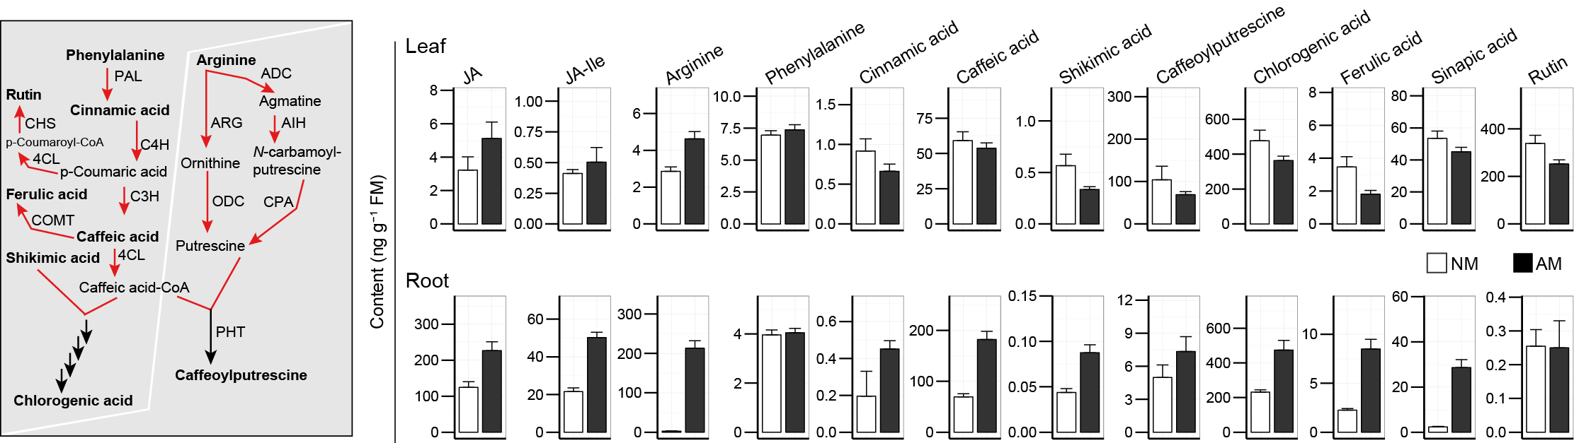
Fig. S1 AMF-induced increases in constitutive jasmonates in the roots of N. attenuata do not translate into systemic increases in JA-dependent secondary metabolites in leaves
Representative phenolic metabolites in N. attenuata were induced in roots but not in leaves after inoculation with R. irregularis. (a) Simplified biosynthetic pathway for caffeoylputrescine and chlorogenic acid; the levels of intermediates in this pathway were quantified in both root and leaf tissues after AMF inoculation. (b) Samples were harvested from EV plants inoculated with R. irregularis (6 wpi). AMF inoculated groups were labeled as “AM”, and non-inoculated groups as “NM”. Data are means (± SD), statistical significance was evaluated with Student’s t tests (*p≤0.05, **p≤0.01, ***p≤0.001).

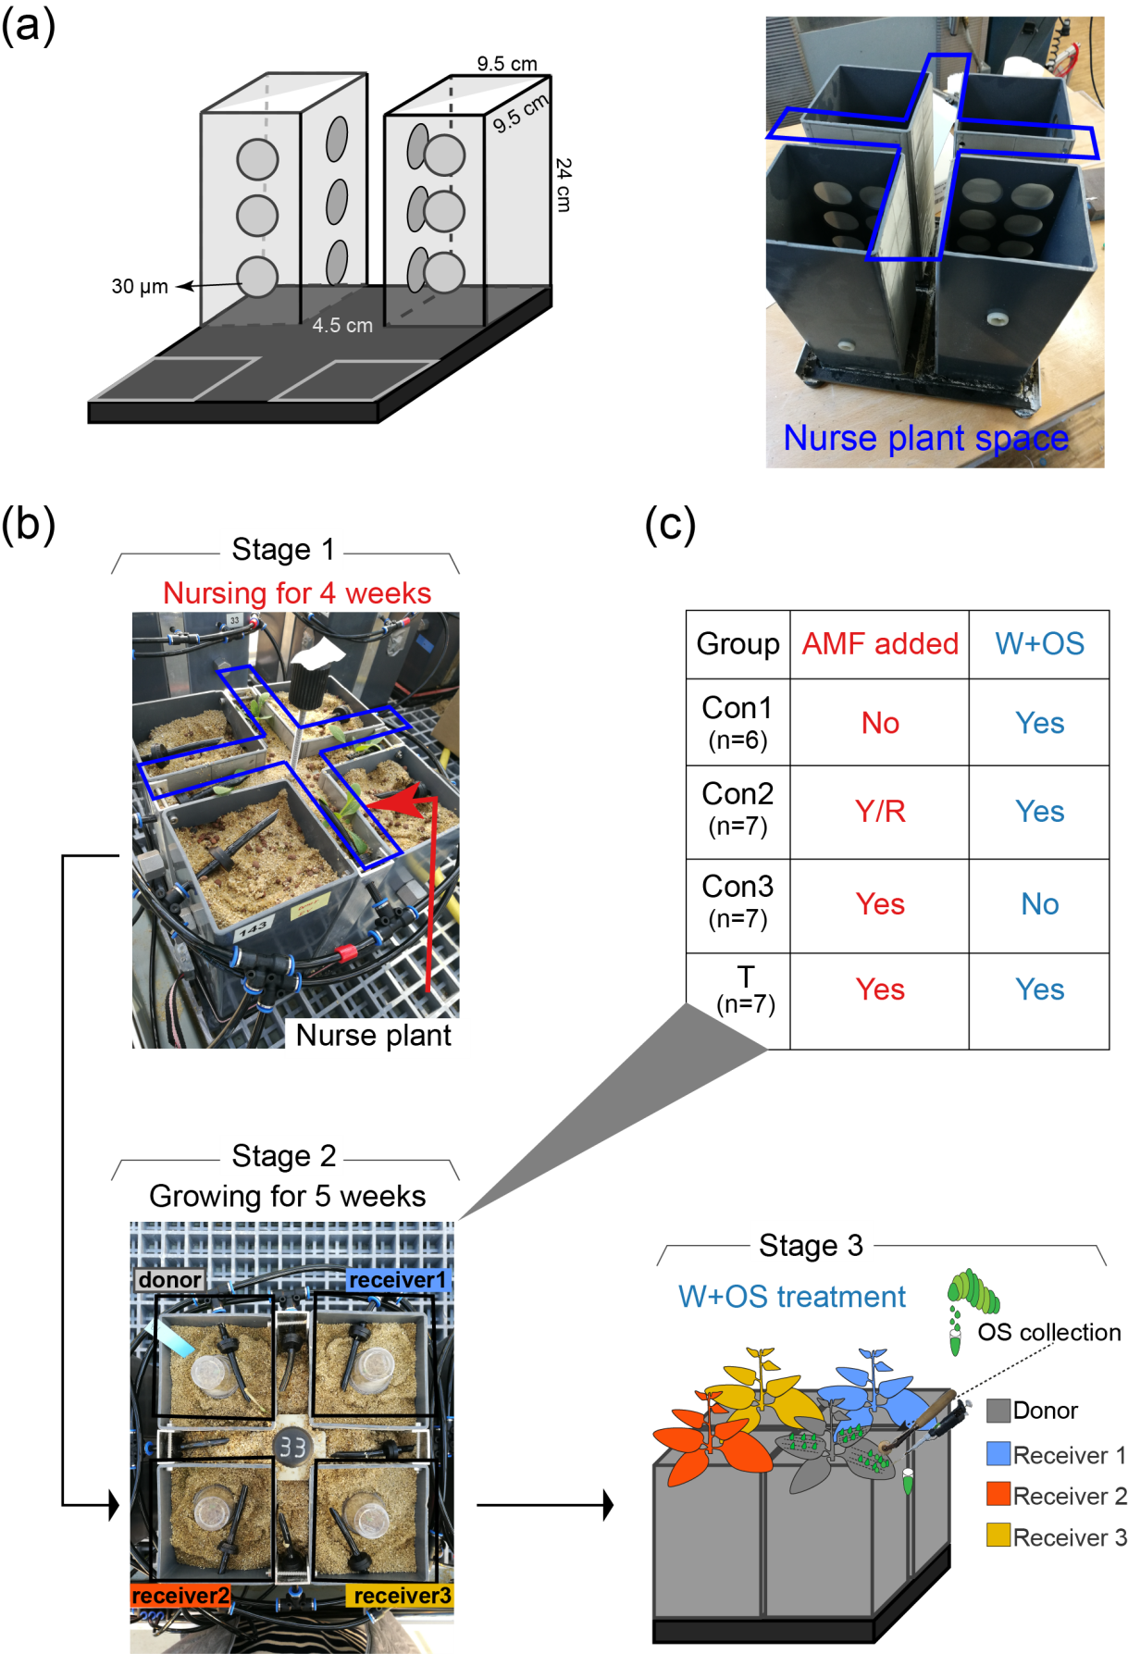
Fig. S2 Mesocosm design, mesocosms grouping and experimental procedures.
(a) Mesocosm designed to test the hypothesis of CMN-mediated OS-elicited JA signaling: 4 boxes [length: width: height=9.5: 9.5: 24 (cm)] constitute a single mesocosm, and each box is separated by metal mesh (pore diameter=30 µm), which excludes plant roots but allows mycelia to penetrate. The spaces separating the 4 boxes of each mesocosm (4.5 cm) were planted with N. attenuata WT nurse plants inoculated with autoclaved or live R. irregularis inoculum. (b) The nurse plants were grown for 4 weeks to activate AMF spores and establish an AMF network that extended into all 4 boxes of the mesocom; these nurse plants were removed just prior to the planting of the experimental plants into their individual boxes for an additional 5 weeks of growth, before plants were W+OS elicited which started the sampling sequence (detailed in Fig. 4a). The four individual plants that comprised each experimental mesocosm were named as: “donor”, “receivers” 1 to 3. (c) Mesocosms were assigned to 4 different treatments that combined AMF addition (in red) and W+OS treatment with “donors” (in blue) with the following terms defined:
If autoclaved AMF inoculum was used: “N”; active inoculum: “Y”; the AMF mycelial network connections among plants were removed by emptying the soil (just prior to first W+OS elicitation) from the spaces separating the boxes that were originally occupied by the nurse plants: (Y/R).
If “donor” plants were treated with W+OS: (Y), if not (N). Based on different combinations of these treatments, Con1, Con2, Con3 and T groups are defined.

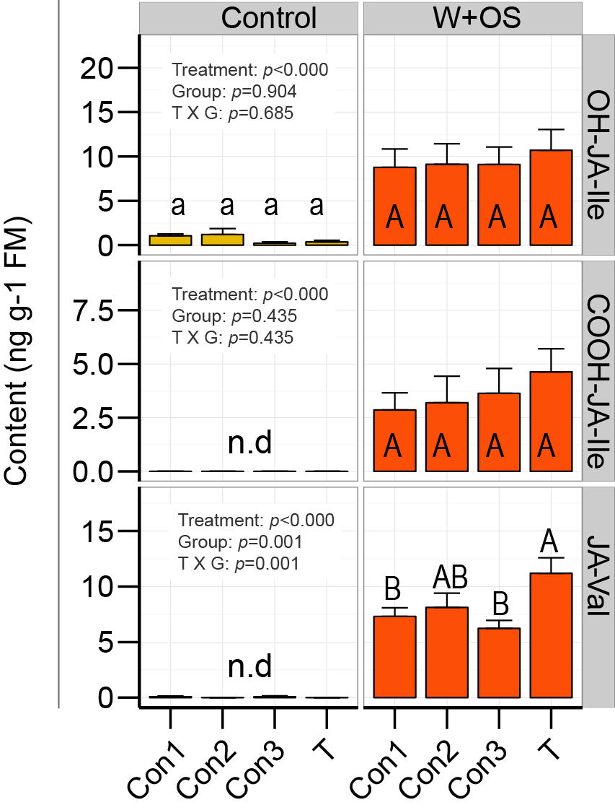
Fig. S3 Evidence of AMF-mediated defense priming: bursts of inactive jasmonate forms are not amplified in the “receiver” plants of the AMF mycelia group (T) after the W+OS elicitation of the “donor” plants. Details are as described in Fig. 4.

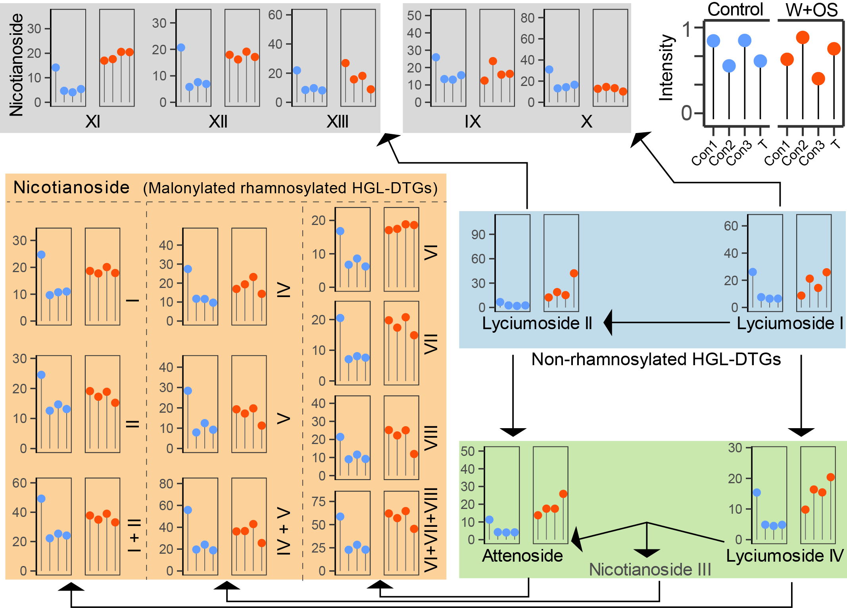
Fig. S4 Hydroxygeranyllinalool diterpene glycosides (HGL-DTGs) exhibit compound-specific increases in response to W+OS elicitation among the 4 mesocosm treatment groups.
The biological replicates used and the quantification method for HGL-DTG analysis are as described in Fig. 7. Data are means (±SE; Con1, n=6; Con2, n=7; Con3, n=7; T, n=7). For the statistical analysis see Table. S1.

Table. S1 Numerical values of each HGL-DTG relative concentration and statistical analysis.
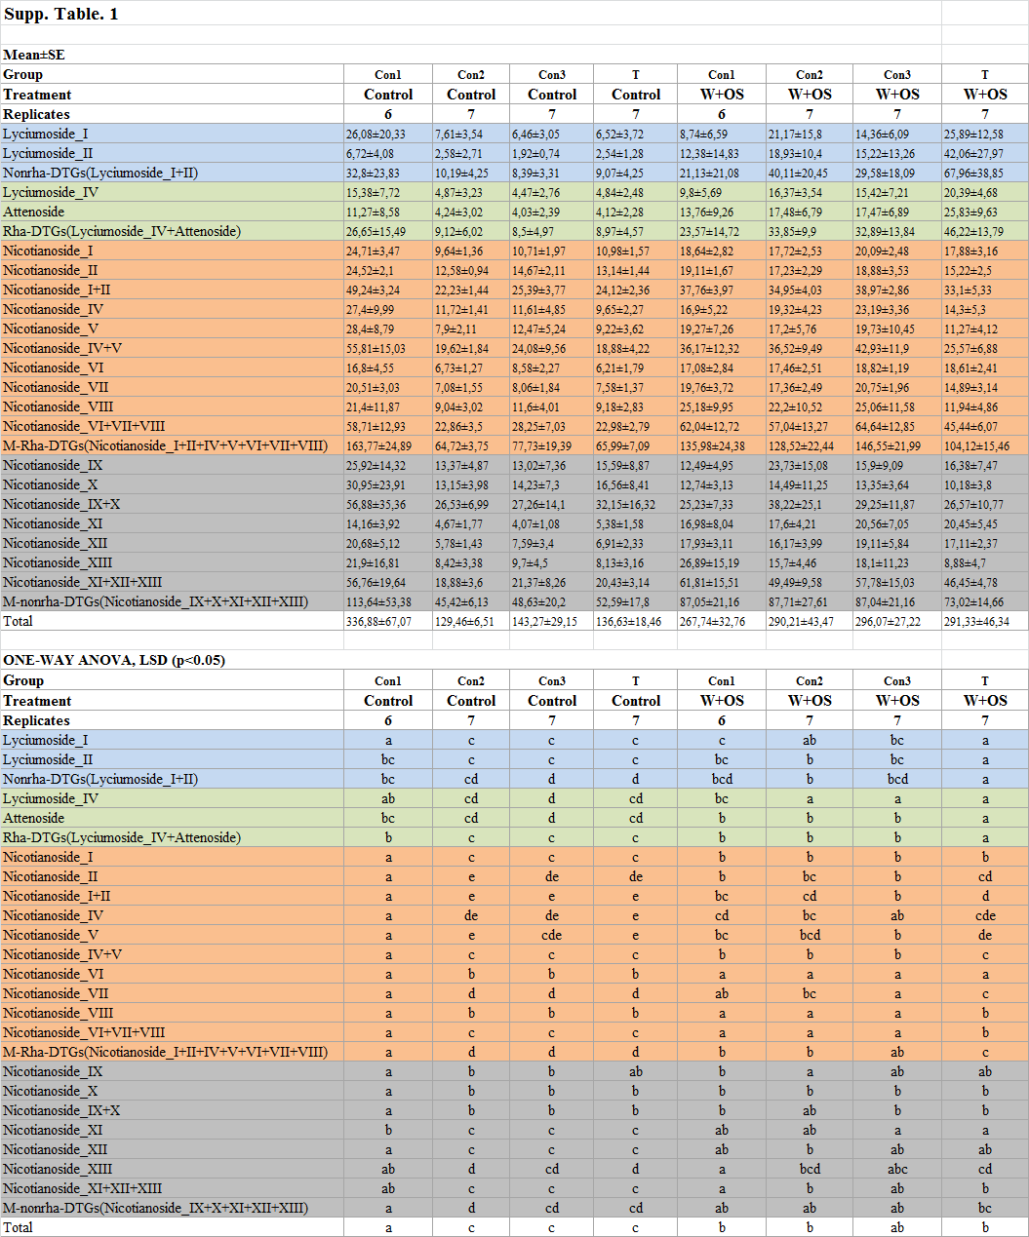
Data presented in Fig. 7 and Fig. S3, sampling and analysis is described in Fig. 4, and background colors are the same as in Fig. 7 and Fig. S3. Different letters indicate significant differences (p<0.05, one-way ANOVA followed by Fisher’s LSD)

Table. S2 Primer sequences for Quantitative (q)PCR.
GeneBank | Name | Forward | Reverse
EXX64097.1 | Ri-tub | TGTCCAACCGGTTTTAAAGT | AAAGCACGTTTGGCGTACAT
XP_019258720.1 | NaSTR1 | TCAGGCTTCCACCTTCAATATCT | GACTCTCCGACGTTCTCCC
XP_019267066.1 | NaPT4 | GGGGCTCGTTTCAATGATTA | AACACGATCCGCCAAACAT
XP_019246749 | NaIF-5a | GTCGGACGAAGAACACCATT | CACATCACAGTTGTGGGAGG

