Supplementary material
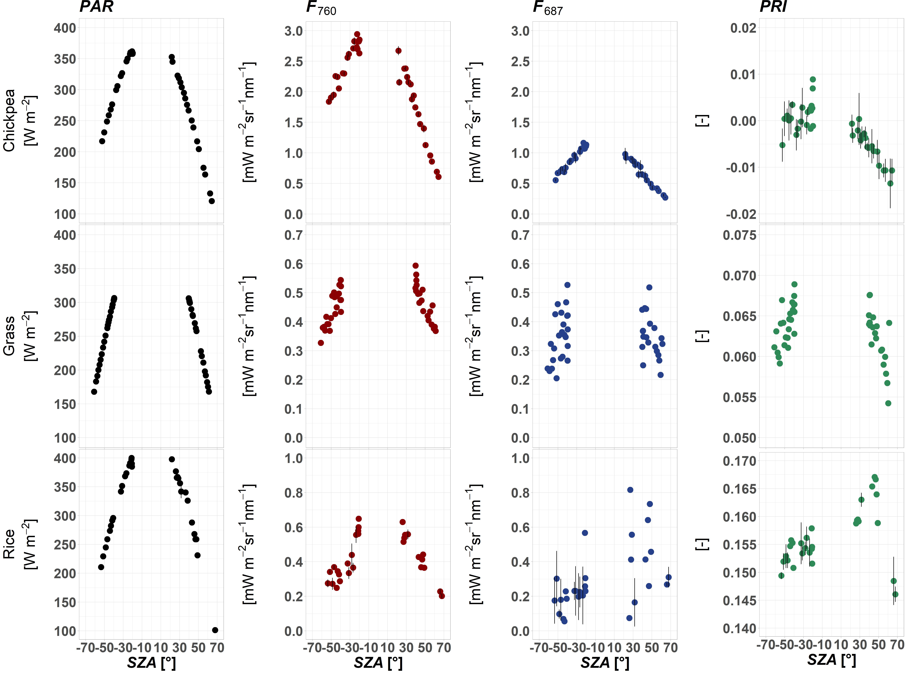
Figure S1. Diurnal cycles of PAR, F₇₆₀, F₆₈₇ and PRI acquired from a nadir-viewing direction for chickpea (row 1), grass (row 2) and rice (row 3). Error bars for chickpea and rice indicate standard deviation (n = 3). Measurements over the grass were collected as a single acquisition (n = 1). Negative values of SZA correspond to the cycles acquired before midday, positive - after midday.
SZA (°) | F₇₆₀_ANIX | F₆₈₇_ANIX | sPRI_ANIX
-52 | 1.968 | 3.862 | 1.0279
-47 | 1.770 | 3.224 | 1.0258
-43 | 1.734 | 2.730 | 1.0166
-37 | 1.776 | 2.347 | 1.0253
-32 | 1.635 | 2.450 | 1.0215
-26 | 1.649 | 2.152 | 1.0175
-23 | 1.660 | 2.266 | 1.0298
-20 | 1.671 | 2.345 | 1.0279
22 | 1.942 | 2.216 | 1.0204
28 | 2.999 | 3.135 | 1.021
31 | 2.468 | 3.555 | 1.0226
35 | 3.255 | 4.198 | 1.0198
39 | 3.626 | 4.320 | 1.0205
44 | 3.048 | 4.354 | 1.0179
49 | 2.835 | 4.205 | 1.013
56 | 2.536 | 4.702 | 1.0197
63 | 1.930 | 4.397 | 1.0227
Table S1. ANIX calculated for F₇₆₀, F₆₈₇ and sPRI measured in the SPP over chickpea.
SZA (°) | F₇₆₀_ANIX | F₆₈₇_ANIX | sPRI_ANIX
-50 | 1.135 | 1.299 | 1.0198
-45 | 1.186 | 1.275 | 1.016
-41 | 1.170 | 1.299 | 1.0161
-36 | 1.209 | 1.299 | 1.0124
-31 | 1.187 | 1.396 | 1.0147
-25 | 1.288 | 1.398 | 1.0139
-21 | 1.579 | 1.96 | 1.0337
-20 | 1.819 | 1.919 | 1.0195
23 | 1.38 | 1.464 | 1.0116
30 | 1.289 | 1.49 | 1.0087
33 | 1.300 | 1.337 | 1.0114
37 | 1.257 | 1.178 | 1.0046
40 | 1.268 | 1.619 | 1.017
45 | 1.270 | 1.286 | 1.0102
51 | 1.438 | 1.296 | 1.0152
58 | 1.360 | 1.316 | 1.0124
65 | 1.326 | 1.176 | 1.0223
Table S2. ANIX calculated for F₇₆₀, F₆₈₇ and sPRI measured in the CPP over chickpea.
SZA (°) | F₇₆₀_ANIX | F₆₈₇_ANIX | sPRI_ANIX
-60 | 1.547 | 2.812 | 1.0106
-57 | 1.638 | 2.104 | 1.0137
-55 | 1.711 | 3.432 | 1.0141
-52 | 1.907 | 3.34 | 1.0146
-50 | 1.775 | 2.408 | 1.0139
-47 | 1.671 | 1.807 | 1.0167
-44 | 1.892 | 3.526 | 1.0108
-42 | 1.762 | 2.068 | 1.0141
-40 | 1.876 | 2.178 | 1.0105
-39 | 1.984 | 3.352 | 1.0102
41 | 1.880 | 2.565 | 1.0085
43 | 1.932 | 2.696 | 1.01
47 | 2.096 | 2.609 | 1.0101
53 | 1.867 | 1.895 | 1.0142
56 | 2.446 | 2.077 | 1.0163
60 | 1.652 | 2.907 | 1.013
Table S3. ANIX calculated for F₇₆₀, F₆₈₇ and sPRI measured in the SPP over grass.

SZA (°) | F₇₆₀_ANIX | F₆₈₇_ANIX | sPRI_ANIX
-58 | 1.368 | 2.035 | 1.0112
-56 | 1.554 | 2.343 | 1.0141
-54 | 1.387 | 1.525 | 1.0075
-51 | 1.443 | 2.149 | 1.0099
-48 | 1.515 | 1.435 | 1.0101
-46 | 1.344 | 1.325 | 1.0094
-43 | 1.329 | 2.845 | 1.0118
-41 | 1.370 | 2.247 | 1.0116
-40 | 1.371 | 2.83 | 1.0103
-39 | 1.383 | 1.57 | 1.0055
41 | 1.337 | 2.227 | 1.0071
54 | 1.528 | 1.982 | 1.0078
Table S4. ANIX calculated for F₇₆₀, F₆₈₇ and sPRI measured in the CPP over grass.
SZA (°) | F₇₆₀_ANIX | F₆₈₇_ANIX | sPRI_ANIX
-53 | 2.615 | 3.165 | 1.0177
-48 | 3.197 | 4.532 | 1.0225
-43 | 3.547 | 8.86 | 1.0246
-32 | 3.144 | 4.205 | 1.0172
-26 | 2.690 | 4.189 | 1.015
-23 | 2.356 | 3.479 | 1.0174
-21 | 3.031 | 34.639 | 1.0246
26 | 3.335 | 8.767 | 1.0232
31 | 3.207 | 2.86 | 1.0198
37 | 5.068 | 3.829 | 1.0136
44 | 2.656 | 13.745 | 1.0172
46 | 2.725 | 4.334 | 1.0188
67 | 2.429 | 2.179 | 1.0181
Table S5. ANIX calculated for F₇₆₀, F₆₈₇ and sPRI measured in the SPP over rice.
SZA (°) | F₇₆₀_ANIX | F₆₈₇_ANIX | sPRI_ANIX
-51 | 2.692 | 2.915 | 1.0168
-46 | 2.508 | 4.124 | 1.0147
-31 | 2.684 | 3.446 | 1.0098
-28 | 1.721 | 6.423 | 1.0107
-22 | 1.345 | 4.299 | 1.0106
27 | 3.682 | 65.169 | 1.0182
32 | 2.397 | 5.435 | 1.0147
39 | 3.528 | 2.265 | 1.0123
68 | 1.814 | 1.984 | 1.0152
Table S6. ANIX calculated for F₇₆₀, F₆₈₇ and sPRI measured in the AR over rice.
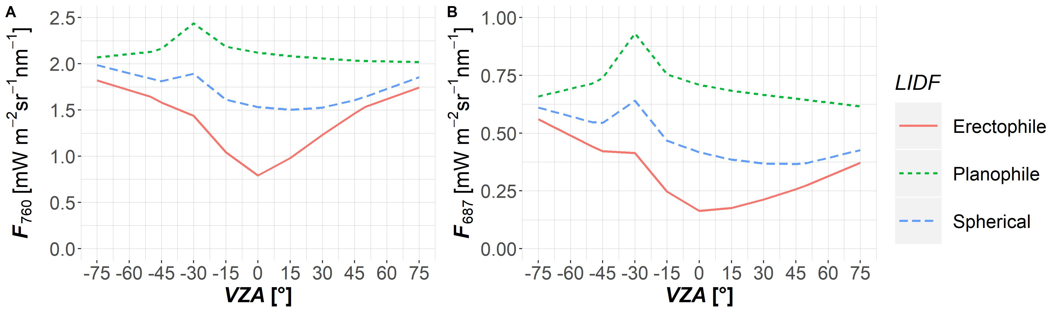Figure S2. Distribution of multi-angular F₇₆₀ (A) and F₆₈₇ (B) in the solar principal plane (SPP) as a function of view zenith angle (VZA) and LIDF (erectophile, planophile and spherical) simulated with the SCOPE model. LAI = 3 m² m⁻², SZA = 0°, C_{ab} = 40 ug cm⁻², hc = 0.5 m, lw = 0.05 m. Negative values of VZAs represent the backscatter direction, positive – the forward scatter direction within a plane.
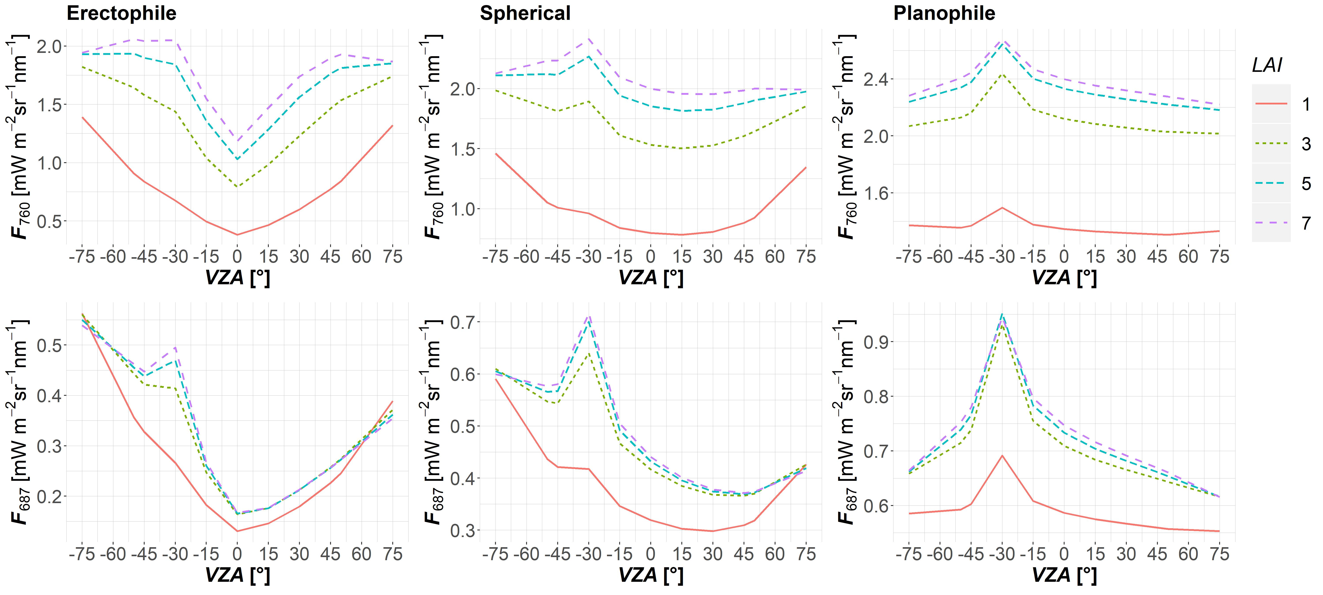Figure S3. Distribution of multi-angular F₇₆₀ (top) and F₆₈₇ (bottom) in the solar principal plane (SPP) as a function of view zenith angle (VZA) and LAI simulated with the SCOPE model for erectophile (left), spherical (middle) and planophile (right) canopy types. SZA = 30°, C_{ab} = 40 ug cm⁻², hc = 0.5 m, lw = 0.05 m. Negative values of VZAs represent the backscatter direction, positive – the forward scatter direction within a plane.

LIDF | C_{ab}  (ug cm⁻²) | LAI  (m² m⁻²) | hc  (m) | lw  (m) | SZA (°) | F₇₆₀_ANIX | F₆₈₇_ANIX
erectophile | 40 | 1 | 0.5 | 0.05 | 30 | 3.677 | 4.3761
erectophile | 40 | 3 | 0.5 | 0.05 | 30 | 2.336 | 3.5383
erectophile | 40 | 5 | 0.5 | 0.05 | 30 | 1.926 | 3.4654
erectophile | 40 | 7 | 0.5 | 0.05 | 30 | 1.783 | 3.3834
spherical | 40 | 1 | 0.5 | 0.05 | 30 | 1.893 | 2.0301
spherical | 40 | 3 | 0.5 | 0.05 | 30 | 1.359 | 1.7913
spherical | 40 | 5 | 0.5 | 0.05 | 30 | 1.271 | 1.9671
spherical | 40 | 7 | 0.5 | 0.05 | 30 | 1.26 | 2.0237
planophile | 40 | 1 | 0.5 | 0.05 | 30 | 1.16 | 1.2665
planophile | 40 | 3 | 0.5 | 0.05 | 30 | 1.232 | 1.5551
planophile | 40 | 5 | 0.5 | 0.05 | 30 | 1.233 | 1.6129
planophile | 40 | 7 | 0.5 | 0.05 | 30 | 1.235 | 1.6241
Table S7. ANIX calculated for F₇₆₀, F₆₈₇ simulated by SCOPE with the input parameters: SZA = 30°, C_{ab} = 40 ug cm⁻², hc = 0.5 m, lw = 0.05 m, LAI = 1, 3, 5,7 m² m⁻² and LIDF corresponding to erectophile, spherical and planophile canopy types.
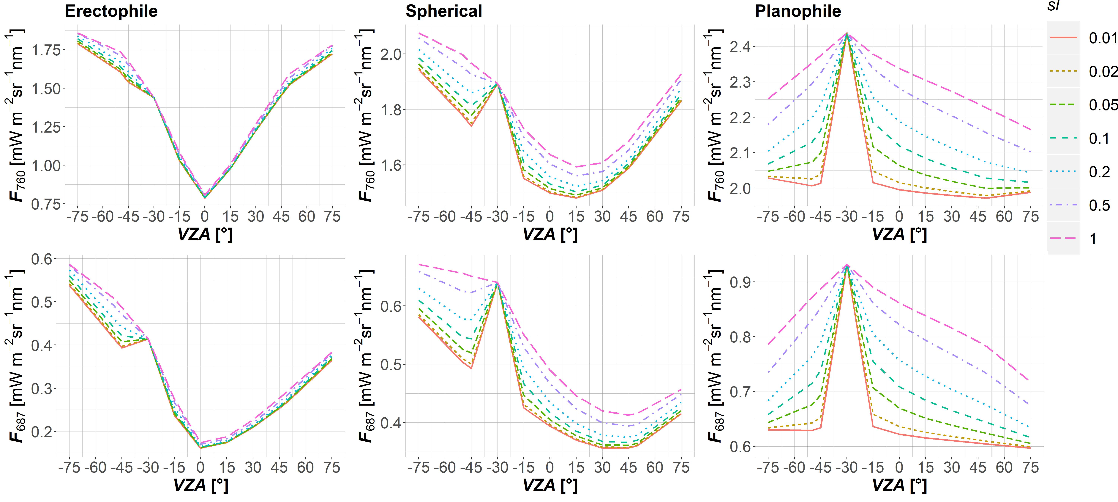Figure S4. Distribution of multi-angular F₇₆₀ (top) and F₆₈₇ (bottom) in the solar principal plane (SPP) as a function of view zenith angle (VZA) and sl simulated with the SCOPE model for erectophile (left), spherical (middle) and planophile (right) canopy types. LAI = 3 m² m⁻², SZA = 30°, C_{ab} = 40 ug cm⁻². Negative values of VZAs represent the backscatter direction, positive - the forward scatter direction within a plane.

LIDF | C_{ab}  (ug cm⁻²) | LAI  (m² m⁻²) | sl | hc  (m) | lw  (m) | SZA (°) | F₇₆₀_ANIX | F₆₈₇_ANIX
erectophile | 40 | 3 | 0.1 | 0.1 | 0.01 | 30 | 2.352 | 3.578
erectophile | 40 | 3 | 0.02 | 0.5 | 0.01 | 30 | 2.336 | 3.538
erectophile | 40 | 3 | 0.01 | 1 | 0.01 | 30 | 2.314 | 3.466
erectophile | 40 | 3 | 0.5 | 0.1 | 0.05 | 30 | 2.352 | 3.578
erectophile | 40 | 3 | 0.1 | 0.5 | 0.05 | 30 | 2.336 | 3.538
erectophile | 40 | 3 | 0.05 | 1 | 0.05 | 30 | 2.314 | 3.466
erectophile | 40 | 3 | 1 | 0.1 | 0.1 | 30 | 2.352 | 3.578
erectophile | 40 | 3 | 0.2 | 0.5 | 0.1 | 30 | 2.336 | 3.538
erectophile | 40 | 3 | 0.1 | 1 | 0.1 | 30 | 2.314 | 3.466
planophile | 40 | 3 | 0.1 | 0.1 | 0.01 | 30 | 1.209 | 1.512
planophile | 40 | 3 | 0.02 | 0.5 | 0.01 | 30 | 1.232 | 1.555
planophile | 40 | 3 | 0.01 | 1 | 0.01 | 30 | 1.236 | 1.561
planophile | 40 | 3 | 0.5 | 0.1 | 0.05 | 30 | 1.209 | 1.512
planophile | 40 | 3 | 0.1 | 0.5 | 0.05 | 30 | 1.232 | 1.555
planophile | 40 | 3 | 0.05 | 1 | 0.05 | 30 | 1.236 | 1.561
planophile | 40 | 3 | 1 | 0.1 | 0.1 | 30 | 1.209 | 1.512
planophile | 40 | 3 | 0.2 | 0.5 | 0.1 | 30 | 1.232 | 1.555
planophile | 40 | 3 | 0.1 | 1 | 0.1 | 30 | 1.236 | 1.561
spherical | 40 | 3 | 0.1 | 0.1 | 0.01 | 30 | 1.381 | 1.834
spherical | 40 | 3 | 0.02 | 0.5 | 0.01 | 30 | 1.359 | 1.791
spherical | 40 | 3 | 0.01 | 1 | 0.01 | 30 | 1.341 | 1.797
spherical | 40 | 3 | 0.5 | 0.1 | 0.05 | 30 | 1.381 | 1.834
spherical | 40 | 3 | 0.1 | 0.5 | 0.05 | 30 | 1.359 | 1.791
spherical | 40 | 3 | 0.05 | 1 | 0.05 | 30 | 1.341 | 1.797
spherical | 40 | 3 | 1 | 0.1 | 0.1 | 30 | 1.381 | 1.834
spherical | 40 | 3 | 0.2 | 0.5 | 0.1 | 30 | 1.359 | 1.791
spherical | 40 | 3 | 0.1 | 1 | 0.1 | 30 | 1.341 | 1.797
Table S8. ANIX calculated for F₇₆₀, F₆₈₇ simulated by SCOPE with the input parameters: SZA = 30°, C_{ab} = 40 ug cm⁻², LAI = 3 m² m⁻², hc = 0.1, 0.5, 1 m, lw = 0.01, 0.05, 0.1 m, sl = 0.01, 0.02, 0.05, 0.1, 0.2, 0.5, 1 and LIDF corresponding to erectophile, spherical and planophile canopy types.

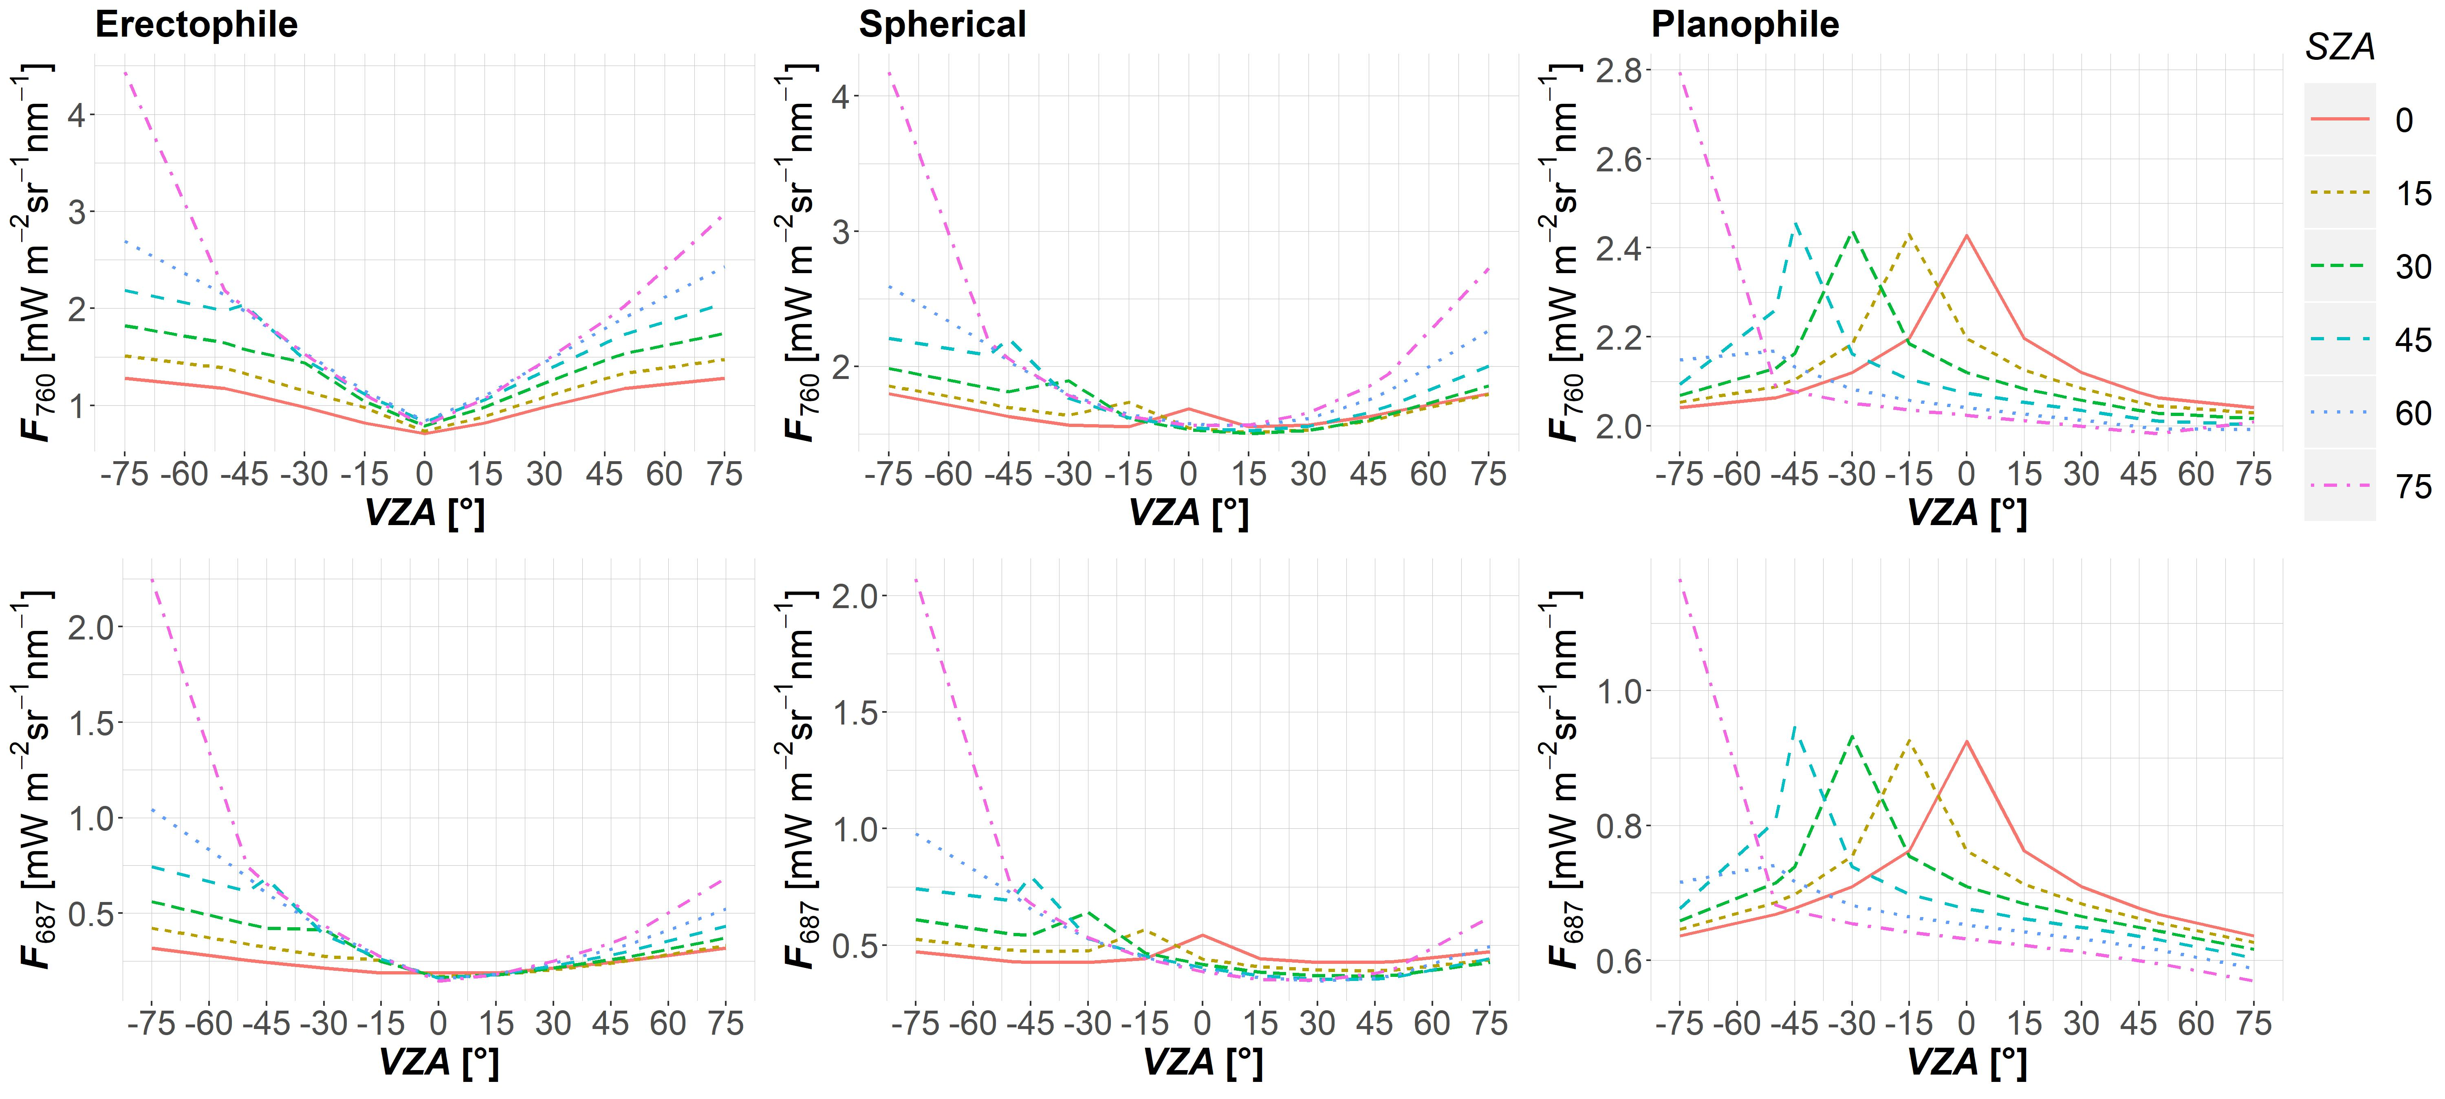Figure S5. Distribution of multi-angular F₇₆₀ (top) and F₆₈₇ (bottom) in the solar principal plane (SPP) as a function of view zenith angle (VZA) and SZA simulated with the SCOPE model for erectophile (left), spherical (middle) and planophile (right) canopy types. LAI = 3 m² m⁻², C_{ab} = 40 ug cm⁻², hc = 0.5 m, lw = 0.05 m. Negative values of VZAs represent the backscatter direction, positive – the forward scatter direction within a plane.
LIDF | C_{ab}  (ug cm²) | LAI  (m² m⁻²) | sl | hc  (m) | lw  (m) | SZA (°) | F₇₆₀_ANIX | F₆₈₇_ANIX
erectophile | 40 | 3 | 0.1 | 0.5 | 0.05 | 75 | 5.621 | 15.664
erectophile | 40 | 3 | 0.1 | 0.5 | 0.05 | 60 | 3.335 | 7.268
erectophile | 40 | 3 | 0.1 | 0.5 | 0.05 | 45 | 2.692 | 4.884
erectophile | 40 | 3 | 0.1 | 0.5 | 0.05 | 30 | 2.336 | 3.538
erectophile | 40 | 3 | 0.1 | 0.5 | 0.05 | 15 | 2.075 | 2.564
erectophile | 40 | 3 | 0.1 | 0.5 | 0.05 | 0 | 1.807 | 1.709
planophile | 40 | 3 | 0.1 | 0.5 | 0.05 | 75 | 1.425 | 2.083
planophile | 40 | 3 | 0.1 | 0.5 | 0.05 | 60 | 1.143 | 1.379
planophile | 40 | 3 | 0.1 | 0.5 | 0.05 | 45 | 1.248 | 1.606
planophile | 40 | 3 | 0.1 | 0.5 | 0.05 | 30 | 1.232 | 1.555
planophile | 40 | 3 | 0.1 | 0.5 | 0.05 | 15 | 1.222 | 1.523
planophile | 40 | 3 | 0.1 | 0.5 | 0.05 | 0 | 1.216 | 1.501
spherical | 40 | 3 | 0.1 | 0.5 | 0.05 | 75 | 2.707 | 6.087
spherical | 40 | 3 | 0.1 | 0.5 | 0.05 | 60 | 1.744 | 3.092
spherical | 40 | 3 | 0.1 | 0.5 | 0.05 | 45 | 1.499 | 2.32
spherical | 40 | 3 | 0.1 | 0.5 | 0.05 | 30 | 1.359 | 1.791
spherical | 40 | 3 | 0.1 | 0.5 | 0.05 | 15 | 1.266 | 1.494
spherical | 40 | 3 | 0.1 | 0.5 | 0.05 | 0 | 1.205 | 1.339
Table S9. ANIX calculated for F₇₆₀, F₆₈₇ simulated by SCOPE with the input parameters: SZA = 10°, 30°, 45°, 60°, 75°, C_{ab} = 40 ug cm⁻², LAI = 3 m² m⁻², hc = 0.5m, lw =0.05 m and LIDF corresponding to erectophile, spherical and planophile canopy types.

