Table S1. Example stimuli in Experiment 1
Exp 1 | Sentence-primes with mappings related to the targets | Conditions | Target Sentences
1 | My argument was not indefensible | conventional | Every point in my argument was attacked
1 | Our time was not indefensible | novel | Every second of our time was attacked
1 | The fort was indefensible because the rain washed away the barricade | anomalous | Every drop of rain was attacked
1 | These soldiers were not indefensible | literal | Every soldier in the frontline was attacked
2 | He spit back the idea that the earth was flat | conventional | The idea was too hard to swallow
2 | He spit back the changes to reduce spending | novel | The changes were too hard to swallow
2 | Her 3-month-old spit up a lot this past summer | anomalous | The summer was too hard to swallow
2 | He spit out the meat that was over cooked | literal | The meat was too hard to swallow
3 | I stumbled onto the opportunity | conventional | I let the opportunity slip
3 | They stumbled onto fear | novel | They let their fear slip
3 | She stumbles often and should schedule a vision exam | anomalous | She lets the vision slip
3 | We stumbled onto the rope | literal | We let the rope slip
4 | There was not a lot of content in his words | conventional | His words seem hollow
4 | There was not a lot of content in her hatred | novel | Her hatred seems hollow
4 | The calcium in the cells of a toad decreases in the dark | anomalous | The darkness seems hollow
4 | There was not a lot of content in these boxes | literal | The boxes seem hollow
5 | Theories usually have structure | conventional | Their theories have collapsed
5 | Compromises usually have structure | novel | Their compromises have collapsed
5 | Apples' cavity structures allow for air circulation after harvest | anomalous | The apples have collapsed
5 | Houses usually have structure | literal | The houses have collapsed
6 | He'd been fishing for the answer for weeks | conventional | Finally the answer surfaced
6 | He'd been fishing for the opinion for weeks | novel | Finally the opinion surfaced
6 | Going fishing always relaxes my mind | anomalous | Finally the mind surfaced
6 | He'd been fishing for the whale for weeks | literal | Finally the whale surfaced
7 | I planted a seed in those children's minds | conventional | Those children’s imagination is fertile
7 | I planted a seed in that author's publication | novel | These authors' publication is fertile
7 | I won't hesitate to plant a seed and grow more trees | anomalous | Those people’s hesitation is fertile
7 | I planted a seed in the garden's soil | literal | Those gardens' soil is fertile

Exp 1 Sentence-primes unrelated with the target sentences

He needs to use the bathroom
Jack was one of the five volunteers
Tom will be back in the office soon
You need to cross the street to get to the café
The visitor waited in the living room
John was at the church yesterday
The pizza guy fell off of the truck
She prefers tortilla chips than potato chips
Scot really would like to graduate this year
They have bacon and eggs for breakfast everyday
Eddie leaned forward against the desk
She borrowed several books from the library
Table S2. Example stimuli in Experiment 2
Exp 2 | Simile-Primes with mappings related to the targets | Conditions | Target Sentences
1 | An argument is like a fortification in war | conventional | Every point in my argument was attacked
1 | One's time is like a fortification in war | novel | Every second of our time was attacked
1 | A barricade is like a fortification in war | anomalous | Every drop of rain was attacked
1 | A frontline is like a combat zone in war | literal | Every soldier in the frontline was attacked
2 | Ideas are like food | conventional | The idea was too hard to swallow
2 | Changes are like food | novel | The changes were too hard to swallow
2 | Protein powder is like food | anomalous | The summer was too hard to swallow
2 | Cloned meat is like food | literal | The meat was too hard to swallow
3 | Opportunities are like moving entities | conventional | I let the opportunity slip
3 | Fears are like moving entities | novel | They let their fear slip
3 | A commodity is like an entity | anomalous | She lets the vision slip
3 | A rope is like a moving entity | literal | We let the rope slip
4 | Words are like containers | conventional | His words seem hollow
4 | Hatred is like a container | novel | Her hatred seems hollow
4 | A cave is like a container | anomalous | The darkness seems hollow
4 | Coffins are like containers | literal | The boxes seem hollow
5 | Theories are like buildings | conventional | Their theories have collapsed
5 | Compromises are like buildings | novel | Their compromises have collapsed
5 | Towers are like tall buildings | anomalous | The apples have collapsed
5 | The houses are like buildings | literal | The houses have collapsed
6 | An answer is like an object in water | conventional | Finally the answer surfaced
6 | A person’s opinion is like an object in water | novel | Finally the opinion surfaced
6 | A buoy is like an object in water | anomalous | Finally the mind surfaced
6 | A whale is like an object in water | literal | Finally the whale surfaced
7 | Imagination is like cultivation | conventional | Those children’s imagination is fertile
7 | Publication is like cultivation | novel | These authors' publication is fertile
7 | Farming is like cultivation | anomalous | Those people’s hesitation is fertile
7 | Gardening is like cultivation | literal | Those gardens' soil is fertile

Exp 2 Literal-comparison-primes unrelated to the target sentences

A condo is like an apartment
A typhoon is like a hurricane
Porridge is like oatmeal
Gelato is like ice cream
A shower is like a waterfall
That door is like a gate
Icons are like symbols
Uncertainty is like doubt
A workshop is a like a conference
A bistro is like a café
Vigilance is like alertness
A dial is like a switch
Figure S1. Experiment 1, N=24, Grand Average ERP waveforms for the literal (orange), conventional (red), novel (green), and anomalous (blue) targets in the unprimed (dark lines) and primed (light lines) conditions recorded at 63 electrode sites grouped into 9 left/mid/right anterior/central/posterior.
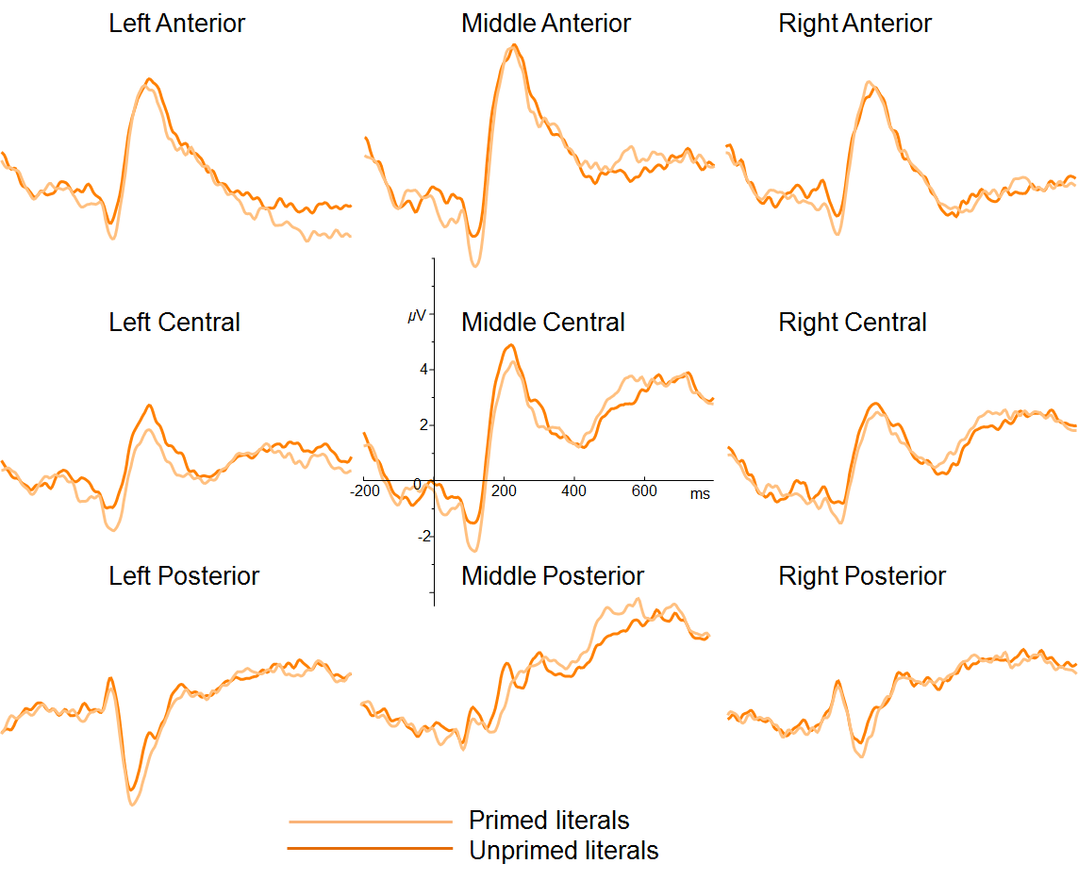
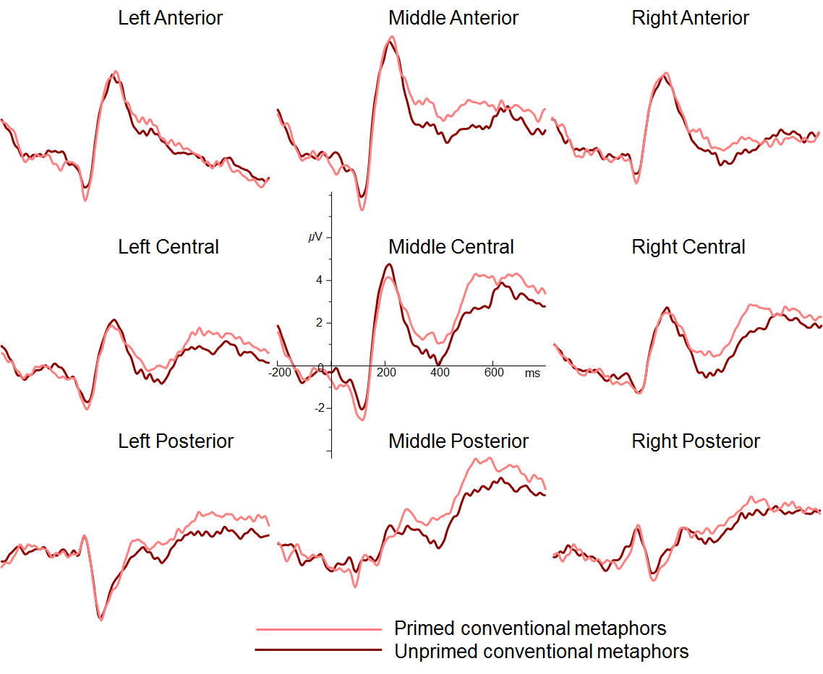
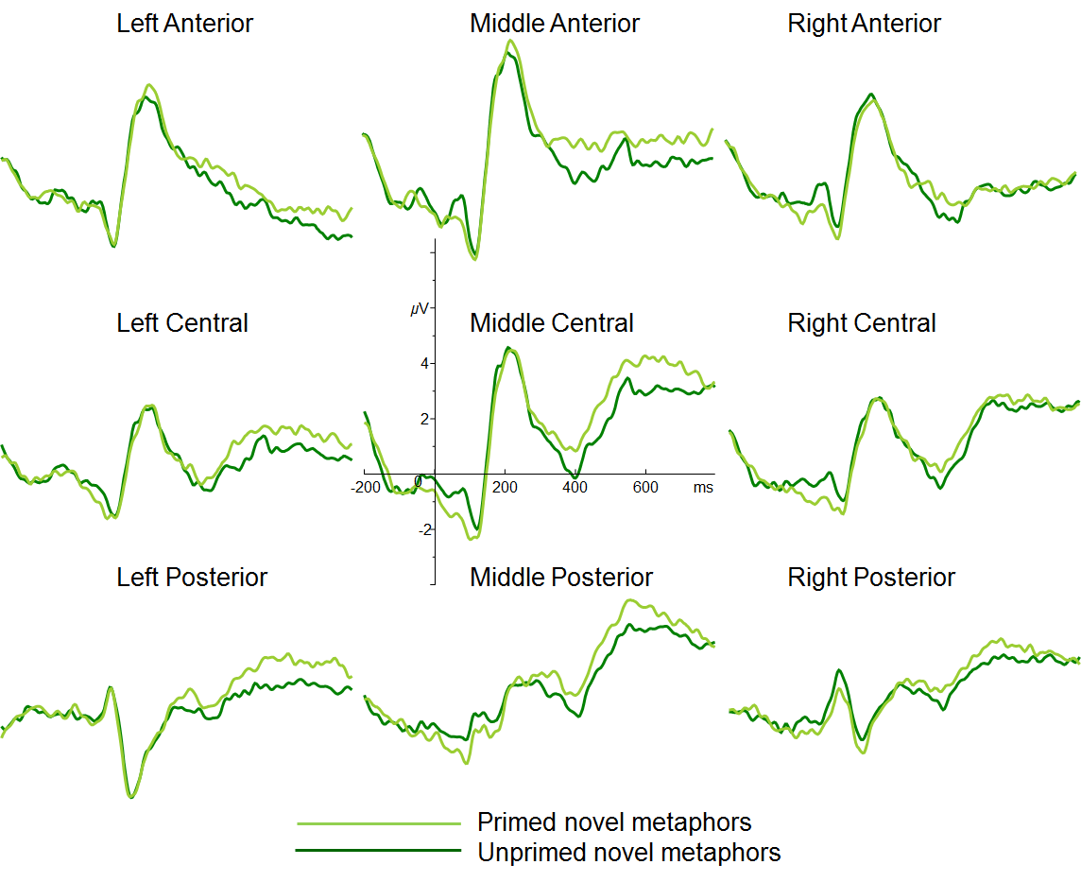

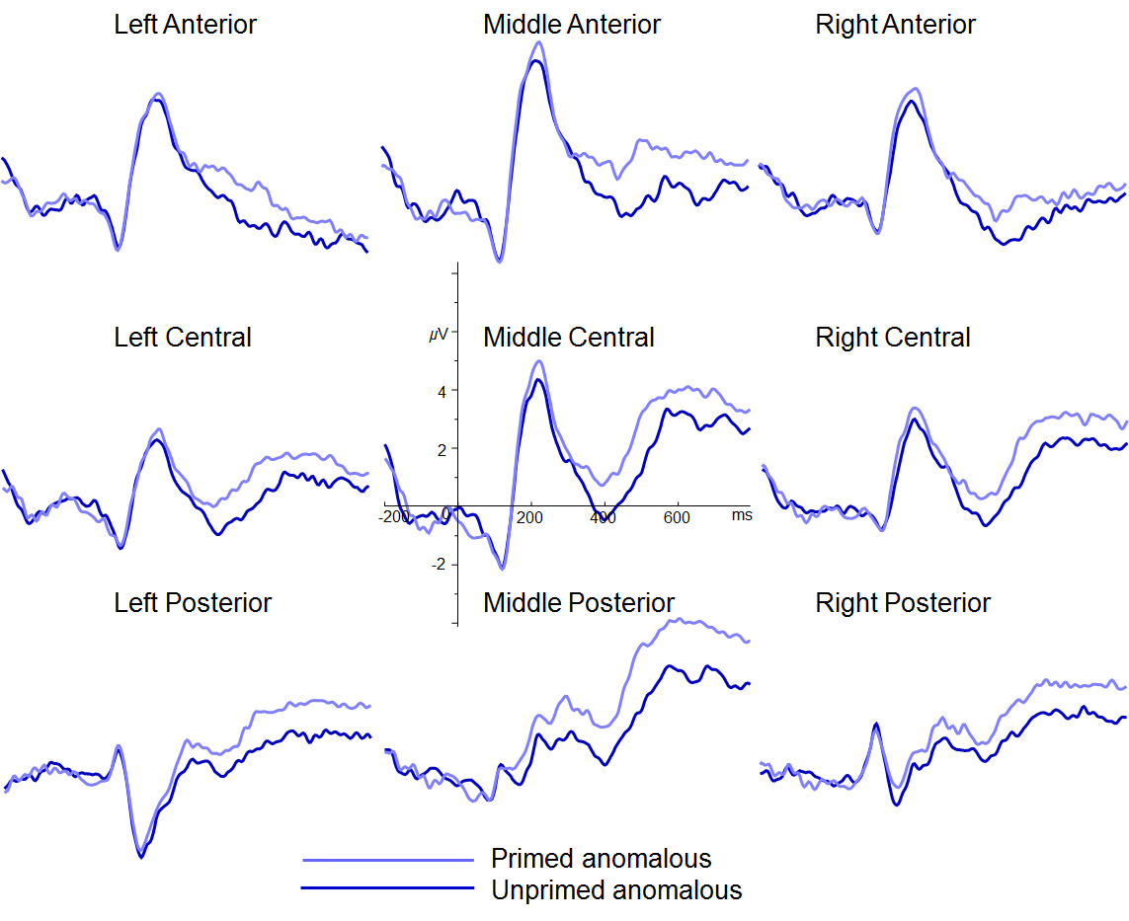

Figure S2. Experiment 1, N=18, Grand Average ERP waveforms for the literal (orange), conventional (red), novel (green), and anomalous (blue) targets in the unprimed (dark lines) and primed (light lines) conditions recorded at 63 electrode sites grouped into 9 left/mid/right anterior/central/posterior.
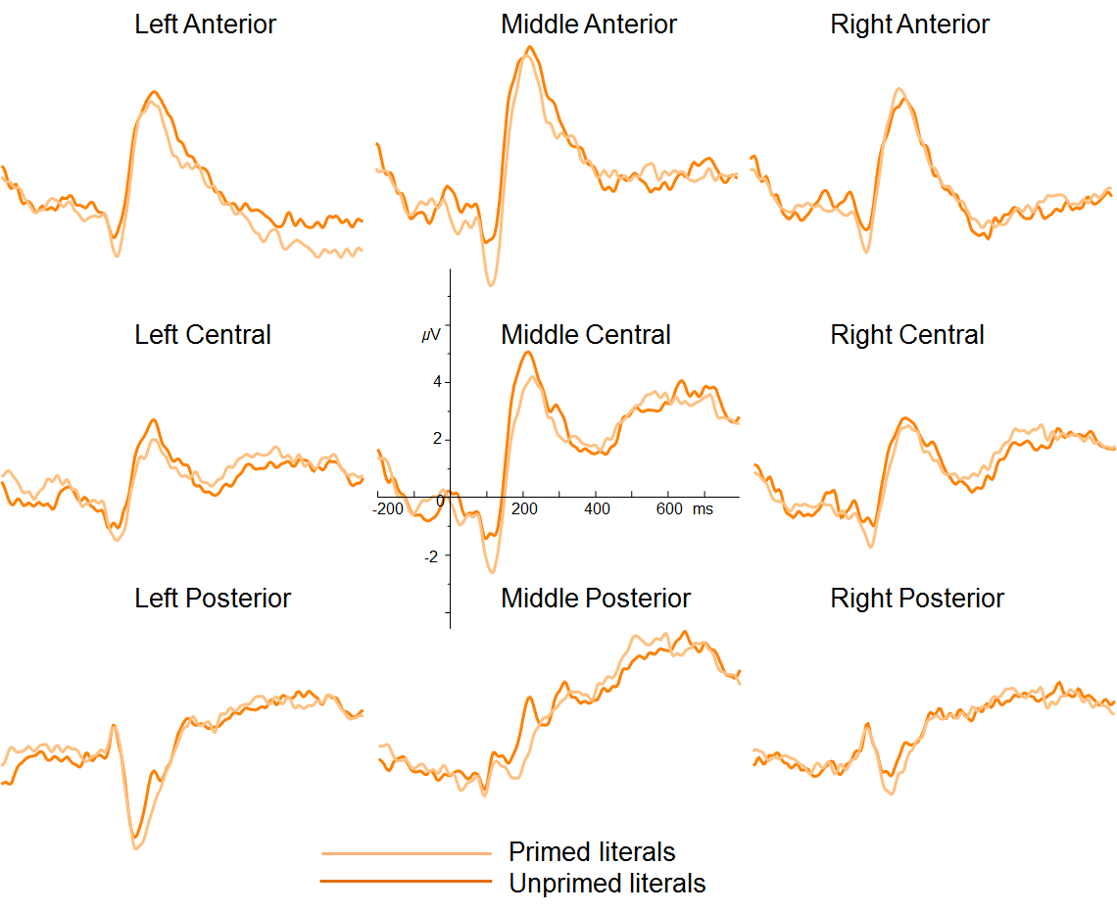
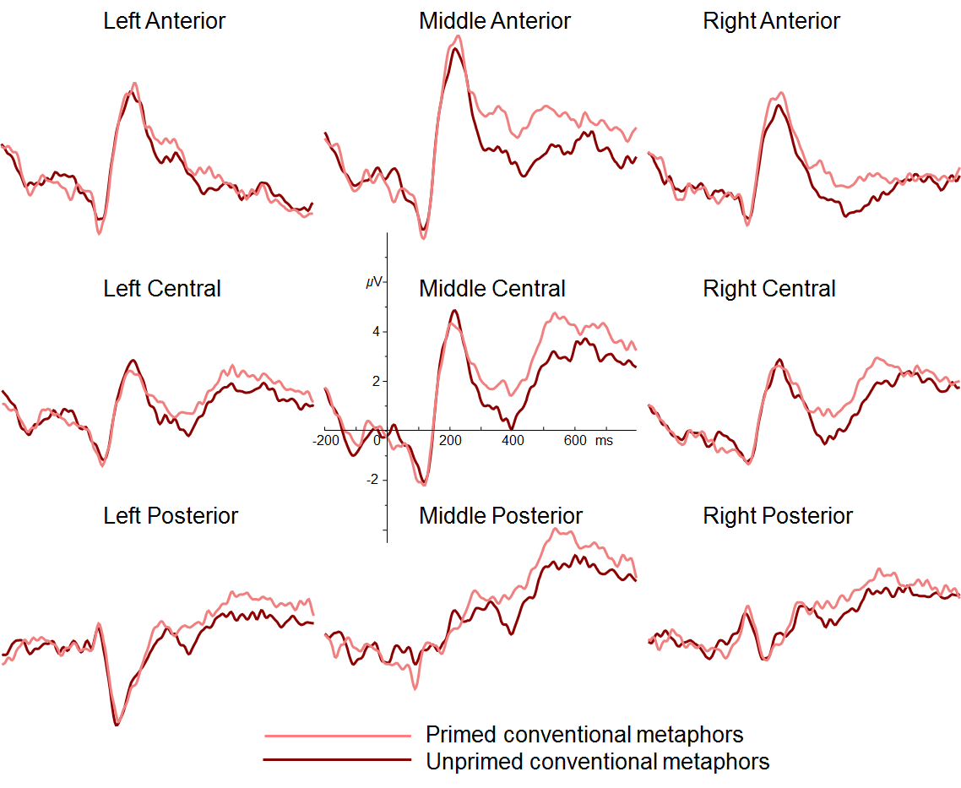
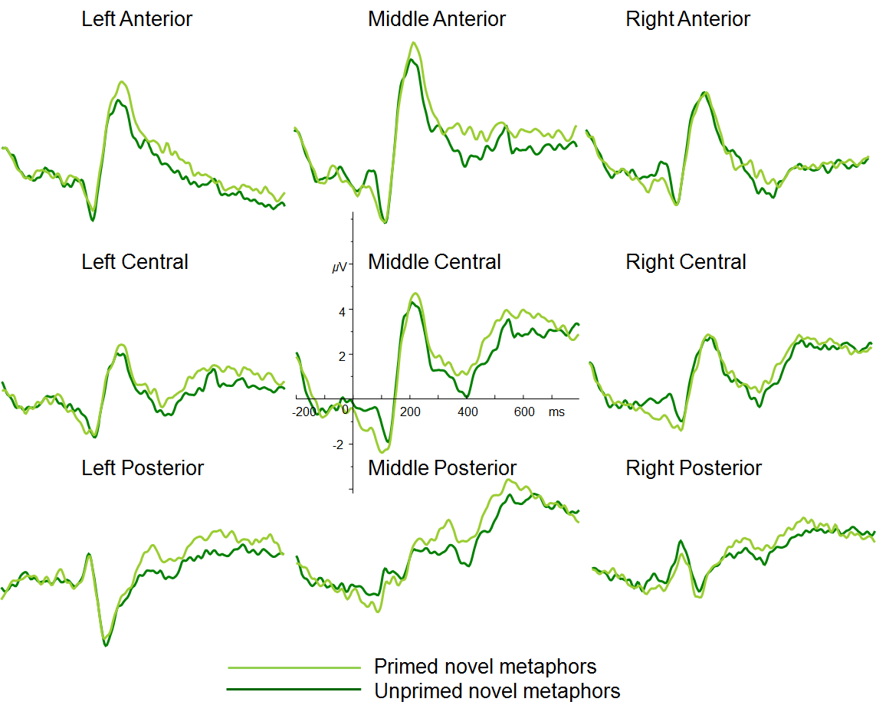
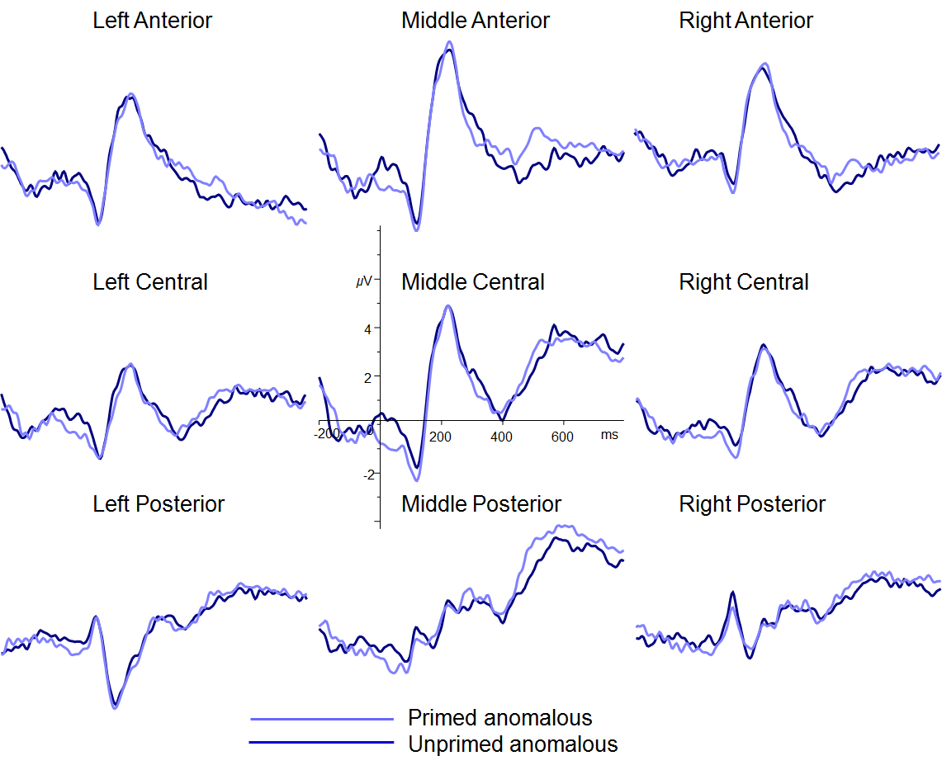

Figure S3. Experiment 1, N=18 (top) and N=24 (bottom), RTs for the literal (orange), conventional (red), novel (green), and anomalous (blue) targets in the unprimed (dark bars) and primed (light bars) conditions. The error bars are standard errors.

Figure S4. Experiment 1, N=18 (top) and N=24 (bottom), Grand Average ERP waveforms for the literal (orange), conventional (red), novel (green), and anomalous (blue) targets in the unprimed conditions recorded at 63 electrode sites grouped into 9 left/mid/right anterior/central/posterior.
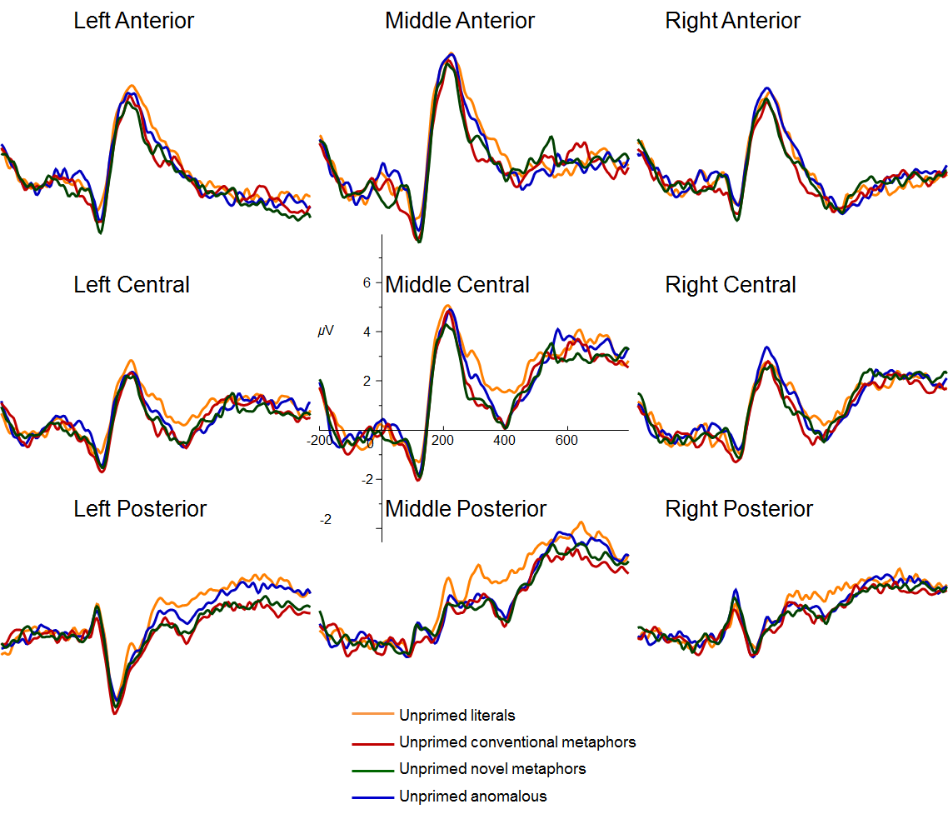
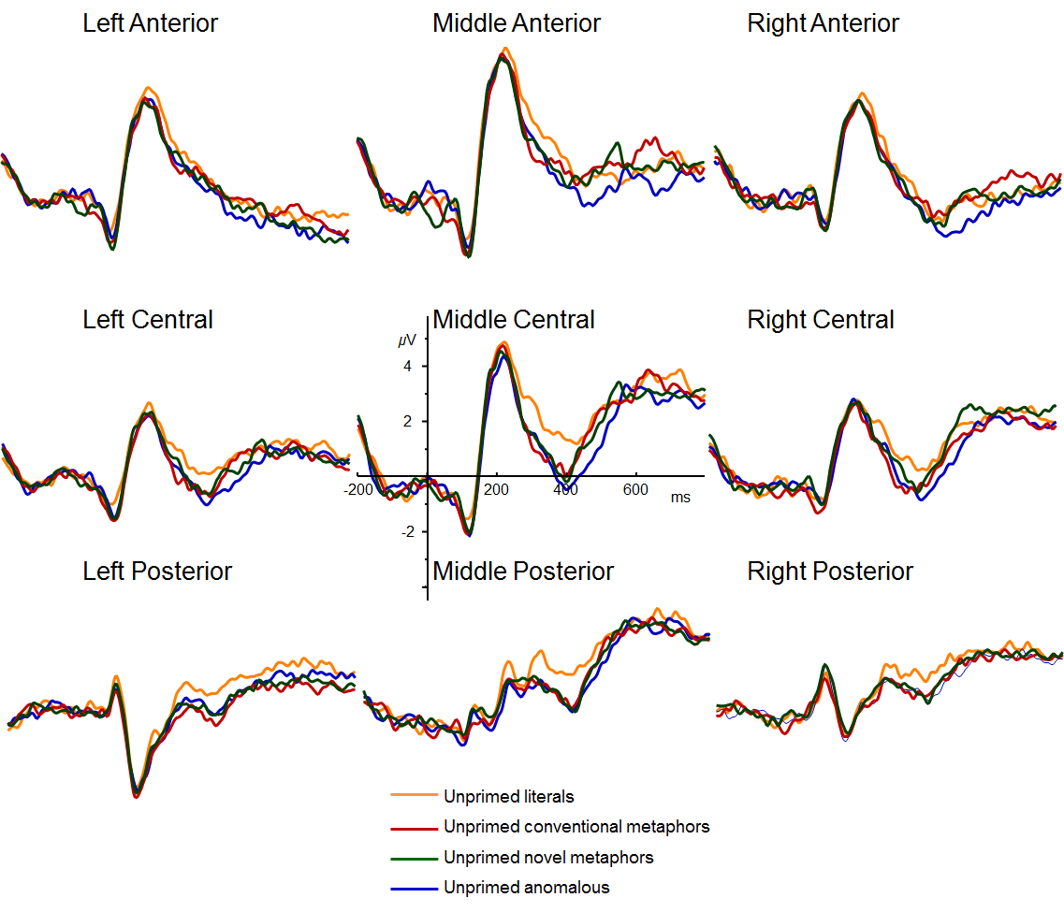
Figure S5. Experiment 2, Grand Average ERP waveforms for the literal, conventional, novel, and anomalous targets in the unprimed (dark lines) and primed (light lines) conditions recorded at 63 electrode sites grouped into 9 left/mid/right anterior/central/posterior.
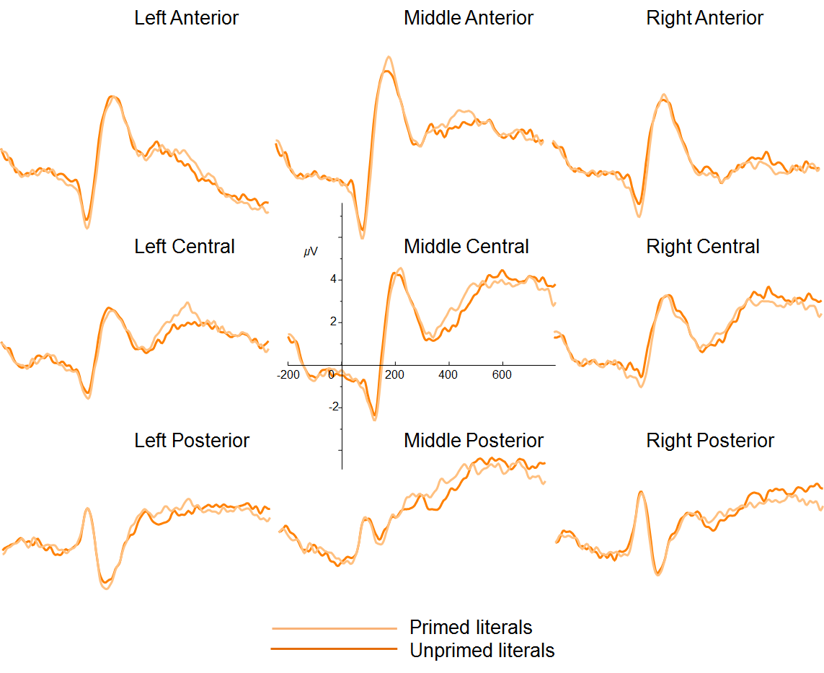
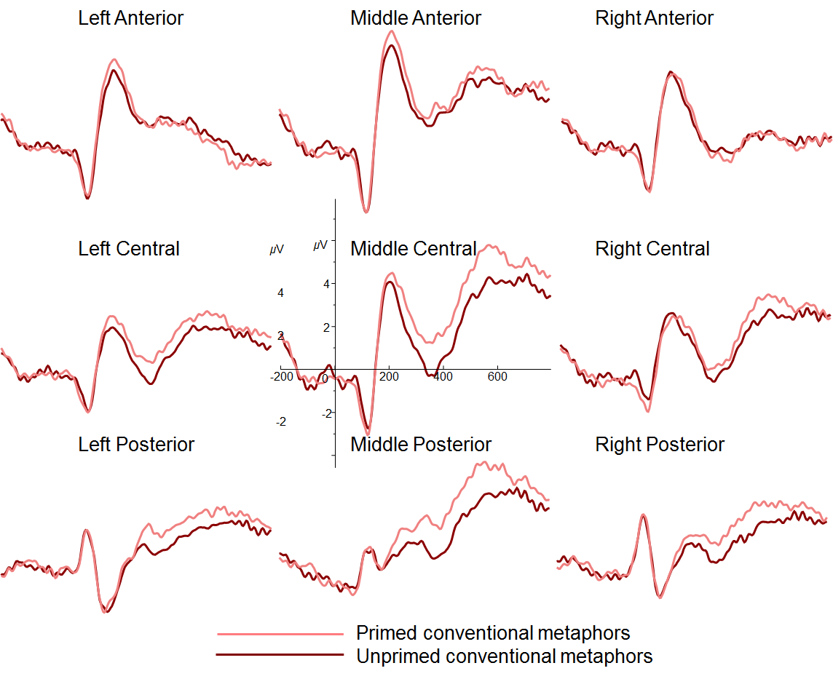
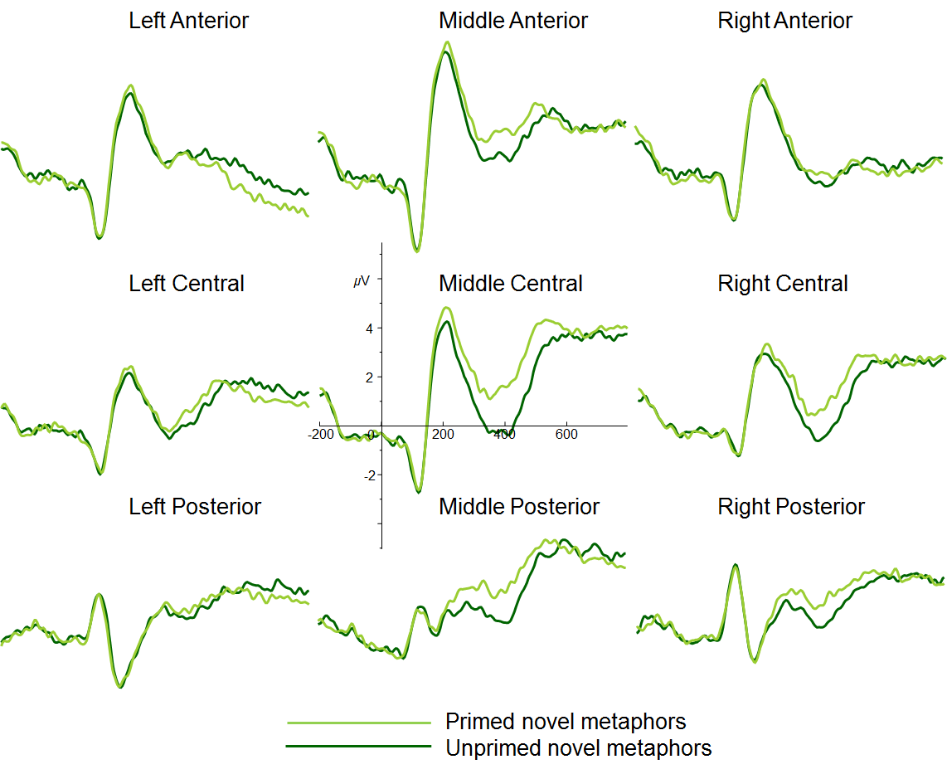
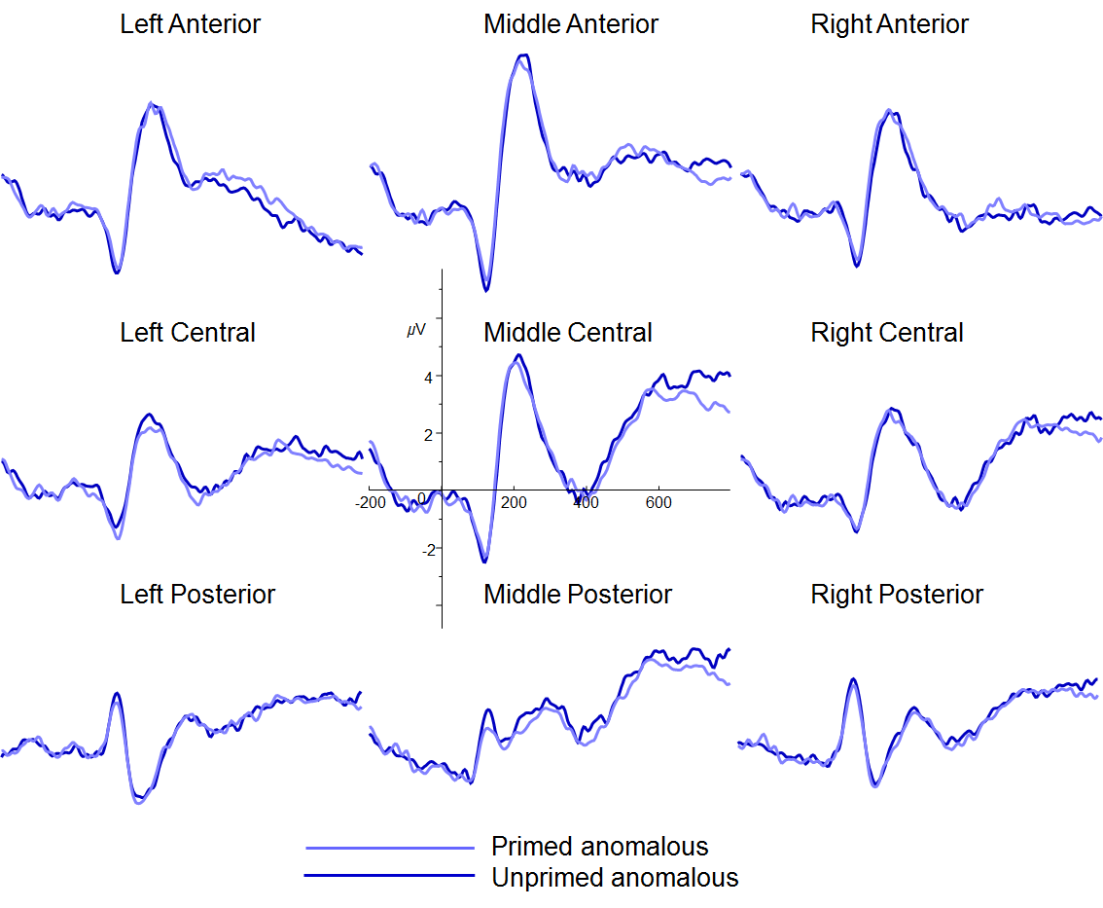

Figure S6. Experiment 2, Grand Average ERP waveforms for the literal (orange), conventional (red), novel (green), and anomalous (blue) targets in the unprimed conditions recorded at 63 electrode sites grouped into 9 left/mid/right anterior/central/posterior.
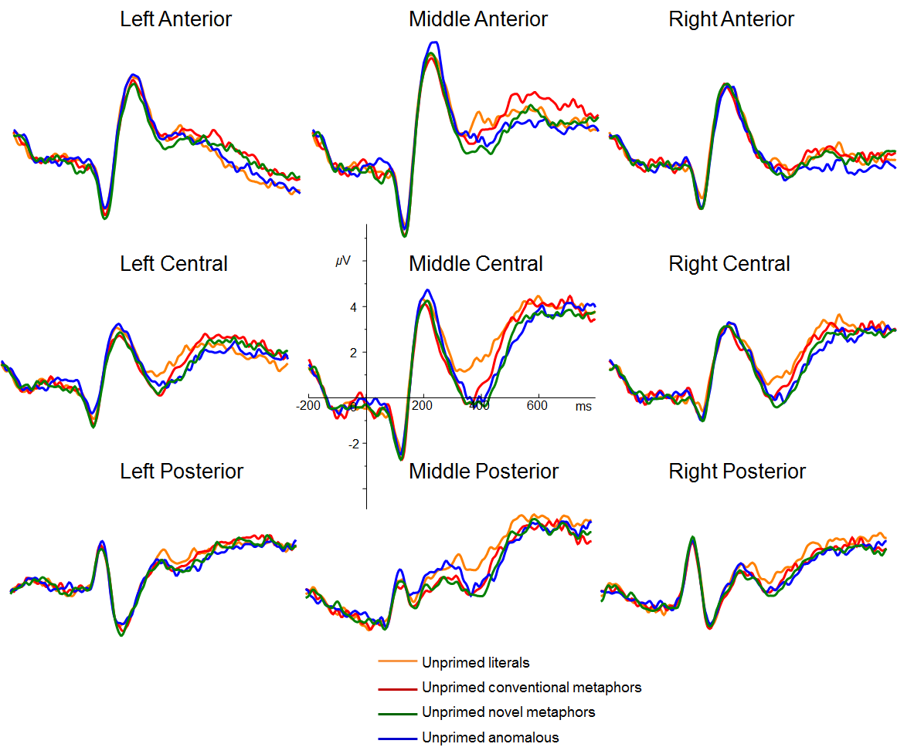

Figure S7. Experiment 2, RTs for the target sentences preceded by the unrelated literal-comparison-primes in the unprimed condition (dark bars) and the related simile-primes in the primed condition (light bars) conditions. The error bars indicate standard errors.

