Appendix A
Critical item. Item versions reflected in parentheses.

Subject Line |  |  | Self-paced reading items: Subject-verb agreement
Message from  Ashley / Sofía / Tiffany | RE: old vase |  | looks like the vase for the flower(s) probably  (was/were) long forgotten in the basement.
Message from  Ashley / Sofía / Tiffany | RE: that's dedication |  | Tom said the author of the novel(s) actually (was/were) in the haunted cabin.
Message from  Ashley / Sofía / Tiffany | RE: party address |  | it's obvious because the door to the room(s) finally (was/were) all nicely decorated.
Message from  Ashley / Sofía / Tiffany | RE: missing paperwork |  | last I heard the memo from the accountant(s) probably (was/were) sent on Thursday.
Message from  Ashley / Sofía / Tiffany | RE: pest control please |  | I found out that the trap for the rat(s) really (was/were) in the basement.
Message from  Ashley / Sofía / Tiffany | RE: to the cabin |  | so yeah the road to the mountain(s) literally  (was/were) all covered with leaves.
Message from  Ashley / Sofía / Tiffany | RE: neon |  | he noticed the sign on the taxi(s) actually ((was/were) lit up brightly.
Message from  Ashley / Sofía / Tiffany | RE: worst professor ever |  | I can't believe that the complaint from the student(s) really (was/were) in the trash.
Message from  Ashley / Sofía / Tiffany | RE: film fest! |  | he said that the director of the film(s) actually (was/were) on the stage.
Message from  Ashley / Sofía / Tiffany | RE: hermit |  | haven't you heard that the house on the hill(s) totally (was/were) from that movie.
Appendix A, continued
Message from  Ashley / Sofía / Tiffany | RE: Fun fact of the day |  | did you know that the inventor of the motorcycle(s) actually (was/were) in the news today.
Message from  Ashley / Sofía / Tiffany | RE: after the meeting |  | I heard the suggestion to the director(s) totally (was/were) made after the meeting.
Message from  Ashley / Sofía / Tiffany | RE: office hours |  | she heard that the teacher of the girl(s) literally (was/were) in her office.
Message from  Ashley / Sofía / Tiffany | RE: Niagara Falls |  | she said the van for the tourist(s) finally (was/were) left parked a mile away.
Message from  Ashley / Sofía / Tiffany | RE: zoo |  | I saw that the banana for the monkey(s) finally (was/were) in the dish.
Message from  Ashley / Sofía / Tiffany | RE: super nice |  | he heard that the medal for the winner(s) literally (was/were) on the podium.
Message from  Ashley / Sofía / Tiffany | RE: for class! |  | but he said that the easel for the artist(s) actually (was/were) in the new studio.
Message from  Ashley / Sofía / Tiffany | RE: love that cooking show |  | it's true that the knife for the chef(s) probably (was/were) in need of sharpening.
Message from  Ashley / Sofía / Tiffany | RE: the good kind |  | so I saw the marker for the whiteboard(s) really (was/were) in the tray.
Message from  Ashley / Sofía / Tiffany | RE: all set |  | no really the microphone for the singer(s) finally (was/were) on the stand.

Appendix A, continued
Message from  Ashley / Sofía / Tiffany | RE: ponies! |  | he told me the horse by the barn(s) probably (was/were) off eating hay.
Message from  Ashley / Sofía / Tiffany | RE: ah well |  | but actually the hanger for the dress(s) literally (was/were) under the bed.
Message from  Ashley / Sofía / Tiffany | RE: it's a choice |  | I can't believe that the tent for the hiker(s) really (was/were) put up over there.
Message from  Ashley / Sofía / Tiffany | RE: convenient |  | did you notice that the tray for the meal(s) totally (was/were) left over there.
Message from  Madison / María / Shelby | RE: beach detour |  | ugh so the highway to the island(s) really (was/were) still under repair.
Message from  Madison / María / Shelby | RE: money |  | I thought that the check from the stockbroker(s) totally (was/were) on the kitchen table.
Message from  Madison / María / Shelby | RE: uhoh |  | we were told that the letter from the detective(s) really (was/were) in the mailbox.
Message from  Madison / María / Shelby | RE: don't try this at home |  | seems like the warning from the expert(s) totally (was/were) on the label.
Message from  Madison / María / Shelby | RE: political debate |  | the news said that the debate over the drug(s) really (was/were) on today's schedule.
Message from  Madison / María / Shelby | RE: baby shower |  | she said the present for the baby(ies) probably (was/were) in the closet.

Appendix A, continued
Message from  Madison / María / Shelby | RE: family reunion |  | Jake saw that the grandfather of the boy(s) totally (was/were) on the porch.
Message from  Madison / María / Shelby | RE: dangerous dog |  | I heard that the lawsuit against the owner(s) actually (was/were) for revenge.
Message from  Madison / María / Shelby | RE: downtown offices |  | I think that the office of the employee(s) actually (was/were) past main street.
Message from  Madison / María / Shelby | RE: Law and Order recap |  | and she said that the witness for the lawyer(s) literally (was/were) out to lunch.
Message from  Madison / María / Shelby | RE: true! |  | did you notice that the plate with the cookie(s) finally (was/were) put on the counter.
Message from  Madison / María / Shelby | RE: top shelf |  | but I saw that the box for the gift(s) literally (was/were) in the closet.
Message from  Madison / María / Shelby | RE: safety problem? |  | so it seems like the bridge over the river(s) literally (was/were) left swinging wildly.
Message from  Madison / María / Shelby | RE: ooo! |  | I mean the cake for the wedding(s) totally (was/were) made of chocolate.
Message from  Madison / María / Shelby | RE: budget restrictions |  | I noticed that the computer for the project(s) actually (was/were) in the lab.
Message from  Madison / María / Shelby | RE: stamps too |  | he noticed that the envelope for the letter(s) finally (was/were) in the drawer.

Appendix A, continued
Message from  Madison / María / Shelby | RE: just a minute ago |  | oh, but the frame for the photo(s) probably (was/were) on the shelf.
Message from  Madison / María / Shelby | RE: behind the door |  | did you notice that the hook for the jacket(s) totally (was/were) on the wall.
Message from  Madison / María / Shelby | RE: no, really |  | I know that the key to the cabinet(s) literally (was/were) on the table.
Message from  Madison / María / Shelby | RE: gotta look good |  | no really the necklace for the model(s) finally (was/were) on the vanity.
Message from  Madison / María / Shelby | RE: takeout order |  | of course the pizza for the teenager(s) really (was/were) ready to eat.
Message from  Madison / María / Shelby | RE: green thumb |  | of course the pot for the plant(s) probably (was/were) on the porch.
Message from  Madison / María / Shelby | RE: so nearsighted |  | I couldn't see but the switch to the light(s) probably (was/were) by the door.
Message from  Madison / María / Shelby | RE: shiny |  | it's so nice that the trophy for the competitor(s) finally (was/were) on the stage.
 |  |  | Self-paced reading items: Without-blends
Message from  Ashley / Sofía / Tiffany | RE: running |  | it's true that Chris ran the trail without his shirt (on/off) the other day.
Message from  Ashley / Sofía / Tiffany | RE: too much chlorine |  | so actually Isabella went out swimming without her goggles (on/off) this afternoon.
Appendix A, continued
Message from  Ashley / Sofía / Tiffany | RE: exercise |  | he saw that Lulu visited the gym without her hat (on/off) late yesterday night.
Message from  Ashley / Sofía / Tiffany | RE: haha? |  | don't tell me Clara danced in the rain without her jacket (on/off) last night.
Message from  Ashley / Sofía / Tiffany | RE: camping prep |  | I mean Brad hiked several miles without his sweater (on/off) this afternoon.
Message from  Ashley / Sofía / Tiffany | RE: did you borrow my stuff? |  | that's not true since Alice went out partying without her earrings (on/off) this Friday night.
Message from  Ashley / Sofía / Tiffany | RE: going out |  | I think Jenny entered the bar without her rings (on/off) early last night.
Message from  Ashley / Sofía / Tiffany | RE: rookie stuff |  | she saw that Sam worked his shift without his sunglasses (on/off) this morning.
Message from  Ashley / Sofía / Tiffany | RE: lake |  | I know that Daniel walked along the lake without his sneakers (on/off) very recently.
Message from  Ashley / Sofía / Tiffany | RE: oh ben |  | did you see that Ben went to work without his belt (on/off) early yesterday morning.
Message from  Ashley / Sofía / Tiffany | RE: cute |  | they heard that Abby was dancing without her heels (on/off) at the fancy dinner.
Message from  Ashley / Sofía / Tiffany | RE: hmm |  | but actually Mark went to graduation without his vest (on/off) last year.
Message from  Madison / María / Shelby | RE: this morning |  | I think Alex left the dorm without his coat (on/off) early this morning.
Appendix A, continued
Message from  Madison / María / Shelby | RE: 5:00PM |  | I noticed that Mary wanted to drive without her glasses (on/off) after work Tuesday.
Message from  Madison / María / Shelby | RE: frostbite |  | it's probably because Patrick decided to ski without his gloves (on/off) last weekend.
Message from  Madison / María / Shelby | RE: bedtime |  | his girlfriend remembered that Jim went to bed without his socks (on/off) last night.
Message from  Madison / María / Shelby | RE: vacation |  | it's nice that Amelia walked on the beach without her sandals (on/off) all day yesterday.
Message from  Madison / María / Shelby | RE: autumn |  | I saw Philip rode his bike without his sweatshirt (on/off) last Wednesday morning.
Message from  Madison / María / Shelby | RE: last week |  | she saw that Jane went to the event without her lipstick (on/off) last week.
Message from  Madison / María / Shelby | RE: he's a monkey |  | I heard Felix climbed up the tree without his shoes (on/off) late yesterday afternoon.
Message from  Madison / María / Shelby | RE: club portraits |  | it was interesting that Natalya took the photo without her bracelet (on/off) last week.
Message from  Madison / María / Shelby | RE: before school |  | he said that Juan left his apartment without his backpack (on/off) last Monday.
Message from  Madison / María / Shelby | RE: yep |  | we all know Claudia walked to class without her headphones (on/off) this afternoon.
Message from  Madison / María / Shelby | RE: groceries |  | seems like Laura went out shopping without her scarf (on/off) all yesterday morning.

Appendix B
Speaker introductions and images

Practice Item Speaker
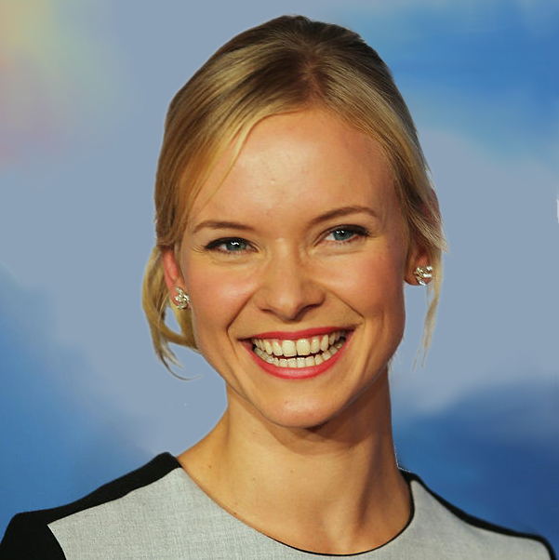 | Hello, my name is Emily Jones. I'm 20 and I'm a college student in Virginia. My major is econ, and I also like to play soccer when I can find the time!
Standardized American English Speakers
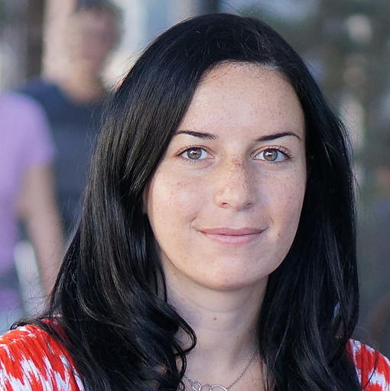 | Hi, my name is Madison Parker. I'm a 22-year-old college student living in central Ohio-- my family has lived here my whole life. I'm majoring in creative writing, and I love playing basketball with my friends.
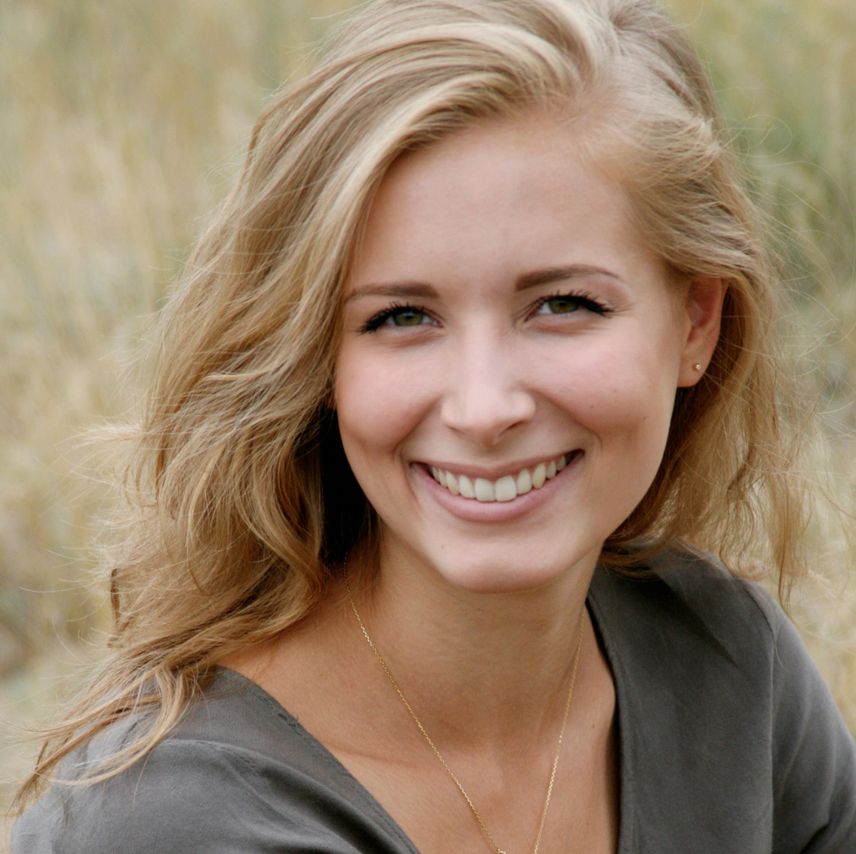 | Hi, I'm Ashley Clark. I'm 21 and I live in Ohio-- I was born and raised here too. I'm a college student and my major is business administration. I also love to draw-- you'll find me sketching and doodling all the time.
L2 English Speakers
 | Hi, my name is Sofía Menéndez. I'm a 22-year-old college student living in south Texas-- I moved here from Mexico with my family when I was a kid. I'm majoring in biology, and I love playing volleyball in my spare time.
Appendix B, continued

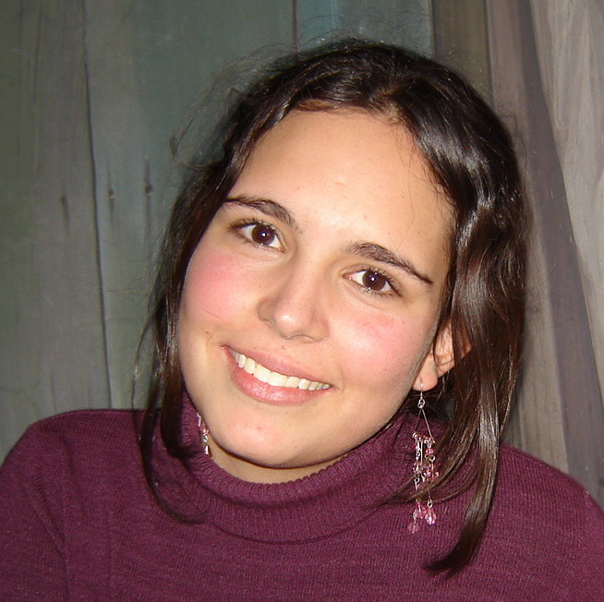 | Hi, I'm María Pérez. I'm 21 and I live in south Texas-- I'm a college student here. I was born in Mexico and we moved to the US when I was little. My major is sociology. I'm also a huge movie fan-- I watch as many movies as I can!
Rural Pennsylvania Speakers
 | Hi, my name is Tiffany Johnson. I'm a 22-year-old college student from a small town in central Pennsylvania. My whole family is from here too. I'm majoring in biology, and I love playing volleyball in my spare time.
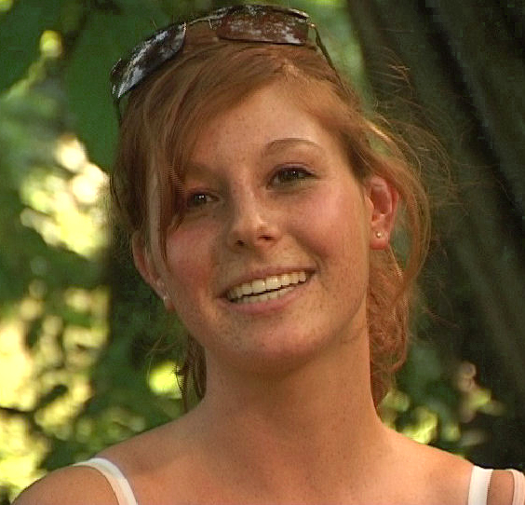 | Hi, I'm Shelby Williams. I'm 21 and I live in central Pennsylvania-- I'm a college student there. I have lived near the same small town my whole life. My major is sociology. I'm also a huge movie fan-- I watch as many movies as I can!

Appendix C
Language History Questionnaire
This questionnaire is designed to give us a better understanding of your background and your experience with English and other languages. We ask that you be as accurate and as thorough as possible when answering the following questions.
1. Gender: ___________________
2. Age: ______ years
3. Do you have any known visual and/or hearing problems (either corrected or uncorrected)?
[ ] No [ ]Yes [Please explain: _________________]
4. Do you have any known reading difficulties or impairment (past or present)?
[ ] No [ ]Yes [Please explain: _________________]
5. How many years of formal education do you have? ___________
Please check your highest education level (or the approximate U.S. equivalent to a degree obtained in another country)
[ ] Less than High School/Grammar School
[ ] High School/Grammar School
[ ] Professional Training
[ ] Some College/University
[ ] College/University
[ ] Some Graduate
[ ] Masters or Equivalent
[ ] PhD/MD/JD or Equivalent
[ ] Other: ___________________
Appendix C, continued
6. Were you born in the United States?
[ ] No [ ]Yes
7a. If no, where were you born (Country & town/city) _______________
At what age did you move to the US? _____________________
How long have you lived in the US? _____________________
7b. If yes, where were you born (State & town/city) _____________________
8. Please list all of the places you have lived for two years or longer
Country State City/town Age when you lived there
_____________________________________________________________________
_____________________________________________________________________
9. What language did you grow up speaking at home with your family? ___________________
10. What do you consider your native language? __________________
11. Did you have exposure to another language prior to the age of 5 years old?
[ ]Yes [ ]No
12. Please list all of the languages you know in order of dominance (i.e. how often you use each language), including your native language.
_____________________________________________________________________
_____________________________________________________________________
13. Do you currently have frequent (daily) exposure to foreign languages?
[ ]Yes [ ]No
14. Do you have frequent (daily) exposure to foreign accents?
[ ]Yes [ ]No
Appendix C, continued
15. If you answered ‘yes’ to 13 or 14, what other languages and/or foreign accents are you currently exposed to? ____________________
16. Please rate how many foreign-accented speakers you currently interact with on a weekly basis
[ ] 0-1
[ ]2-5
[ ]6-10
[ ]more than 10
17. Do you currently have frequent (daily) exposure to dialects/accents of American English that are different from your own?
[ ]Yes [ ]No
18. If you answered ‘yes’ to 17, what other dialects/accents of American English are you currently exposed to?____________________
19. Please rate how many speakers of other dialects/accents of American English you currently interact with on a weekly basis
[ ] 0-1
[ ]2-5
[ ]6-10
[ ]more than 10

Appendix D
Reading time results
Many studies of non-literal comprehension also use a reading-time measure (e.g., Patson & Husband, 2016; Swets, Desmet, Clifton, & Ferriera, 2008). In line with this work, we measured word-by-word reading times (reported in milliseconds). For analysis, by-word response times above 10 seconds and below 100 ms were trimmed (excluding 2.5% of the data). Then, all by-word reading times above three standard deviations by participant were removed (1.4% of the data). The remaining reading times were length-residualized by participant (following the procedure outlined in Fine et. al., 2013). Residualized reading times were submitted to linear mixed effects regression separately for each critical sentence type for sentence regions reflecting the site of the anomaly and the following word (Agreement: verb and verb spillover region; Without-blends: preposition and preposition spillover region), in order to address reading the anomalous word and any processing that continues on the following word. For both sentence types, we analyzed only the modal response, which in both cases was ‘no’—this was the literal response for agreement items and the ‘without+on’ items, and the non-literal response for ‘without+off’ items. Predictors and random effects were as described in Methods.
Experiment 1: Agreement Items. At the verb region, there was a main effect of Block only, such that reading times were faster in later blocks (β = -11.75, SE = 0.76, p(χ²) < .001). At the verb spillover region, there was a similar effect of Block (β = -12.35, SE = 0.74, p(χ²) < .001) and an effect of Verb such that ungrammatical plural verbs were read slower (β = 17.09, SE = 3.77, p(χ²) < .001). No other effects approached significance in either region.
Appendix D, continued
Experiment 1: Without-blends. The only significant reading time difference was an effect of Block, which was significant in both critical regions (At preposition: β = -10.04, SE = 1.26, p(χ²) < .001; at spillover: β = -11.85, SE = 1.31, p(χ²) < .001). The pattern was such that reading times were faster in later blocks. No other effects approached significance in either region.
Experiment 2: Agreement Items. At the verb region, there was a main effect of Local Noun such that local plural nouns were read slower than local singular ones (β = 9.00, SE = 3.43, p(χ²) < .01). There was also a main effect of Block such that reading times were faster in later blocks (β = -10.87, SE = 0.89, p(χ²) < .001). At the verb spillover region, there was a similar effect of Block (β = -11.86, SE = 0.70, p(χ²) < .001) and an effect of Verb such that ungrammatical plural verbs were read slower (β = 34.56, SE = 6.02, p(χ²) < .001). No other effects approached significance in either region.
Experiment 2: Without-blends. At the preposition, there was a significant effect of Block (β = -9.55, SE = 1.31, p(χ²) < .001), such that reading times were faster in later blocks. At the spillover region, there was again the same effect of Block (β = -11.20, SE = 1.45, p(χ²) < .001) and also a main effect of Preposition such that the ‘off’ items were read more slowly (β = 33.68, SE = 9.31, p(χ²) < .001). No other effects approached significance in either region.

