This file contains supplementary material to the paper:

Counting ‘uhm’s: how tracking the distribution of native and non-native disfluencies influences online language comprehension
Hans Rutger Bosker, Marjolein van Os, Rik Does, and Geertje van Bergen

Contents:
- Figures S1-S3
- Table S1

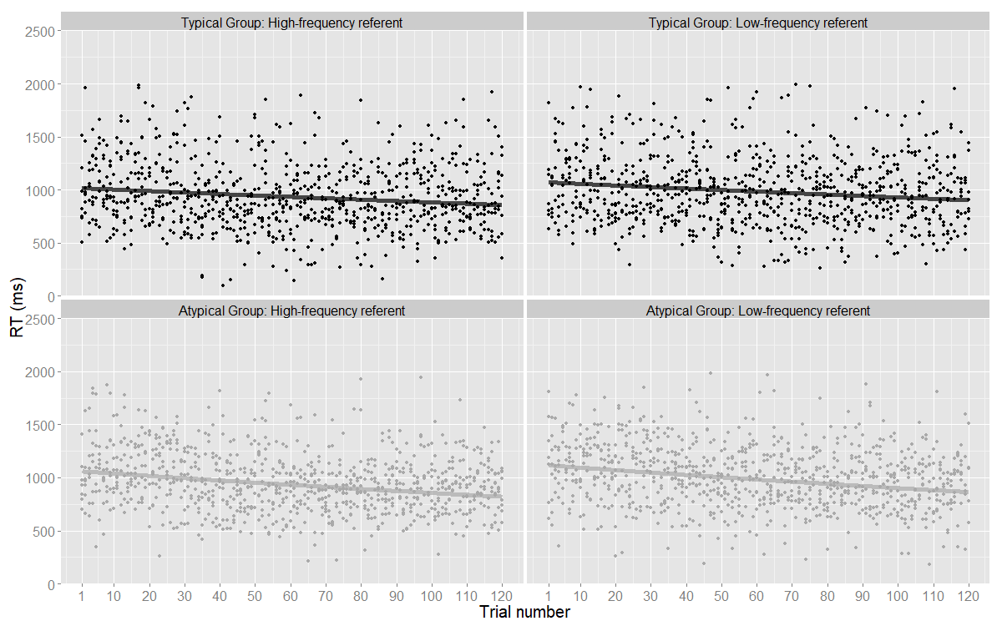
Figure S1. Raw reaction times (RTs) in ms from Experiment 1 (native speaker) as a function of the trial number, split by target frequency and listener group. The lines show the predicted RT as predicted by the Linear Mixed Effects Regression model.

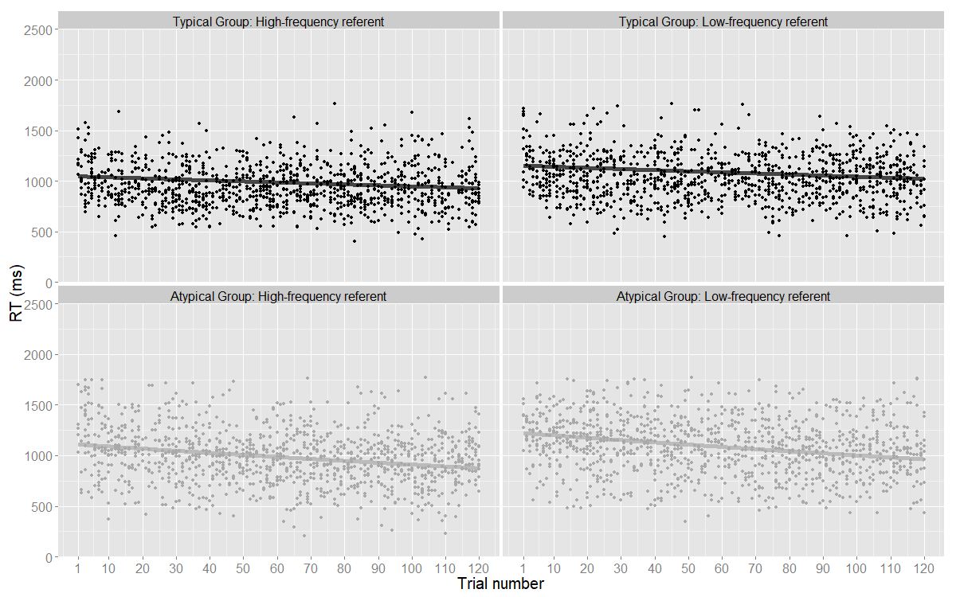
Figure S2. Raw reaction times (RTs) in ms from Experiment 2 (native speaker, no item repetitions) as a function of the trial number, split by target frequency and listener group. The lines show the predicted RT as predicted by the Linear Mixed Effects Regression model.

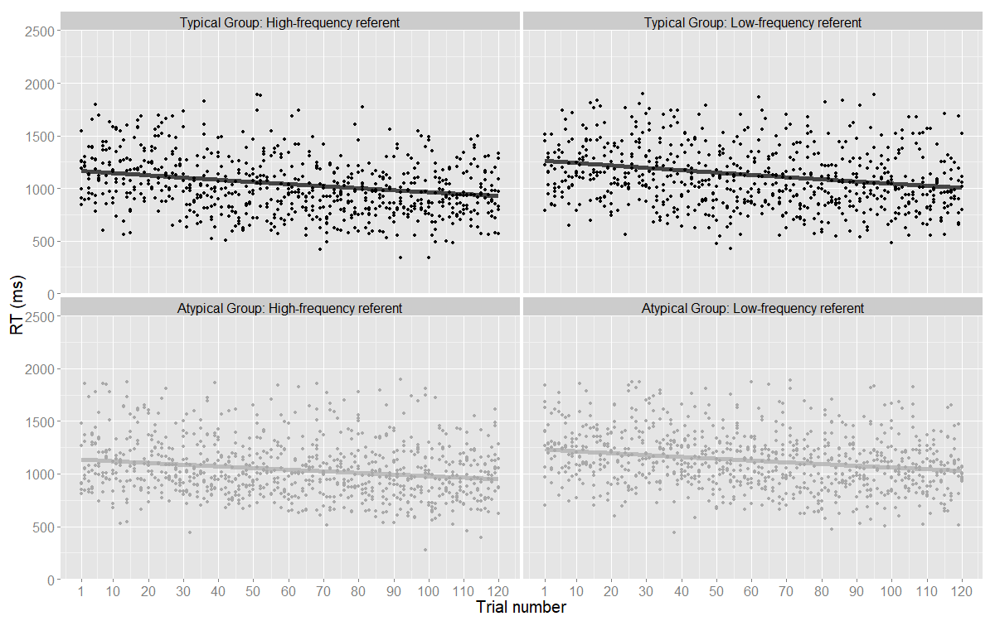
Figure S3. Raw reaction times (RTs) in ms from Experiment 3 (non-native speaker) as a function of the trial number, split by target frequency and listener group. The lines show the predicted RT as predicted by the Linear Mixed Effects Regression model.

Table S1. List of items (N = 240). Freq = Frequency (retrieved from Severens et al., 2005) in counts per million. FreqGroup = Frequency category (LF = low-frequency; HF = high-frequency). Experiment indicates which 30 HF and 30 LF items were used in Experiment 1 and 3, and the new items used in Experiment 2.
 | Dutch label | English translation | Freq | FreqGroup | Experiment
1 | hand | hand | 1028.0165 | HF | 1, 2, 3
2 | deur | door | 376.0106 | HF | 1, 2, 3
3 | arm | arm | 266.0113 | HF | 1, 2, 3
4 | tafel | table | 247.0017 | HF | 1, 2, 3
5 | voet | foot | 225.0091 | HF | 1, 2, 3
6 | auto | car | 208.0175 | HF | 1, 2, 3
7 | kerk | church | 205.0218 | HF | 1, 2, 3
8 | hond | dog | 167.9964 | HF | 1, 2, 3
9 | stoel | chair | 151.008 | HF | 1, 2, 3
10 | muur | wall | 146.9941 | HF | 1, 2, 3
11 | boom | tree | 136.9935 | HF | 1, 2, 3
12 | trap | stairs | 116.0112 | HF | 1, 2, 3
13 | bank | bench | 113.9987 | HF | 1, 2, 3
14 | fles | bottle | 111.9954 | HF | 1, 2, 3
15 | neus | nose | 100.9951 | HF | 1, 2, 3
16 | koning | king | 100 | HF | 1, 2, 3
17 | bloem | flower | 93.994 | HF | 1, 2, 3
18 | tand | tooth | 89.002 | HF | 1, 2, 3
19 | telefoon | telephone | 84.004 | HF | 1, 2, 3
20 | trein | train | 81.0028 | HF | 1, 2, 3
21 | baby | baby | 78.9951 | HF | 1, 2, 3
22 | sigaret | cigarette | 73.9946 | HF | 1, 2, 3
23 | vis | fish | 72.9962 | HF | 1, 2, 3
24 | kom | bowl | 70.0003 | HF | 1, 2, 3
25 | schoen | shoe | 67.9986 | HF | 1, 2, 3
26 | maan | moon | 64.998 | HF | 1, 2, 3
27 | ster | star | 60.9958 | HF | 1, 2, 3
28 | bus | bus | 57.9963 | HF | 1, 2, 3
29 | regen | rain | 55.0047 | HF | 1, 2, 3
30 | brug | bridge | 51.9996 | HF | 1, 2, 3
31 | bij | bee | 3796.6455 | HF | 2
32 | man | man | 1189.8713 | HF | 2
33 | vrouw | woman | 899.912 | HF | 2
34 | weg | road | 882.0636 | HF | 2
35 | oog | eye | 819.9739 | HF | 2
36 | huis | house | 629.9411 | HF | 2
37 | net | net | 461.9552 | HF | 2
38 | boek | book | 386.9901 | HF | 2
39 | stad | city | 322.9982 | HF | 2
40 | bed | bed | 299.9853 | HF | 2
41 | brief | letter | 199.9862 | HF | 2
42 | schouder | shoulder | 190.9853 | HF | 2
43 | hart | heart | 190.0203 | HF | 2
44 | been | leg | 188.0182 | HF | 2
45 | raam | window | 173.9803 | HF | 2
46 | paard | horse | 158.0156 | HF | 2
47 | vinger | finger | 157.0001 | HF | 2
48 | glas | glass | 153.003 | HF | 2
49 | dokter | doctor | 145.0107 | HF | 2
50 | steen | rock | 117.0038 | HF | 2
51 | blad | leaf | 113.9987 | HF | 2
52 | papier | paper | 113.0056 | HF | 2
53 | soldaat | soldier | 113.0056 | HF | 2
54 | zak | bag | 113.0056 | HF | 2
55 | oor | ear | 110.0018 | HF | 2
56 | vuur | fire | 103.992 | HF | 2
57 | vogel | bird | 96.0064 | HF | 2
58 | bureau | desk | 88.0035 | HF | 2
59 | traan | tear | 77.0016 | HF | 2
60 | spoor | railway | 72.9962 | HF | 2
61 | slot | lock | 71.9946 | HF | 2
62 | kat | cat | 71.9946 | HF | 2
63 | brood | bread | 70.0003 | HF | 2
64 | ei | egg | 67.9986 | HF | 2
65 | boot | boat | 67.0039 | HF | 2
66 | vloer | floor | 67.0039 | HF | 2
67 | rook | smoke | 65.9933 | HF | 2
68 | bord | plate | 64.003 | HF | 2
69 | dak | roof | 57.0033 | HF | 2
70 | hals | neck | 57.0033 | HF | 2
71 | berg | mountain | 55.0047 | HF | 2
72 | tak | branch | 54.0008 | HF | 2
73 | kaas | cheese | 53.0029 | HF | 2
74 | vliegtuig | airplane | 51.9996 | HF | 2
75 | radio | radio | 51.9996 | HF | 2
76 | spiegel | mirror | 51.0035 | HF | 2
77 | jas | coat | 49.0004 | HF | 2
78 | koffer | suitcase | 49.0004 | HF | 2
79 | sleutel | wrench | 49.0004 | HF | 2
80 | sleutel | key | 49.0004 | HF | 2
81 | fiets | bicycle | 47.9954 | HF | 2
82 | wolk | cloud | 47.9954 | HF | 2
83 | kast | dresser | 47.9954 | HF | 2
84 | bar | bar | 47.9954 | HF | 2
85 | zon | sun | 46.0045 | HF | 2
86 | priester | priest | 46.0045 | HF | 2
87 | gordijn | curtains | 44.9987 | HF | 2
88 | stuur | steeringwheel | 44.0048 | HF | 2
89 | mes | knife | 41.0015 | HF | 2
90 | hoed | hat | 41.0015 | HF | 2
91 | poot | paw | 40.0037 | HF | 2
92 | doos | box | 39.0032 | HF | 2
93 | schilderij | painting | 38.0014 | HF | 2
94 | klok | clock | 36.9999 | HF | 2
95 | kasteel | castle | 35.9998 | HF | 2
96 | touw | rope | 35.9998 | HF | 2
97 | ring | ring | 34.0016 | HF | 2
98 | horloge | watch | 34.0016 | HF | 2
99 | teen | toe | 34.0016 | HF | 2
100 | plank | shelf | 34.0016 | HF | 2
101 | kip | chicken | 32.9989 | HF | 2
102 | staart | tail | 31.9963 | HF | 2
103 | lamp | lamp | 31.0027 | HF | 2
104 | hek | fence | 31.0027 | HF | 2
105 | duim | thumb | 29.9985 | HF | 2
106 | vlag | flag | 29.0001 | HF | 2
107 | roos | rose | 29.0001 | HF | 2
108 | bot | bone | 29.0001 | HF | 2
109 | aardappel | potato | 28.0027 | HF | 2
110 | sigaar | cigar | 28.0027 | HF | 2
111 | laars | boot | 27.0022 | HF | 2
112 | slang | snake | 27.0022 | HF | 2
113 | schaap | sheep | 26.0016 | HF | 2
114 | appel | apple | 23.9994 | HF | 2
115 | eend | duck | 23.9994 | HF | 2
116 | kaars | candle | 22.9985 | HF | 2
117 | varken | pig | 22.9985 | HF | 2
118 | konijn | rabbit | 22.9985 | HF | 2
119 | emmer | bucket | 21.9988 | HF | 2
120 | muis | mouse | 20.9991 | HF | 2
121 | vleermuis | bat | 6.0007 | LF | 1, 2, 3
122 | vlieger | kite | 6.0007 | LF | 1, 2, 3
123 | krokodil | alligator | 5.0003 | LF | 1, 2, 3
124 | weegschaal | scale | 5.0003 | LF | 1, 2, 3
125 | aardbei | strawberry | 5.0003 | LF | 1, 2, 3
126 | slak | snail | 5.0003 | LF | 1, 2, 3
127 | kruiwagen | wheelbarrow | 5.0003 | LF | 1, 2, 3
128 | tandenborstel | toothbrush | 4.0004 | LF | 1, 2, 3
129 | dolfijn | dolphin | 4.0004 | LF | 1, 2, 3
130 | puzzel | puzzle | 4.0004 | LF | 1, 2, 3
131 | cactus | cactus | 2.9999 | LF | 1, 2, 3
132 | palmboom | palmtree | 2.9999 | LF | 1, 2, 3
133 | stofzuiger | vacuum cleaner | 2.9999 | LF | 1, 2, 3
134 | zaag | saw | 2.9999 | LF | 1, 2, 3
135 | eekhoorn | squirrel | 2.9999 | LF | 1, 2, 3
136 | eskimo | eskimo | 2.9999 | LF | 1, 2, 3
137 | ventilator | fan | 1.9999 | LF | 1, 2, 3
138 | pompoen | pumpkin | 1.9999 | LF | 1, 2, 3
139 | naaimachine | sewingmachine | 1.9999 | LF | 1, 2, 3
140 | ananas | pineapple | 1.9999 | LF | 1, 2, 3
141 | schommel | swing | 1.9999 | LF | 1, 2, 3
142 | trechter | funnel | 1.9999 | LF | 1, 2, 3
143 | accordeon | accordion | 1 | LF | 1, 2, 3
144 | neushoorn | rhino | 1 | LF | 1, 2, 3
145 | iglo | igloo | 1 | LF | 1, 2, 3
146 | eenhoorn | unicorn | 1 | LF | 1, 2, 3
147 | stethoscoop | stethoscope | 1 | LF | 1, 2, 3
148 | gieter | wateringcan | 1 | LF | 1, 2, 3
149 | typemachine | typewriter | 1 | LF | 1, 2, 3
150 | sneeuwman | snowman | 1 | LF | 1, 2, 3
151 | tractor | tractor | 4.0004 | LF | 2
152 | microscoop | microscope | 4.0004 | LF | 2
153 | wasbak | sink | 4.0004 | LF | 2
154 | thermometer | thermometer | 2.9999 | LF | 2
155 | hangmat | hammock | 2.9999 | LF | 2
156 | spuit | syringe | 2.9999 | LF | 2
157 | scharnier | hinge | 2.9999 | LF | 2
158 | vuurtoren | lighthouse | 2.9999 | LF | 2
159 | rits | zipper | 2.9999 | LF | 2
160 | magneet | magnet | 2.9999 | LF | 2
161 | kever | bug | 2.9999 | LF | 2
162 | kalkoen | turkey | 2.9999 | LF | 2
163 | spinneweb | spiderweb | 2.9999 | LF | 2
164 | egel | hedgehog | 2.9999 | LF | 2
165 | schorpioen | scorpion | 2.9999 | LF | 2
166 | pincet | tweezers | 1.9999 | LF | 2
167 | hoefijzer | horseshoe | 1.9999 | LF | 2
168 | lama | llama | 1.9999 | LF | 2
169 | waterput | well | 1.9999 | LF | 2
170 | hoef | hoof | 1.9999 | LF | 2
171 | kurketrekker | corkscrew | 1.9999 | LF | 2
172 | schommelstoel | rockingchair | 1.9999 | LF | 2
173 | hark | rake | 1.9999 | LF | 2
174 | sprinkhaan | grasshopper | 1.9999 | LF | 2
175 | asperge | asparagus | 1.9999 | LF | 2
176 | microfoon | microphone | 1.9999 | LF | 2
177 | duikboot | submarine | 1.9999 | LF | 2
178 | draaimolen | carousel | 1.9999 | LF | 2
179 | wafel | waffle | 1.9999 | LF | 2
180 | strijkijzer | iron | 1 | LF | 2
181 | popcorn | popcorn | 1 | LF | 2
182 | mixer | mixer | 1 | LF | 2
183 | paperclip | paperclip | 1 | LF | 2
184 | radijs | radish | 1 | LF | 2
185 | wereldbol | globe | 1 | LF | 2
186 | muizeval | mousetrap | 1 | LF | 2
187 | strijkplank | ironingboard | 1 | LF | 2
188 | tuinslang | hose | 1 | LF | 2
189 | saxofoon | saxophone | 1 | LF | 2
190 | denneappel | pinecone | 1 | LF | 2
191 | rolschaats | rollerskate | 1 | LF | 2
192 | pelikaan | pelican | 1 | LF | 2
193 | spaarvarken | piggybank | 1 | LF | 2
194 | tennisracket | tennisracket | 1 | LF | 2
195 | selderij | celery | 1 | LF | 2
196 | wasknijper | clothespin | 1 | LF | 2
197 | box | speaker | 1 | LF | 2
198 | eland | moose | 1 | LF | 2
199 | stinkdier | skunk | 1 | LF | 2
200 | riek | pitchfork | 1 | LF | 2
201 | blikopener | canopener | 1 | LF | 2
202 | palet | palette | 1 | LF | 2
203 | spatel | spatula | 1 | LF | 2
204 | boormachine | drill | 1 | LF | 2
205 | pollepel | ladle | 1 | LF | 2
206 | slijper | pencilsharpener | 1 | LF | 2
207 | glijbaan | slide | 1 | LF | 2
208 | step | step | 1 | LF | 2
209 | wigwam | teepee | 1 | LF | 2
210 | artisjok | artichoke | 1 | LF | 2
211 | aambeeld | anvil | 1 | LF | 2
212 | broodrooster | toaster | 1 | LF | 2
213 | drumstel | drumkit | 1 | LF | 2
214 | gewei | antlers | 1 | LF | 2
215 | houweel | pickaxe | 1 | LF | 2
216 | kinderbed | crib | 1 | LF | 2
217 | lieveheersbeestje | ladybug | 1 | LF | 2
218 | luipaard | leopard | 1 | LF | 2
219 | vingerhoed | thimble | 1 | LF | 2
220 | walrus | walrus | 1 | LF | 2
221 | zaklamp | flashlight | 1 | LF | 2
222 | dwarsfluit | flute | 1 | LF | 2
223 | veiligheidsspeld | safetypin | 1 | LF | 2
224 | bever | beaver | 1 | LF | 2
225 | banjo | banjo | 1 | LF | 2
226 | platenspeler | recordplayer | 1 | LF | 2
227 | wasbeer | raccoon | 1 | LF | 2
228 | rugbybal | football | 1 | LF | 2
229 | notenbalk | staff | 1 | LF | 2
230 | brandkraan | fire hydrant | 1 | LF | 2
231 | spinnewiel | spinningwheel | 1 | LF | 2
232 | springtouw | jumprope | 1 | LF | 2
233 | statief | tripod | 1 | LF | 2
234 | krik | jack | 1 | LF | 2
235 | katapult | slingshot | 1 | LF | 2
236 | jojo | yoyo | 1 | LF | 2
237 | zeppelin | zeppelin | 1 | LF | 2
238 | struisvogel | ostrich | 1 | LF | 2
239 | kado | present | 0 | LF | 2
240 | skateboard | skateboard | 0 | LF | 2

