Kristijan Armeni
Roel M. Willems
Antal van den Bosch
Jan-Mathijs Schoffelen

Frequency-specific MEG dynamics related to prediction in naturalistic language comprehension: SUPPLEMENTARY INFORMATION

Epoch creation respecting word onsets

We repeated the analysis with a different way of epoch creation compared to the procedure described in section 2.5 of the manuscript. Instead of creating 0.5 second data snippets (with 0 % overlap), without considering the word boundaries, we created epochs which were explicitly locked to the onset of words. In this way, epoch onsets did not straddle word boundaries, but this strategy resulted in highly overlapping data snippets. To allow for a fair comparison to the original analysis results, we subsequently removed the epochs with a high amount of temporal overlap, allowing for a maximal 20% overlap between the epochs.

We show the outcome of this analysis in the figures below. This analysis largely reproduces the patterns obtained with the original pipeline. We notice that the overall spatio-temporal extent of clusters (i.e. observed data patterns after thresholding) is less pronounced. E.g. the originally reported medio-lateral positive theta cluster for entropy contrast (Figure 4, panel A, of the manuscript) is now clustered by the algorithm into two separate clusters, one medial and a separate lateral cluster (rows A and B, Figure S2, respectively); the entropy-beta band differences are clustered to a smaller extent (row C, Figure 2). Similar observations hold for the perplexity contrast (Figure 2).
The overall contrasts (perplexity, entropy) in this pipeline are not conservatively controlled for the family-wise error rate at the desired alpha-level of 0.05.

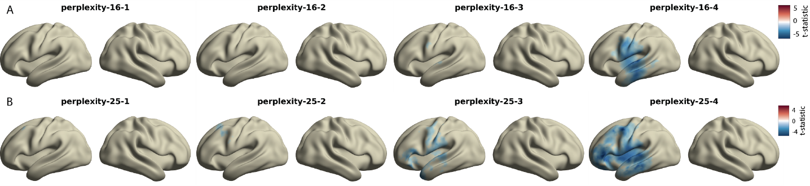
Figure S1 Group level t-maps for low beta (11--21 Hz, row A) and high beta band (21--31 Hz, row B) power quantifying differences between high and low perplexity bins. Source maps show paired-samples t-statistic per source location and time lag (0, 200, 400, and 600 msec). For the purposes of visualization, displayed are only t-statistics for source locations belonging to the cluster with the highest negative cluster statistic, that is, source locations not belonging to the maximal clusters the cluster are set to a value of zero.

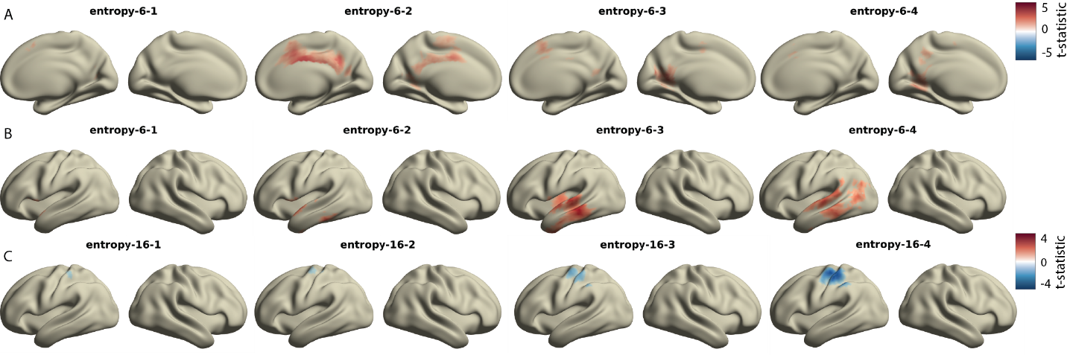
Figure S2 Frequency-specific power differences between conditions visualized here as group-level t-maps for theta-band (4--8 Hz, rows A and B) and lower beta-band (11--21 Hz, row C) power quantifying differences between high and low entropy bins. Source maps show paired-samples t-statistic per source location and time lag (0, 200, 400, and 600 msec). We show the first two highest positive clusters and the highest negative cluster for theta and beta bands, respectively. For the purposes of visualization, displayed are only t-statistics for source locations belonging to the cluster with the highest cluster statistic, that is, source locations not belonging to the maximal clusters the cluster are set to a value of zero.

