Supplementary materials:

Supplementary Figure 1: Spatial alignment of contrast across spatial frequencies is a fundamental property of natural images (Olshausen and Field, 1996; Simoncelli and Olshausen, 2001; Hansen and Hess, 2007). To illustrate the statistical dependencies between spatial frequency ranges in intact, compared to scrambled images used in this study, we calculated their mutual information. To map mutual information in image space, we calculated the joint histogram (see e.g. Maes, Collignon, Vandermeulen, Marchal, & Suetens, 1997) for a sliding window of 50x50 pixels and 20 bins as
$$I\left(X;Y\right)=\sum_{y∈Y}{\sum_{x∈X}{p\left(x,y\right)}\log\left(\frac{p\left(x,y\right)}{p\left(x\right) p\left(y\right)}\right)}$$
where X is LSF and Y is HSF and p(x,y) is their joint intensity probability distribution (i.e., the histogram). The figure shows mutual information between LSF and HSF images, averaged over all intact (a) and scrambled (b) images. (c) shows the difference in mutual information between intact and scrambled images.

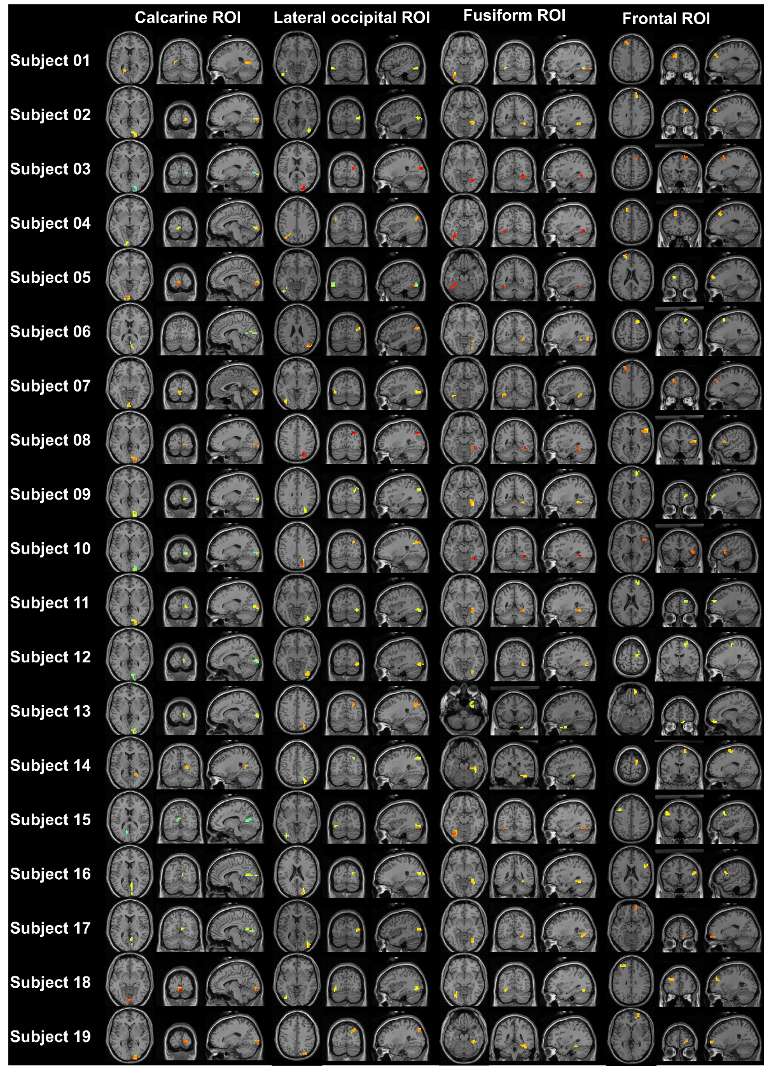
Supplementary Figure 2: Source ROIs. Note that the lateralization of the face selective response in the Fusiform gyrus was used to select which hemisphere was used for further analysis.
Spatial frequency dominance classification (figure 5 in main manuscript) cannot be compared to a known ground truth. To demonstrate that source level classification can deliver robust results and generalizes across spatial frequencies, we constructed a classification problem with a known ground truth to evaluate our classification approach. We classified between intact and scrambled broadband image trials, and found the classifier’s performance to be significantly above chance for all investigated ROIs (see Table 1).
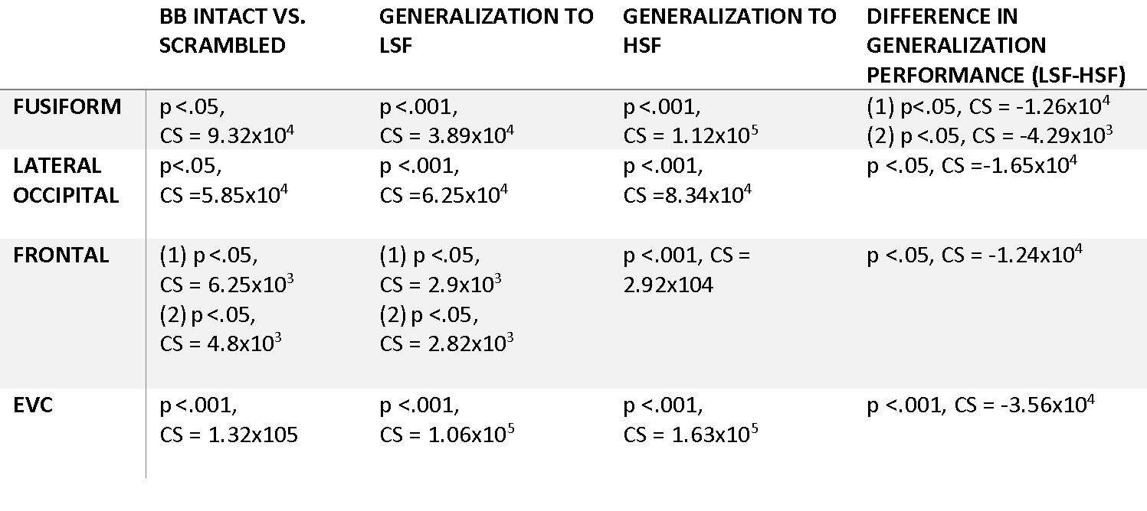 Supplementary Table 1: intact vs scrambled image classification results. LDA classifiers were trained on broadband trials to differentiate between intact and scrambled image trials. Classifiers generalized to both LSF and HSF conditions. CS = cluster statistic (maximum sum).

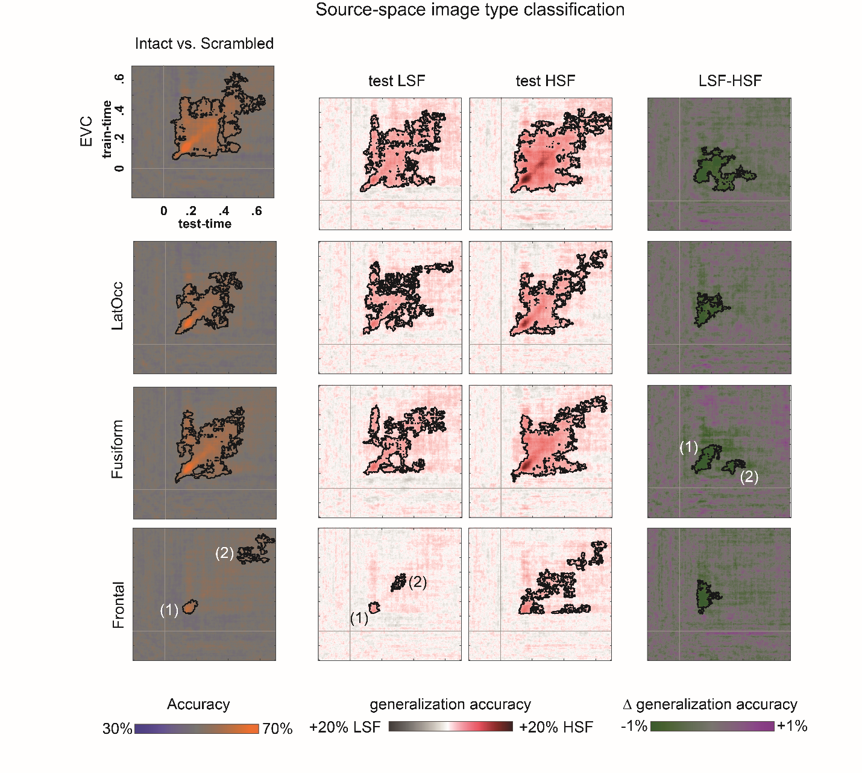
Supplementary Figure 3: Classifiers trained on broadband image trial data generalized to both LSF and HSF trial data. Interestingly, generalization performance was significantly higher and widespread for HSF, compared to LSF image trials, indicating a preferential use of HSF information for image type classification.

When presented with the ill-posed classification problem of categorizing broadband image trials into low spatial frequency and high spatial frequency, classifiers trained on post-stimulus data periods can deviate significantly from chance assignments for pre-stimulus validation data (see also Petras et al., 2019). In the current study, we find classifiers trained on data from ~170ms after stimulus onset in scrambled LSF vs. HSF image trials to assign HSF and classifiers trained on data from ~400ms post stimulus onset (i.e. ~100ms post stimulus offset) to assign LSF labels to the pre-stimulus interval of broadband trials.
This counterintuitive non-random label assignment to pre-stimulus time periods is explained by classifier bias. Supplementary figure 4 shows classifier bias across time for LSF and HSF scrambled trials. Instead of displaying decoding accuracy (proportion of classifier label matching true LSF/HSF class label, independent of label identity), we are showing the proportion of LSF and HSF label-identity assigned by the classifier, independent of the true class label. The bias map derived from LSF vs. HSF scrambled image trials in both training and (held-out) testing data closely resembles the pre-stimulus classification pattern observed when testing data came from broadband trials (Figure 3). Importantly, classifiers trained on the pre stimulus period assign class labels at random

Supplementary Figure 4: a) Response preference of classifier trained and tested on LSF vs. HSF scrambled image trials. Color code corresponds to the proportion of LSF and HSF labels assigned to the testing data. Note that all classification was stratified, i.e. true class frequencies were equalized in each cross validation fold. b) Along the diagonal of the train time x test time matrix, i.e. when training time and testing time were the same, classifier bias is minimal and inconsistent.

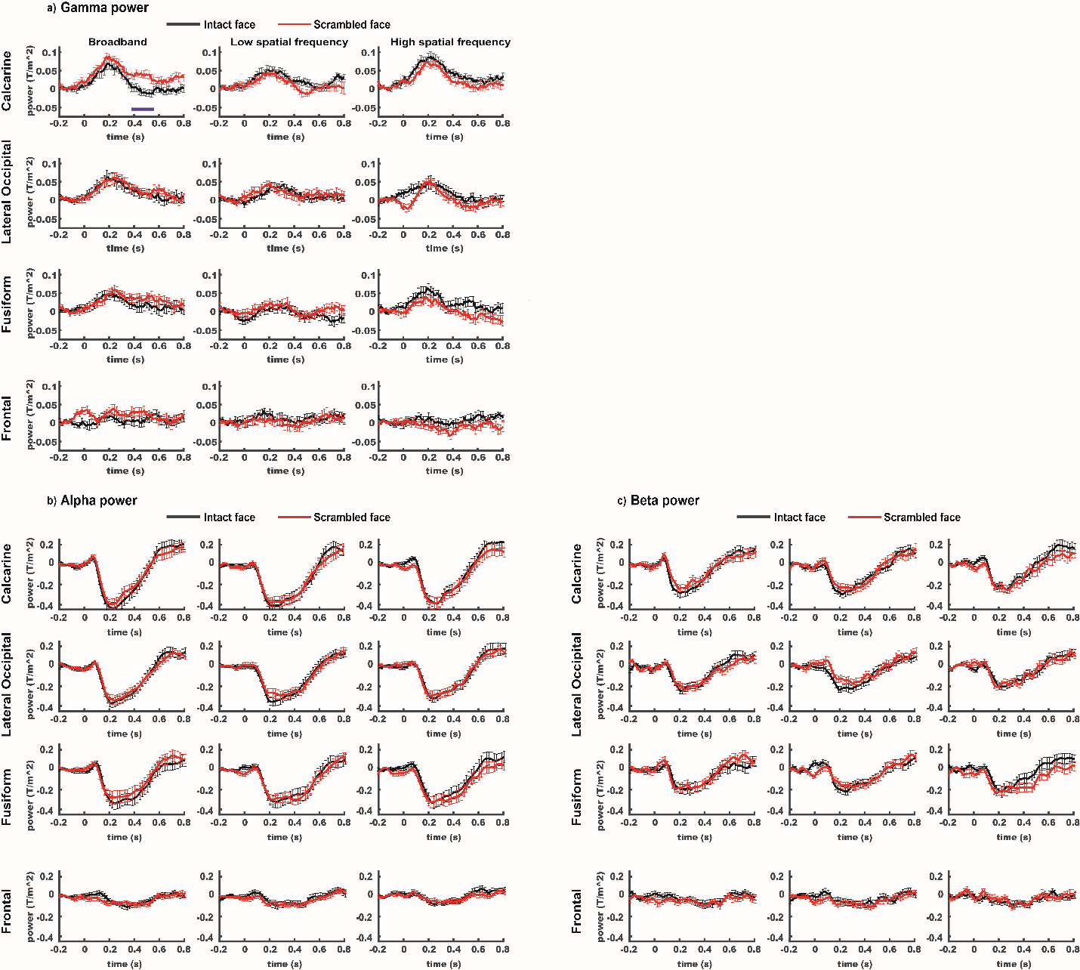
Supplementary Figure 5: Source power in the gamma (a), alpha (b) and beta (c) bands. Error bars indicate standard error of the mean.

Individual gamma frequency was determined for each participant and ROI via cluster-based permutation testing of the condition-averaged high frequency power difference between pre stimulus baseline and post stimulus response (see methods). We chose the frequency at the centre of the cluster with the maximum sum of t-values ±10Hz as our frequency of interest. For participants and ROIs where no significant difference between baseline and post-stimulus high frequency power was found, we resorted to using the average gamma frequency of all other participants. This was necessary for the Calcarine ROI in 3 participants, the Lateral Occipital ROI in 7 participants, the Fusiform ROI in 5 participants and the Frontal ROI in 14 participants. We are cautioning against drawing strong conclusions from gamma band comparisons in ROIs that showed weak overall gamma band responses, such as Lateral Occipital and Frontal. Statistical evaluations of those ROIs (see table 2 with marked cluster location indices in figure 5) are only added here for completeness and are not corrected for multiple tests, though they are corrected for multiple timepoints via cluster-based permutation testing.

 | 3 x 2 Interaction spatial frequency - image type | Simple effect spatial frequency | Simple effect Image type
Calcarine | CS=220.48, p<.05 | Broadband vs. Low spatial frequency  Intact: max CS=-14.5, p>.05  Scrambled: CS=59.1; p<.05 | Broadband: CS=-42.9, p <.05  Low spatial frequency: max CS=4.7, p >.05  High spatial frequency: max CS=-2.7, p >.05
Broadband vs. High spatial frequency
Intact: CS=-57.8, p<.05
Scrambled: max CS=4.4, p>.05
Lateral Occipital | CS=9.1, p>.05 | n.a. | n.a
Fusiform | CS=77.2, p>.05 | n.a | n.a
Frontal | CS=42.1, p>.05 | n.a | n.a
Supplementary Table 2: Gamma power effects in all ROIs. CS = cluster statistic (maximum sum of t values). Note that p-values have been corrected for multiple comparisons across timepoints within each test, but not for the number of tests. In ROIs where no significant effect for the interaction term of spatial frequency and image type was found, we did not test for simple effects.

Lagged PPC between “higher level” ROI α/β and early visual cortex γ-power

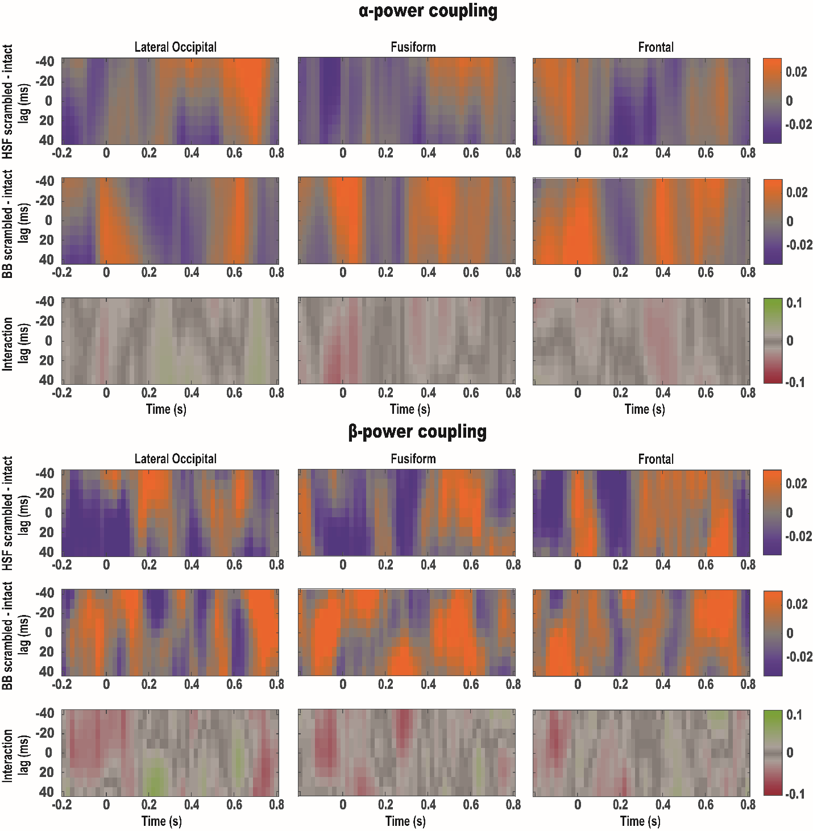
Figure 6: Lagged PPC between “higher level” ROI α/β and early visual cortex γ-power. We tested for condition differences in coupling between high level ROI low frequency (α/β) band power and early visual cortex γ band power. To account for finite transmission velocities of cortical signals, we considered a ±40 ms lag. After correcting for multiple comparisons using cluster based permutation testing, none of the conditions differences or their interaction met our threshold for statistical significance (p<0.05).

