Fig.1 Supplementary Materials.
Publication bias assessment by funnel plot for each cognitive domain for both cross-sectional (a-e) and longitudinal studies (f-j):
- Cognitive screening, cross-sectional studies
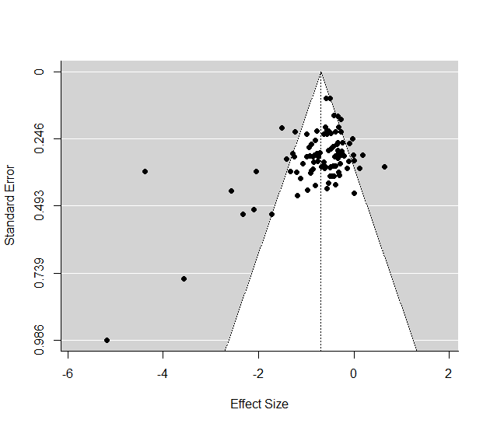

- Language, cross-sectional studies
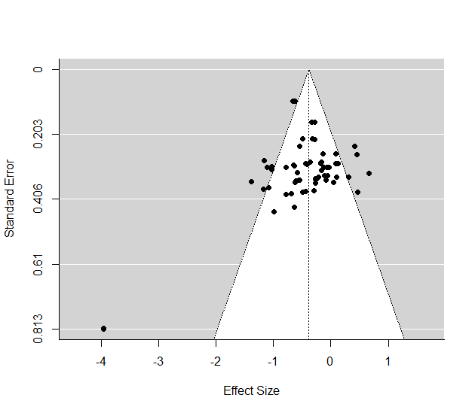

- Memory, cross-sectional studies
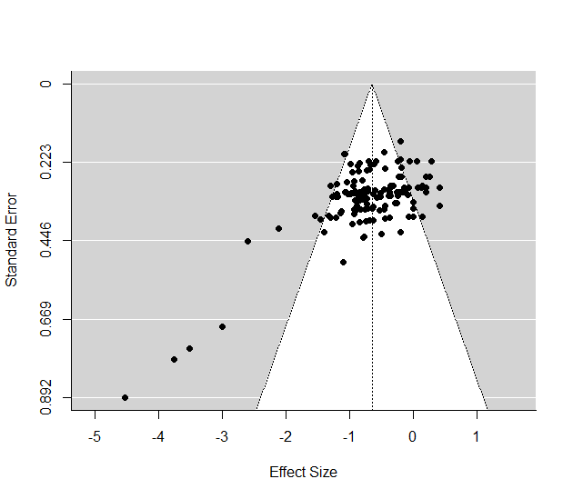

- Executive functions, cross-sectional studies
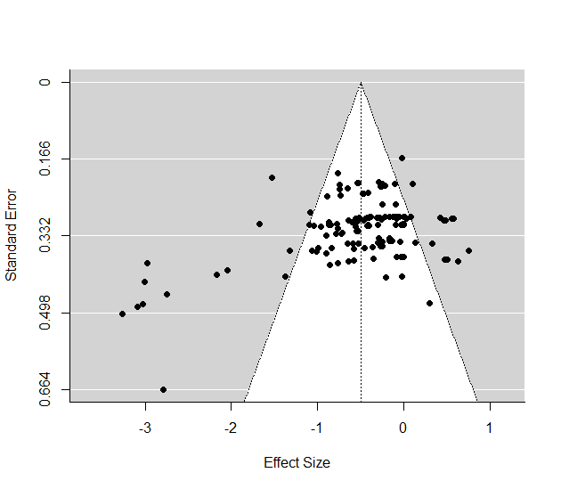

- Visuospatial abilities, cross-sectional studies
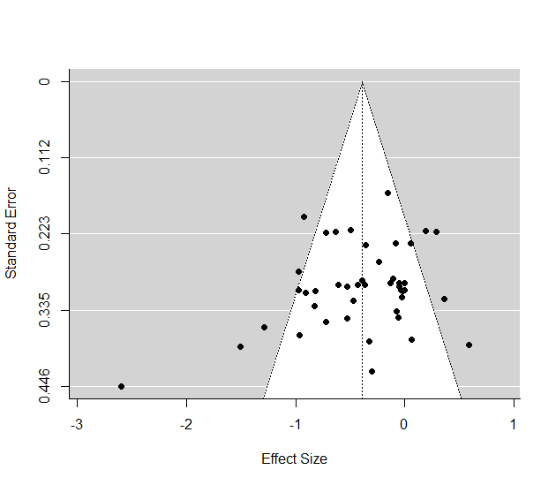

- Cognitive screening, longitudinal studies
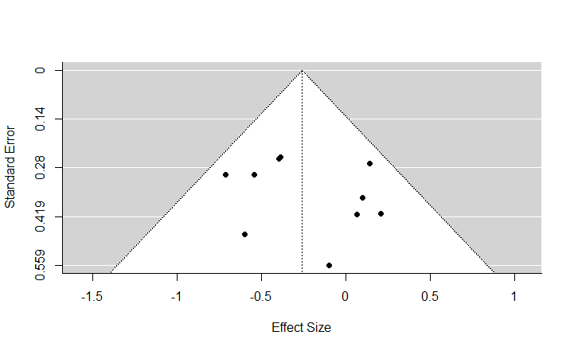

- Language, longitudinal studies
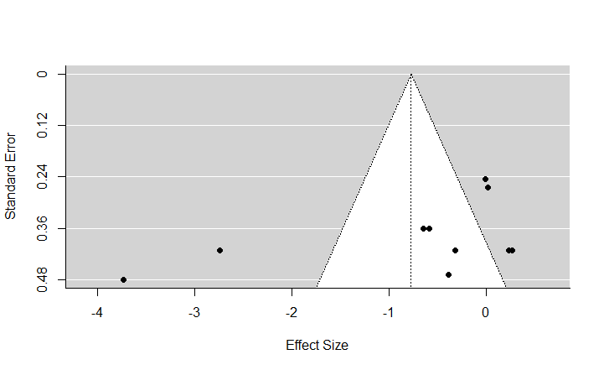

- Memory, longitudinal studies
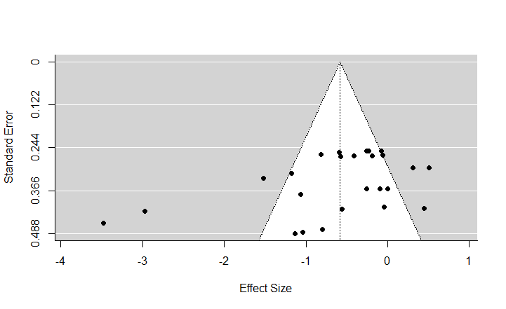

- Executive functions, longitudinal studies
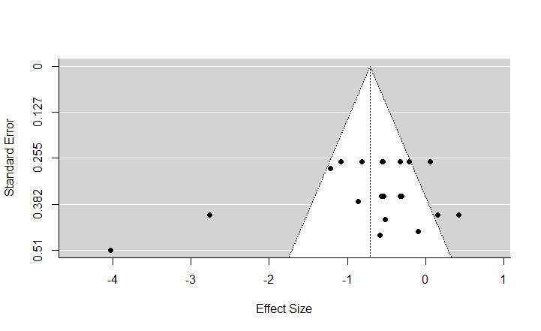

- Visuospatial abilities, longitudinal studies
